MATHEMATICS WEEKLY/UNIT PLANNER
Level: Gr 3/4 Term: 4 2017 Weeks: 7-8
Teachers: Sinead, Kellie and Marg
Dimension: Number
Specific Focus for Unit: Number – Addition and Subtraction
Victorian Curriculum Content Descriptions  http://victoriancurriculum.vcaa.vic.edu.au/mathematics/introduction/rationale-and-aims | Key Concepts  https://drive.google.com/file/d/0B3ydL4IWBSAbbk5laWtLOEprYXc/edit
Yr 2:  Explore the connection between addition and subtraction (VCMNA106)  Solve simple addition and subtraction problems using a range of efficient mental and written strategies(VCMNA107)  Solve problems by using number sentences for addition or subtraction (VCMNA113)  Yr 3:  Recognise and explain the connection between addition and subtraction (VCMNA132)  Recall addition facts for single-digit numbers and related subtraction facts to develop increasingly efficient mental strategies for computation(VCMNA133)  Yr 4:  Apply place value to partition, rearrange and regroup numbers to at least tens of thousands to assist calculations and solve problems (VCMNA153)  Use equivalent number sentences involving addition and subtraction to find unknown quantities(VCMNA163)  Yr 5:  Recognise and explain the connection between addition and subtraction (VCMNA132)  Recall addition facts for single-digit numbers and related subtraction facts to develop increasingly efficient mental strategies for computation(VCMNA133)  Describe, continue, and create number patterns resulting from performing addition or subtraction(VCMNA138) | Addition  Part-whole  When part of the quantity or the whole quantity is unknown,  e.g. 3 + ̈ = 7 and ̈ + 4 = 7 and 3 + 4 = ̈.  Commutative property  The order in which two numbers are added does not affect the sum, e.g. 6 + 3 gives the same sum as 3 + 6.  Associative property  Allows for purposeful grouping of three or more addends without affecting the sum, e.g. 2 + 9 + 8 could be solved by (2 + 8) + 9 or 2 + (8 + 9).  Relationship to subtraction  Recognising the inverse relationship between addition and subtraction,  e.g. 7 + 2 = 9 and 9 – 2 = 7.  Subtraction  Part-whole  When part of the quantity or the whole quantity is unknown,  e.g. 7 – ̈ = 4, ̈ – 3 = 4, 7 – 3 = ̈ .  Relationship to addition  Recognising the inverse relationship between addition and subtraction,  e.g. 9 – 2 = 7 and 2 + 7 = 9.

Pre-Assessment | Insights | Learning Intentions & Success Criteria
Task:  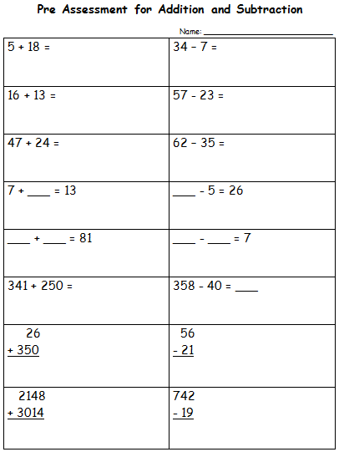 | Most students were successful with most of the addition. Most students had difficulty with vertical addition with regrouping. Some students showed an inability to know what to do with ‘the extra ten’  A significant group of students had difficulty with subtraction. Most students were not able to subtract with regrouping. Some students who seemed capable in subtraction displayed a misconception that you take the smaller number from the larger number.  Many students were unfamiliar with the vertical layout of addition and subtraction. | We are learning to understand the connections between addition and subtraction.  Success Criteria: I will be successful if…  I can take an addition or a subtraction and create other addition and subtraction problems out of it (‘three for free’).  I can solve addition and subtraction sums with missing numbers.  We are learning to complete addition and subtraction with large numbers.  Success Criteria: I will be successful if…  I can solve addition using horizontal and vertical methods.  I can solve subtraction using horizontal and vertical methods.  I can use what I know about place value and ‘regrouping’ to solve problems.  We are learning to master strategies that will assist us solve problems quickly and efficiently.  Success Criteria: I will be successful if…  I am able to quickly recall addition and subtraction facts to 20.  I can read a word problem and work out how to solve it.

SESSION NUMBER  KEY IDEA  LEARNING INTENTION | TOOLS SESSION  A short, sharp task relating to fluency in mental computation or the focus of the lesson.  WHOLE CLASS FOCUS  Sets the scene/context for what students do in the independent session. | INVESTIGATION SESSION  Extended opportunity for students to work in pairs, small groups or individually. A time for teacher to probe children’s thinking or work a small group for part of the time. | WHOLE CLASS REFLECTION  Focused teacher questions and summary to draw out the mathematics and assist students to make links. At end, or 20 mins before end | TEACHER ASSESSMENT  We are looking for...
Session 1  LEARNING INTENTION  We are learning to understand the connections between addition and subtraction.  SUCCESS CRITERIA  I will be successful if…  I can take a sum and create other sums out of it (‘three for free’).  I can solve addition and subtraction sums with missing numbers. | TOOLS SESSION  Tables at Tables & 20 Sum Challenge (number fact practise)  WHOLE CLASS FOCUS  Introduction of topic and guidance through the learning intentions on the cover sheet.  Tuning in Task:  Brainstorm times someone in your family uses addition  Share and discuss  Repeat with subtraction  Share and discuss | INVESTIGATION  Task: ‘Triangle Three for Free’  Use a triangle frame to create 3 for Free problems. (Could use a simple origami fold using large post-it/kinder square). Do lots of examples of the format (working first on what the missing number has to be) then have students create their own using numbers of differentiated ability.  12  + -  ?  8  12 + 8 = 20 8 + 12 = 20  20 – 8 = 12 20 – 12 = 8  Students use dice (various types) or random number generator to create a triangle frame and the accompanying 4 algorithms  Worksheet: ‘Three for Free’  (probably best to do this on a separate day)  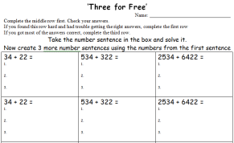  Students create problems – use calculators to solve as it’s about the 3 for free, not the solutions.  Extending and  Enabling Prompts:  Built into worksheet | REFLECTION  What are some of the tricks and tips to learning these?  How have you been successful?  What might someone else find hard? How would you help them?  Who’d like a study buddy to help them finish?  Revisit success criteria and use the ‘Where Am I At with My Learning?’ poster:  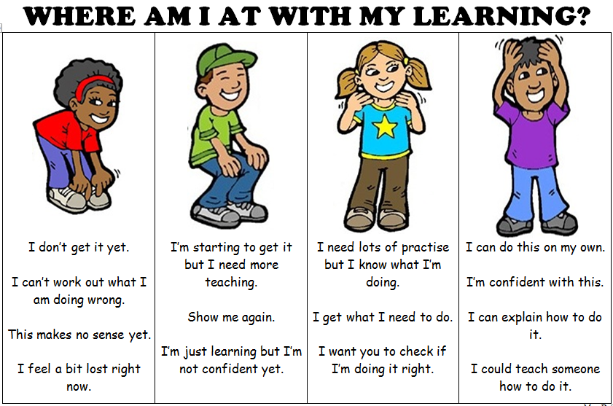  Keep working for 10 more minutes then we’ll correct together  Study Ladder: Addition and Subtraction pods | ASSESSMENT  Check

Session 2  LEARNING INTENTION  We are learning to complete addition and subtraction with large numbers.  SUCCESS CRITERIA  I will be successful if…  I can solve addition using horizontal and vertical methods. | TOOLS SESSION  Tables at Tables & 20 Sum Challenge (number fact practise)  WHOLE CLASS FOCUS  Tuning in Task:  Show examples of horizontal addition with 2-digit, 3-digit and 4-digit numbers on powerpoint.  https://docs.google.com/presentation/d/1j2tZmVYqcoVUDkUaSvjLGApnfwU6mEPXs6uI8X5sn4c/edit  Students choose from the various difficulty levels and complete 6 examples.  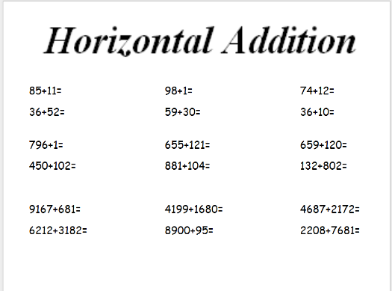  Answers on 2nd slide
Session 3  LEARNING INTENTION  We are learning to complete addition and subtraction with large numbers.  SUCCESS CRITERIA  I will be successful if…  I can solve addition using horizontal and vertical methods.  I can use what I know about place value and ‘regrouping’ to solve problems. | TOOLS SESSION  Tables at Tables & 20 Sum Challenge (number fact practise)  WHOLE CLASS FOCUS  Video: ‘Vertical Addition’ - Mathantics  http://www.mathantics.com/section/lesson-video/multi-digit-addition  Work through video over 2 days as it covers regrouping.  Worksheet: ‘Vertical Addition’  Over the next few days, the students can work through the sheets available.  Do the ones without regrouping first then the regrouping ones  Students work can be differentiated by choosing between 2-digit, 3-digit and 4-digit sheets

Session 4  LEARNING INTENTION  We are learning to complete addition and subtraction with large numbers.  SUCCESS CRITERIA  I will be successful if…  I can solve subtraction using horizontal and vertical methods.  I can use what I know about place value and ‘regrouping’ to solve problems. | TOOLS SESSION  Tables at Tables & 20 Sum Challenge (number fact practise)  WHOLE CLASS FOCUS  Video: ‘Vertical Subtraction - Mathantics  http://www.mathantics.com/section/lesson-video/multi-digit-subtraction  Work through video over 2 days as it covers regrouping.  Worksheet: ‘Vertical Subtraction  Over the next few days, the students can work through the sheets available.  Do the ones without regrouping first then the regrouping ones  Students work can be differentiated by choosing between 2-digit, 3-digit and 4-digit sheets
Session 5  LEARNING INTENTION  We are learning to master strategies that will assist us solve problems quickly and efficiently.  SUCCESS CRITERIA  I will be successful if…  I am able to quickly recall addition and subtraction facts to 20.  I can read a word problem and work out how to solve it. | TOOLS SESSION  Tables at Tables & 20 Sum Challenge (number fact practise)  WHOLE CLASS FOCUS  Focus: ‘Worded Problem Solving’  Talk about the concept of word problems and discuss how these are the most common ways people use their addition and subtraction skills in every day life.  Work through a few samples from the worksheets, then have students choose from the colours  See worksheets included

