MATHEMATICS WEEKLY/UNIT PLANNER
Level: Gr 3/4 Term: 2 2019 Weeks: 1-3
Teachers: Fran, Marg, Leonie
Dimension: Number
Specific Focus for Unit: Number – Addition and Subtraction
Victorian Curriculum Content Descriptions  http://victoriancurriculum.vcaa.vic.edu.au/mathematics/introduction/rationale-and-aims | Key Concepts  https://drive.google.com/file/d/0B3ydL4IWBSAbbk5laWtLOEprYXc/edit
Yr 2:  Explore the connection between addition and subtraction (VCMNA106)  Solve simple addition and subtraction problems using a range of efficient mental and written strategies(VCMNA107)  Solve problems by using number sentences for addition or subtraction (VCMNA113)  Yr 3:  Recognise and explain the connection between addition and subtraction (VCMNA132)  Recall addition facts for single-digit numbers and related subtraction facts to develop increasingly efficient mental strategies for computation(VCMNA133)  Yr 4:  Apply place value to partition, rearrange and regroup numbers to at least tens of thousands to assist calculations and solve problems (VCMNA153)  Use equivalent number sentences involving addition and subtraction to find unknown quantities(VCMNA163)  Yr 5:  Recognise and explain the connection between addition and subtraction (VCMNA132)  Recall addition facts for single-digit numbers and related subtraction facts to develop increasingly efficient mental strategies for computation(VCMNA133)  Describe, continue, and create number patterns resulting from performing addition or subtraction(VCMNA138) | Addition  Part-whole  When part of the quantity or the whole quantity is unknown,  e.g. 3 + ̈ = 7 and ̈ + 4 = 7 and 3 + 4 = ̈.  Commutative property  The order in which two numbers are added does not affect the sum, e.g. 6 + 3 gives the same sum as 3 + 6.  Associative property  Allows for purposeful grouping of three or more addends without affecting the sum, e.g. 2 + 9 + 8 could be solved by (2 + 8) + 9 or 2 + (8 + 9).  Relationship to subtraction  Recognising the inverse relationship between addition and subtraction,  e.g. 7 + 2 = 9 and 9 – 2 = 7.  Subtraction  Part-whole  When part of the quantity or the whole quantity is unknown,  e.g. 7 – ̈ = 4, ̈ – 3 = 4, 7 – 3 = ̈ .  Relationship to addition  Recognising the inverse relationship between addition and subtraction,  e.g. 9 – 2 = 7 and 2 + 7 = 9.

Pre-Assessment | Insights | Learning Intentions & Success Criteria
Task:  -Addition from 1-5 digits.  - Difference  - Relationship between addition and subtraction & commutative property  - Part-whole | -Understanding of difference  - Breaking up a number for efficient computation  - Interesting seeing the different ways students worked out problems- they all seemed to stick to a comfortable strategy, suggesting they could try using other strategies.  - Part whole: 30= __-7 and 24=40-__  - Most students skipped question 2. But out of those who attempted it, most got them correct.  Reporting Statements  Grade 3:  Manipulate numbers to at least 10 000 to solve problems.  Recall addition and subtraction facts to support efficient strategies for problem solving.  Grade 4:  Manipulate numbers to solve problems to tens of thousands.  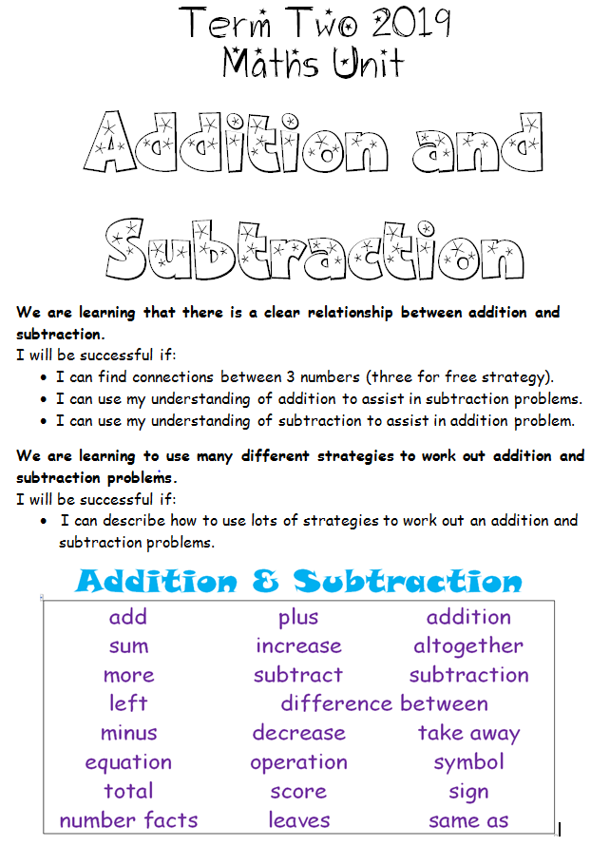 | We are learning to work out equations with missing parts (part-whole)  I will be successful if I can find the difference between two numbers  I will be successful if I can identify which operations can be used to work out the missing part  We are learning that you can change the order of the numbers in an addition problem and achieve the same total (commutative/associative property)  I will be successful if I can swap the numbers in an addition problem and still have the same total (three for free strategy)  I will be successful if I can use this strategy to be a quick/efficient problem solver  We are learning that there is a clear relationship between addition and subtraction  I will be successful if I can find connections between 3 numbers (three for free strategy)  I will be successful if I can use my understanding of addition to assist in subtraction problems  I will be successful if I can use my understanding of subtraction to assist in addition problem  We are learning to use many different strategies to work out addition and subtraction problems (strategy posters)  I will be successful if I can describe how I used a strategy to work out an addition problem.  I will be successful if I can describe how I used multiple strategies to work out an addition problem.  I will be successful if I can describe how I used a strategy to work out a subtraction problem.  I will be successful if I can describe how I used multiple strategies to work out a subtraction problem

SESSION NUMBER  KEY IDEA  LEARNING INTENTION  & SUCCESS CRITERIA | TOOLS SESSION  A short, sharp task relating to fluency in mental computation or the focus of the lesson.  WHOLE CLASS FOCUS  Sets the scene/context for what students do in the independent session. | INVESTIGATION SESSION  Extended opportunity for students to work in pairs, small groups or individually. A time for the teacher to probe children’s thinking or work with a small group for part of the time. | WHOLE CLASS REFLECTION  Focused teacher questions and summary to draw out the mathematics and assist chn to make link/s. | TEACHER ASSESSMENT  We are looking for...
Session 1  LEARNING INTENTION  & SUCCESS CRITERIA  We are learning to understand the connections between addition and subtraction.  We are learning that you can change the order of the numbers in an addition problem and achieve the same total (commutative/associative property) | TOOLS SESSION  NAPLAN slideshow & 20 Sum Challenge (number fact practise)  WHOLE CLASS FOCUS  Introduction of topic and guidance through the learning intentions on the cover sheet.  Relationship between Addition and Subtraction:  https://www.youtube.com/watch?v=zVLjWIftX_o | INVESTIGATION  Introduce the three for free strategy  8 + 5 = 13  5 + 8 = 13  13 - 8 = 5  13 - 5 = 8  What patterns do you notice? Is there a combination that would be incorrect?  (eg. 8-15=5, 5-8=15 are incorrect  13+ 5= 8, 13+8= 5 are incorrect)  Note commutative property: the order of the numbers in an addition problem can change and achieve the same total.  Note that commutative property does not work in subtraction.  Complete the following sheet:  Extension: Choose your own numbers to use the three for free strategy. | REFLECTION  What are some of the tricks and tips to learning these?  How have you been successful?  What might someone else find hard? How would you help them?  Who’d like a study buddy to help them finish?  Study Ladder: Addition and Subtraction pods  Matific: curriculum connected content | ASSESSMENT  Check

Show horizontal and vertical and sentence

Splitting Numbers
https://www.youtube.com/watch?v=J9bhsHzpgi8
https://www.youtube.com/watch?v=ZF-MWwuyid8
Regrouping
http://www.mathantics.com/files/lesson-videos/MultiDigitAddition.mp4
Session 2  LEARNING INTENTION  & SUCCESS CRITERIA  We are learning to understand the connections between addition and subtraction.  We are learning that you can change the order of the numbers in an addition problem and achieve the same total (commutative/associative property) | TOOLS SESSION  NAPLAN slideshow & 20 Sum Challenge (number fact practise)  WHOLE CLASS FOCUS  Refresh of what was learnt about the three for free strategy.  Tuning in: Repeated addition  In pairs verbally play skip counting tennis by counting by 2,5,10 (grade 3) and 3,4,6,7,8,9 (grade 4).  Try skip counting from a different number. | INVESTIGATION  Step 1: In this session, your challenge is to identify numbers that are connected and then show how with the ‘three for free’ strategy.  Step 2: When using the ‘three for free’ strategy, try to find ‘7 for free/7th heaven’ by showing equality (swapping over to the other side of the equal sign).  eg.  5+14=19  14+5=19  19-14=5  19-5=14  19= 5+4  19= 4+5  5= 19-14  14= 19-5  Addition/subtraction Relationship cards (difficulty increases as slide continues)  Have the students work in pairs or threes to do the ‘three for free strategy’ with these cards.  Extension: Try a more challenging card or choose your own numbers to use the three for free strategy. | REFLECTION  What patterns did you notice when trying the ‘7 for free’ strategy?  How have you been successful?  What might someone else find hard? How would you help them?  Study Ladder: Addition and Subtraction pods  Matific: curriculum connected content | ASSESSMENT

Session 3  LEARNING INTENTION  & SUCCESS CRITERIA  We are learning to work out equations with missing parts (part-whole) | TOOLS SESSION  NAPLAN slideshow & 20 Sum Challenge (number fact practise)  WHOLE CLASS FOCUS  Introduction of topic and guidance through the learning intentions on the cover sheet.  Tuning in task: Refresh of ‘friends of ten’ and the connection with friendly numbers. See slide 4:  https://docs.google.com/presentation/d/11XQHFzA-qGPbLie7_HmQ8JF5N7rHZFz_lDyBoIaEhHE/edit#slide=id.g345e4deb8d_0_76  Discuss poster then give the students a number and a friendly number and ask for the missing part. Gradually increase difficulty  eg. What goes with 5 to make 10?  5+__=10  What goes with 3 to make 10?  3+ __ = 10  What goes with 13 to make 20?  13+ __=10 | INVESTIGATION  Watch: Finding missing parts https://www.youtube.com/watch?v=Mvm0y1Qr_JQ  Model the headache game: Use post-it notes on two students with numbers on them(e.g. 20 and 10). Give the students the total (which is 30). The students need to work out what number is on their forehead.  Students prepare to play this game (for tomorrow) by creating a page in the Maths books with squares filled accordingly:  Whole  Part Part  30  10 20  The squares will represent what they will write on the post-it notes tomorrow.  Use calculators to check answers. | REFLECTION  How do you find missing parts of a problem?  Study Ladder: Addition and Subtraction pods  Matific: curriculum connected content | ASSESSMENT  Students can check answers with a calculator. Teacher to check.

Session 4  LEARNING INTENTION  & SUCCESS CRITERIA  We are learning to work out equations with missing parts (part-whole) | TOOLS SESSION  NAPLAN slideshow & 20 Sum Challenge (number fact practise)  WHOLE CLASS FOCUS  Model the headache game. Then allow kids to play the headache game (book work from yesterday to guide their game) | INVESTIGATION  Refocus everyone and discuss what strategies they used to find the ‘difference’.  Discuss the word difference and how it helps to solve problems with missing parts.  Create posters with ‘difference’ statements for the Maths Wall:  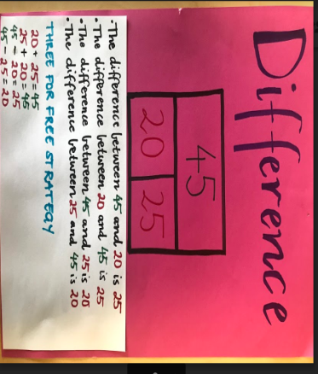  Students should fit at least 4 diagrams with matching statements per A3 sheet. | REFLECTION  What strategies do you need to use to find the difference?  Study Ladder: Addition and Subtraction pods  Matific: curriculum connected content | ASSESSMENT  Teacher to check for understanding of difference.

Session 5-18  LEARNING INTENTION  & SUCCESS CRITERIA  We are learning to use many different strategies to work out addition and subtraction problems (strategy posters) | TOOLS SESSION  NAPLAN slideshow & 20 Sum Challenge (number fact practise)  TUNING IN  Refer to slideshow  https://docs.google.com/presentation/d/11XQHFzA-qGPbLie7_HmQ8JF5N7rHZFz_lDyBoIaEhHE/edit#slide=id.g348770bc7e_4_47  WHOLE CLASS FOCUS  Refer to slideshow | INVESTIGATION  Refer to slideshow  Add examples of each strategy to your Maths Wall as you go (early finishers are helpful with this!). It may be difficult to remember the names of different strategies so the wall will be used as a point of reference throughout the unit and will assist students in articulating their thinking.  Possible activity: Students to teach strategies and add to Flip Grid account throughout the unit or at the end of the unit:  https://flipgrid.com/443ca2 | REFLECTION  What was helpful about this strategy?  What was difficult about this strategy?  Would you use this strategy in real life situations?  Study Ladder: Addition and Subtraction pods  Matific: curriculum connected content | ASSESSMENT

