We’re Learning About Blends

Learning about blends helps us to spell words correctly and increases our vocabulary.

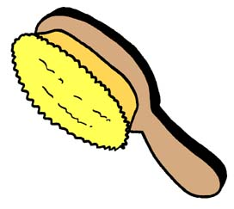
Words that begin with
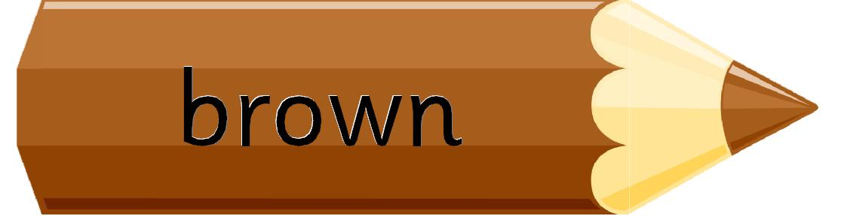
br

What words have a ‘br’ blend?
Would a dictionary help?

What words have a ‘br’ blend?

brake | branch | brave
broom | bread | brick
bridge | brown | brush
brother | bring | break

Word Search for ‘br’ Blend Words
B I B M L B Q D B B P C M U N  M R C R R K A E R B D S O R R  A H O I O E H I U W M C O O K  I O D W R T N Q S E Y Q R B A  K G U B N G H K H W V O B K O  E T B Q T O M E X S V A S N C  Z P A J F X F T R L B J R Y O  H C W P X H N E K A R B B B H  A T L O M A V W H P A M D D I  B R I C K M N U E Y N O A R Y  F G U L K Z B S S T C T P I K  R P F F W M R U P B H W V X C  Y G B T C R H X F X C B I B J  H T N B O H H Z E M V Y O Q V  B I L H E M K B Z A G J V P O | BRAKE  BRANCH  BRAVE  BROOM  BREAD  BRICK  BRIDGE  BROWN  BRUSH  BROTHER  BRING  BREAK

Make a Flip Book

br

Words you can do  (Verbs) | Words that are something  (Nouns)
Words that describe something  (Adjectives) | Not sure

My brother Brendan
likes breakfast in bed.
Sometimes all his breakfast
ends up on his head!

