We’re Learning About Blends

Learning about blends helps us to spell words correctly and increases our vocabulary.

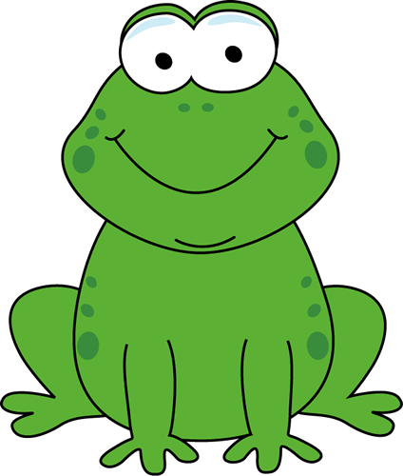
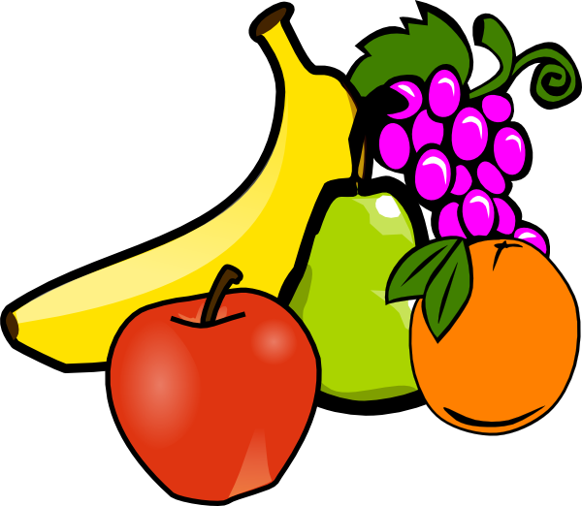
Words that begin with
fr

What words have an ‘fr’ blend?
Would a dictionary help?

What words have an ‘fr’ blend?

free | freeze | fresh
Friday | friend | fright
frog | frost | from
fry | fruit | front

Word Search for ‘fr’ Blend Words
J R L Y J S H T S E A O S H U  G F B E L O N U H Z F R U I T  C R R J M F Q N U G W A R S K  H E Y M Z F Y M R C I M O R F  S E R J R H X P S V Q R Q K Y  E E N O F E F R P Q E D F G T  R F G U O B R G Z G U Z G E A  F M R C U X E Y C E T U E O E  W J L O W F E G Y S F M U J J  J G D A N F Z C O R E Z O G O  K W A M R T E R L Q F E Z F W  M L X I T C F X T U L U T B B  X V D V A P H H K E I U B U C  D A P C R Y Q T P U L Q K C M  Y S P N S Y R M O D N E I R F | FREE  FREEZE  FRESH  FRIDAY  FRIEND  FRIGHT  FROG  FROST  FROM  FRY  FRUIT  FRONT

Make a Flip Book

fr

Words you can do  (Verbs) | Words that are something  (Nouns)
Words that describe something  (Adjectives) | Not sure

