We’re Learning About Blends

Learning about blends helps us to spell words correctly and increases our vocabulary.

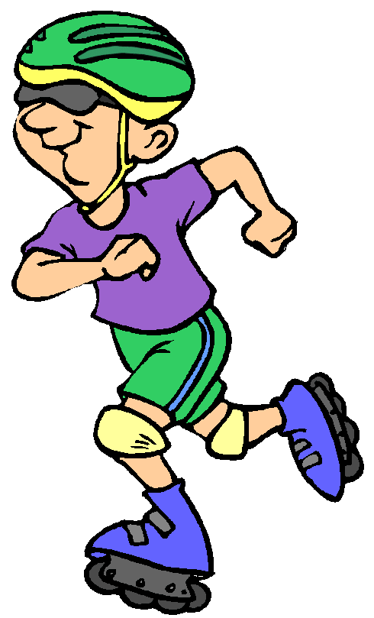
Words that begin with
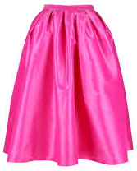
sk

What words have a ‘sk’ blend?
Would a dictionary help?

What words have a ‘sk’ blend?

skate | ski | skin
skirt | sky | skip

Word Search for ‘sk’ Blend Words
S V O H J R N H Y E L M V P K  E K F E E M T L G N S F N N C  J Q I T T X T H M C K J A B H  C H A N F I W P J R I V B O Y  R K Q O R M N F F Q P W X E A  S L M T J D I S F W R E N V D  S K I R T C G S P O M M I T H  E C V R D D J T I N O F Z Q H  A N F B K S D E X Z B H B E R  G A H Y A I S Q Z S K S H N U  W C P A A M A I K O L M E S N  F J A U S B P I I T N Y O P J  K J R A Y K S A X D N D D A H  R G N L P Q J H J V R X Y X B  E A B S B F L B V U F L Z Q V | SKATE  SKI  SKIN  SKIRT  SKY  SKIP

Make a Flip Book

sk

Words you can do  (Verbs) | Words that are something  (Nouns)
Words that describe something  (Adjectives) | Not sure

Skates and skateboards,
skipping and skis,
Sky rockets zoom over
clouds and the trees.

