We’re Learning About Blends

Learning about blends helps us to spell words correctly and increases our vocabulary.

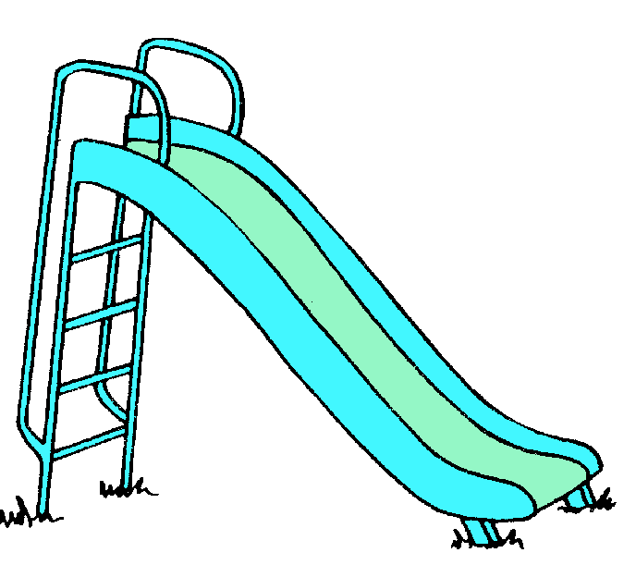
Words that begin with
sl

What words have a ‘sl’ blend?
Would a dictionary help?

What words have a ‘sl’ blend?

slam | sled | sleep
slide | slept | slim
slow | slipper | slip

Word Search for ‘sl’ Blend Words
D B V X Z R G N S I J G E Q Q  A L J H U E G V L L Y Z G M J  P F Q Y Y P H J A H R W K W C  L O D I U P K C M Y T M D J D  S L I D E I S M X D V W T W C  U B X I C L D L X Z Q F S O Y  Q V C V N S P V E V J B A D C  T B N N W F B X N P M I L S S  A H O D P O X A K H T J A L R  I C L E O I L J X K Z S E E D  P W E G Q G Z S Y P L D E I V  U L B U I E W A X S N O F O P  S D H L P T L D J H R I K Q I  M P T H U E S W Z B W F W W L  H N E L G U E C R Q O T M Z S | SLAM  SLED  SLEEP  SLIDE  SLEPT  SLIM  SLOW  SLIPPER  SLIP

Make a Flip Book

sl

Words you can do  (Verbs) | Words that are something  (Nouns)
Words that describe something  (Adjectives) | Not sure

I like to slide and I like to hide,
I like to sleep and I like to ride,
but I don’t like slings
or slimy things!

