Counting by 3s
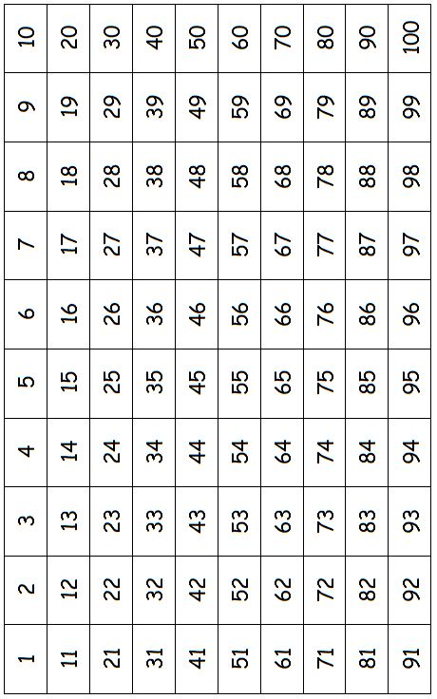
When I count by 3s, this is the number pattern:

____________________________________________________________________________

Counting by 4s
When I count by 4s, this is the number pattern:

____________________________________________________________________________

Counting by 5s
When I count by 5s, this is the number pattern:

____________________________________________________________________________

Counting by 6s
When I count by 6s, this is the number pattern:

____________________________________________________________________________

Counting by 7s
When I count by 7s, this is the number pattern:

____________________________________________________________________________

Counting by 8s
When I count by 8s, this is the number pattern:

____________________________________________________________________________

Counting by 9s
When I count by 9s, this is the number pattern:

____________________________________________________________________________

