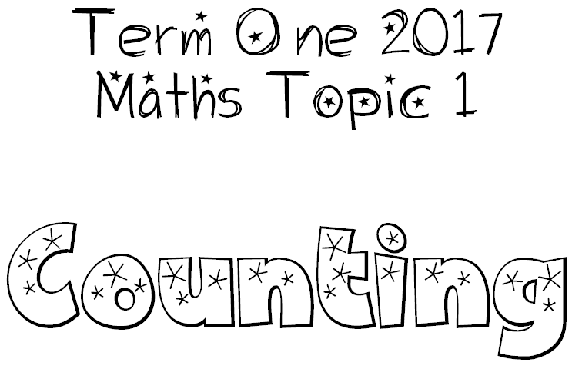

- Counting is a skill we need to make maths quicker and easier.

- We need to count forwards, backwards, skip count and count from any starting point.

- Numbers can be divided into odd and even.

- We need to count from 1 digit to 2 digit to 3, 4, 5 digit numbers (eg. Knowing what to do when we get to numbers that end in 9).

- We can use the repeat function on a calculator to work more quickly.

