|  |
| --- |
| Name: ______________________________ |

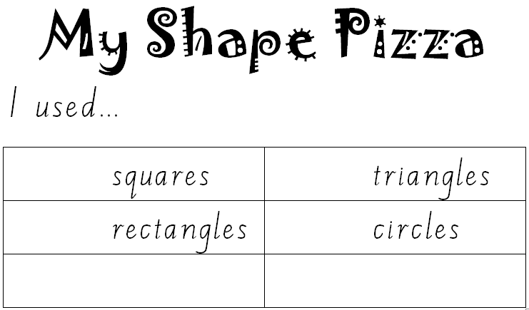

MargD