|  |
| --- |
|  |

MargD

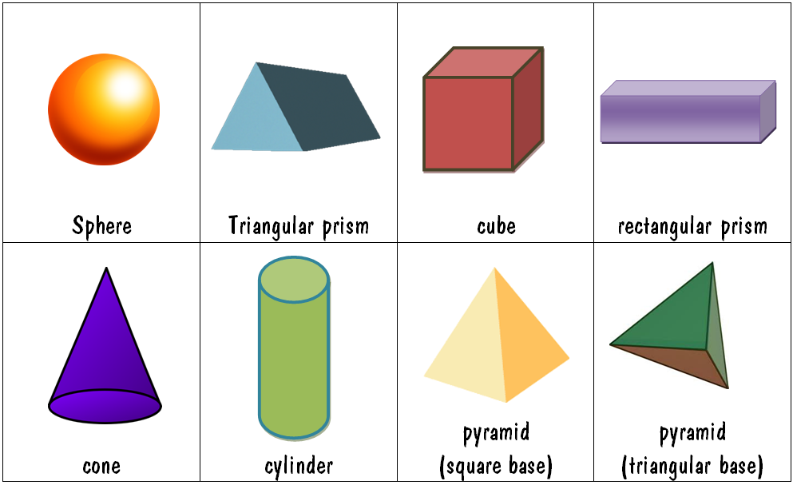

MargD

|  |  |
| --- | --- |
|  |  |

MargD