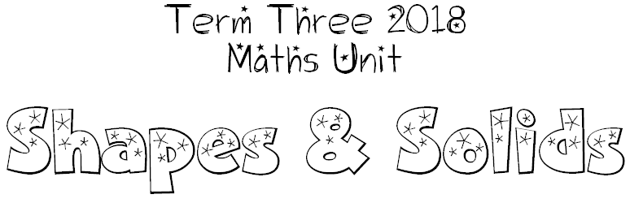

We can investigate…

The properties of shapes and solids.
corners, sides, edges, faces, vertices, surfaces, convexity, concavity

How to group (classify) different shapes and objects by their shared properties

How to make 3D solids from nets

Types of angles
reflex, acute, obtuse

How to measure angles
using a protractor

Symmetry and lines of symmetry

Tessellations

Transformation
What happens when we flip (reflect), slide (translate) and turn (rot)ate shape?

