MATHEMATICS WEEKLY/UNIT PLANNER
Level: Gr 3-4 Term: 3 Weeks: 4
Teachers: Sinead, Fran, Sarah, Marg
Dimension: Measurement and Geometry Specific Focus for Unit: Geometry - Shapes and Solids
Victorian Curriculum Content Descriptions | Key Concepts
Yr 2:  Describe and draw two-dimensional shapes, with and without digital technologies (VCMMG120)  Elaborations  - identifying key features of squares, rectangles, triangles, kites, rhombuses and circles, such as straight lines or curved lines, and counting the edges and corners  Yr 3:  Make models of three-dimensional objects and describe key features (VCMMG142)  Yr 4:  Compare the areas of regular and irregular shapes by informal means (VCMMG169)  Compare and describe two dimensional shapes that result from combining and splitting common shapes, with and without the use of digital technologies (VCMMG170)  Explain and compare the geometric properties of two-dimensional shapes and three-dimensional objects(VCMMG171)  describing the similarities and differences between two-dimensional shapes and three-dimensional objects  recognising two-dimensional shapes that are the faces for three-dimensional objects such as prisms, pyramids and platonic solids (including tetrahedrons, cubes and dodecahedrons)  Yr 5:  Explain and compare the geometric properties of two dimensional shapes and three-dimensional objects (VCMMG171) | Properties  Shapes and objects have distinguishable characteristics and are named because of their properties  The properties of two-dimensional (2D) shapes include the number of sides, the number of corners, the lines of symmetry, the length of sides, the size and types of angles, convexity and concavity  The properties of 3D objects include faces, edges, vertices and surfaces.  Categories/Classification  Relationships between shapes or objects are established because of shared properties:  A rectangle is a parallelogram, as well as a trapezium, as well as a quadrilateral, as well as a polygon  A cube is a prism, as well as a polyhedron.  Symmetry  One shape becomes exactly like another when it is translated, rotated and reflected: the shape appears unchanged after a transformation.  Reflective symmetry – when a shape can be folded on a line so the two halves match  Rotational symmetry – when a shape or object can be rotated about a point and appears unchanged from the original in any fraction of the turn.  Point of View  Object can be seen from different perspectives  Transformation  A change in the position (isometric) or size or shape (non-isometric) of a shape or object.  Isometric transformation  Translation (slide) – the process by which an object or figure changes position without turning  Rotation (turn) – the process by which an object or figure changes position by rotating about a fixed point through a given angle.  Reflection (flip) – the mirror image of an object or figure, where each point of the object is the same distance from the ‘mirror line’ as its corresponding point.
Pre Assessment

Matching activity - 2D shapes
Students cut and paste shapes

Misconceptions & Strengths  Misconceptions  -Confusion between pyramids and prisms  - Particular confusion between triangular prism and square based pyramids (perhaps clarity of picture of square based pyramid)  Strengths  - most students were able to identify cylinders, spheres, cones and cubes | Pre-assessment adjustments for next year | Learning Intentions

TOOL SESSION  MUSCLE MEMORY | WHOLE CLASS FOCUS  (Repeat X3) | INVESTIGATION SESSIONs PLUS MATIFIC TASKS  (3 tasks exploring same concept) | REFLECTION  (you may begin with this or place in in the middle of lesson)
Session 1  Celebrity Shapes  Using post it notes for a selection of children, they play celebrity heads… each wearing a picture of a 2D shape on their heads. They may ask questions in relation to properties of their shapes with answers of yes/no.  Possible properties:  -the number of sides  -the number of corners  -the lines of symmetry  -the length of sides  -the size and types of angles, -convexity and concavity  - pairs of parallel lines  - regular shape/irregular shape  - curved lines/straight lines  OR  BRAG TAGS: Practise learning times tables and or maths concepts/facts | Provocation:  What are Polygons?  What is a Regular/Irregular Polygon?  Learning Intention/Understanding:  Shapes can be sorted into groups according to their properties.  Success Criteria:  I can sort polygons into regular and irregular groups  Teach:  Maths Antics: Polygons and Regular/Irregular Shapes  https://www.youtube.com/watch?v=IaoZhhx_I9s  Quiz | Task 1  Children use MS Word to create regular shapes using ‘Insert Shape: edit/format and caption the shapes, then print. This can be done in pairs.  Use this poster to inspire.  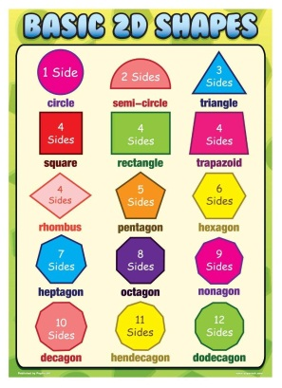  Task 2  Make regular and irregular shapes from matchsticks and plastecine. You must be able to name the regular shapes.  Task 3  Make regular and irregular shapes about of pretzels and marshmallows. Don not each them until we have seen your shapes  MATIFIC  Levelled Geometry tasks related to topic and ability level. | What is Geometry?  Why do people need to learn about shape? Where do we see shape? How does it affect our day to day life?  Shapes can be defined by their properties and belong to different groups. Discuss.  Enabling:  Review knowledge of basic shapes and their properties. Have children name, describe and regularly sort shapes into different groups.  Extending:  Discuss the names of shape groups and word origins including quadrilaterals, triangles etc.  Assessment Piece if required:  Located in folder.

TOOL SESSION  MUSCLE MEMORY | WHOLE CLASS FOCUS  (Repeat X3) | INVESTIGATION SESSIONs PLUS MATIFIC TASKS  (3 tasks exploring same concept) | REFLECTION  (you may begin with this or place in in the middle of lesson)
Session 2  Shared Quiz based on Combination of regular shapes to create other shapes.  https://www.studyladder.com.au/games/activity/combining-or-splitting-2d-shapes-21337?lc_set= | Provocation:  Can you combine shapes to make other shapes? What are there properties?  Can you split shapes and create multiple shapes?  Learning Intention/Understanding:  Shapes can be split and combined to make new shapes.  Success Criteria:  I can combine and split regular shapes to make new regular shapes using many different materials.  Teach: Combining shapes using pattern blocks  (basic but educational)  https://www.youtube.com/watch?v=RpW3tjWUZi8  Shared Quiz  https://www.studyladder.com.au/games/activity/combining-or-splitting-2d-shapes-21337?lc_set= | Investigation  Task 1  Shape Towers: Using examples from the video, how can we use pattern blocks how shapes can be combined to make a new shape.  e.g use a hexagon as a base and build on top with other shapes.  Task 2  Watch the story of the origin of Tangram:https://www.youtube.com/watch?v=X5mc-dkYLfI  Decorate and manipulate the tangra as below:  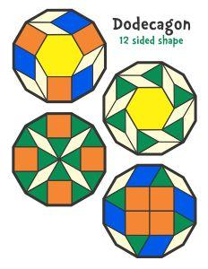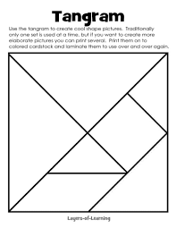  Task 3: Extending:  Complete the  complex tangram  BLMs using pattern  Blocks. Flip the shapes  as an extension. | How is shape used in the creation of art?  Enabling  What are my favourite shapes and why? Describe your favourite shape and it’s properties.  Extending  What are tangrams?  How do they add to our knowledge of geometry?  Maths Wall  Assessment  Use photos of the shape towers to show how shape can be combined and split.

TOOL SESSION  MUSCLE MEMORY | WHOLE CLASS FOCUS  (Repeat X3) | INVESTIGATION SESSIONs PLUS MATIFIC TASKS  (3 tasks exploring same concept) | REFLECTION  (you may begin with this or place in in the middle of lesson)
Session 4  Use pattern blocks and rulers to ‘create’ mirror images in pairs.  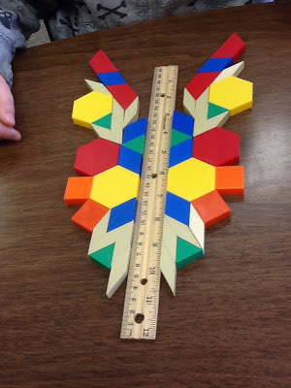  OR  Revise the definition of regular and irregular shapes. (very important to keep revising this.  Sort regular and irregular shapes using shapes box as found in math’s cupboard. | Provocation: Another property of a shape is symmetry, but what is it?  Learnng Intention/Understanding  Symmetry: Reflective symmetry – when a shape can be folded on a line so the two halves match  Success Criteria: I can sort shapes into groups based on the number of lines of symmetry  Teach:  Youtube: Symmetry https://www.youtube.com/watch?v=vEro2-qcFqU  Youtube  Reflectional Symmetry https://www.youtube.com/watch?v=YFzktJNmnPU | Investigation  Task 1  Make a chatter box/cootie catcher that requires symmetrical folding and focuses on geometry as below.  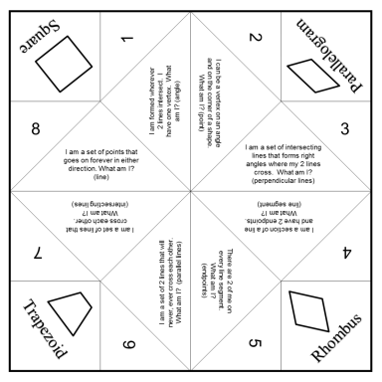  Task 2  Use photos of the children’s faces to explore whether human faces are actually symmetrical and/or cut the faces in half and ask the children to draw the other side.  Task 3 Keep for Assessment  This task enables the high achievers to express higher level knowledge.  See worksheet to the right. | Symmetry and Art: Google and discuss.  Enabling and Entending as explored in the assessment task below. Check for ‘open’ ended task.  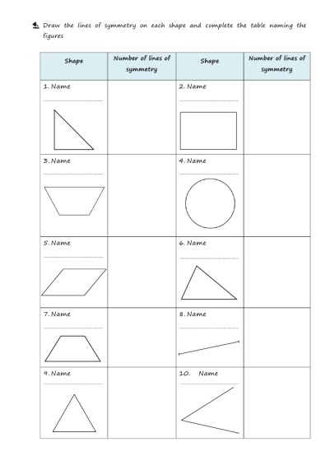

TOOL SESSION  MUSCLE MEMORY | WHOLE CLASS FOCUS  (Repeat X3) | INVESTIGATION SESSIONs PLUS MATIFIC TASKS  (3 tasks exploring same concept) |  | REFLECTION  (you may begin with this or place in in the middle of lesson)
Session 5  Revise the definition of regular and irregular shapes.  Sort regular and irregular shapes using shapes box as found in math’s cupboard.  AND/OR  Exploration of 3D shapes.  https://youtu.be/DGKwdHMiqCg?list=PLUPEBWbAHUsx47fzhccfRSk4uNnBwtk7n | Provocation: What are the properties of shapes we have learnt about or know so far?  What are the different ways that shapes can be sorted according to their properties?  Learning Intention/Understanding  Shapes can be sorted and resorted into different categories.  Shapes can have many different labels or names.  Teach:  Session 1 Maths Antics: Quadilaterals  https://www.youtube.com/watch?v=yiREqzDsMP8  Session 2: Maths Antics  https://www.mathantics.com/section/lesson-video/triangles  Session3: Angles Basics  https://youtu.be/DGKwdHMiqCg?list=PLUPEBWbAHUsx47fzhccfRSk4uNnBwtk7n |  | Rotational Groups  Sort shapes into regular and irregular shape groups.  Use hoops to sort shapes into different properties: quadilaterals: parallel and non parallel,  Triangles that have 90 degree angles, obtuse and acute.  Concave and convex: shapes with more than four sides.

Learning Intention
We are learning about ‘transformations’

Success Criteria
I will be successful if I:
- Learn about transformations from the video
- Watch Miss Marg’s instructions and ask any questions I have
- Practise what I have learned by showing the 3 types of transformations using lots of examples with different shapes

Extension
What happens to shapes when you rotate (turn) by differing amounts?
½ turn ¼ turn

Transformations
Flip slide turn
Easy
https://www.youtube.com/watch?v=wSjQ0RTjKxg
Harder
https://www.youtube.com/watch?v=VJTxv-tRKj0

Extension
What happens to shapes when you rotate (turn) by differing amounts.
https://www.youtube.com/watch?v=NVuMULQjb3o

Angles Song by NUMBEROCK
https://www.youtube.com/watch?v=3QRRdAaLZBA

Using a Protractor to Measure Angles
https://www.youtube.com/watch?v=cehqgTk-r24

How To Measure Angles? Degrees and Protractors

Transformation Name
Shape | Flip  Reflect | Slide  Translate | Turn  Rotate

