Kristy the Cat

For heads, bodies and tails handwriting help

|  |  |  |  |  |
| --- | --- | --- | --- | --- |
|  |  |  |  |  |
|  | Bodies | Bodies and Tails | Heads and Bodies | Heads, Bodies and Tails |
|  |  |  |  |  |
|  | Bodies | Bodies and Tails | Heads and Bodies | Heads, Bodies and Tails |

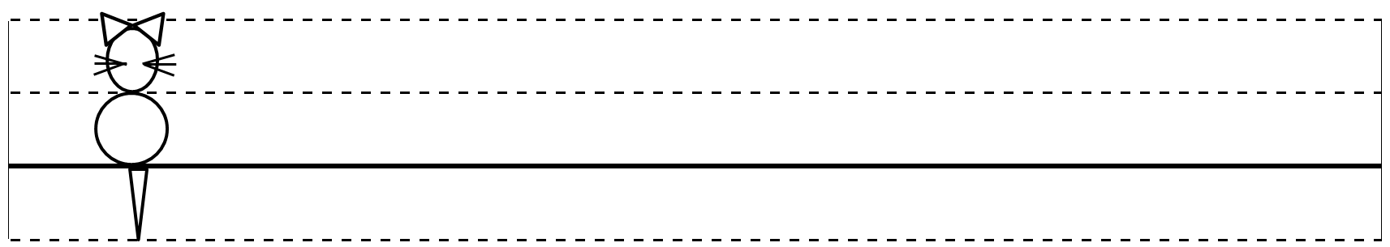

Kristy the Cat

For heads, bodies and tails handwriting help

|  |
| --- |
|  |
|  |
|  |

|  |
| --- |
|  |
|  |
|  |

|  |
| --- |
|  |
|  |
|  |

|  |
| --- |
|  |
|  |
|  |

|  |
| --- |
|  |
|  |
|  |

|  |
| --- |
|  |
|  |
|  |

|  |
| --- |
|  |
|  |
|  |

|  |
| --- |
|  |
|  |
|  |

|  |
| --- |
|  |
|  |
|  |

|  |
| --- |
|  |
|  |
|  |

|  |
| --- |
|  |
|  |
|  |