English Unit Planner
Level: Gr 3/4 Term: 1 2019 Weeks: 4-10
Teachers: Leonie, Fran and Marg
Language Mode: Writing - Handwriting

Victorian Curriculum Content Descriptions
http://victoriancurriculum.vcaa.vic.edu.au/english/curriculum/f-10

Grade 2
Write words and sentences legibly using upper- and lower-case letters that are applied with growing fluency using an appropriate pen/pencil grip and body position (VCELY232)
Grade 3
Understand the conventions for writing words and sentences using joined letters that are clearly formed and consistent in size (VCELY268)
Grade 4
Handwrite using clearly-formed joined letters, and develop increased fluency and automaticity(VCELY301)
Grade 5
Develop a handwriting style that is becoming legible, fluent and automatic (VCELY331)

Learning Intentions and Success Criteria
We are learning to write using joined letters that are clearly formed and consistent in size.
I will be successful if…
I am able to sort letters by their formation features
I am able to correctly form letters.
I am able to keep my writing ‘sitting’ on the lines.
I am able to join letters correctly.
I am able to keep the size of my letters accurate.
I am able to use consistent spacing between letters and words.
I am able to develop a clear, attractive and fluid writing style.

Reporting Statements
Grade 3
Write clearly using joined letters that are accurately formed and consistent in size.
Grade 4
Write fluently using clearly-formed joined letters.

SESSIONS
WHOLE CLASS FOCUS >> INDIVIDUAL / SMALL GROUP / CLASS SESSION
Warm Ups:
‘I TO 9’ Each finger touching each finger on the other hand
Rock paper scissors championship
Thumb rolls

Focus: Handwriting Posture and Pencil/Pen grip
Examine poster with students and discuss.
Students given worksheet with text to transpose under as practise of today’s skill.

Focus: Even Spacing
Looking at example of writing with even and uneven spacing.
Practise with finger/icypole stick.
Students given worksheet with text to transpose under as practise of today’s skill.

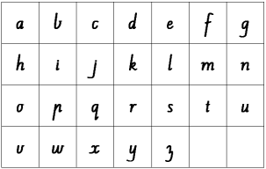
Focus: Heads, Bodies, Tails
Students are given an alphabet set of lower case letters to cut and sort into correct categories. Use Kristy the Cat to demonstrate segments.
‘Bodies’ ‘Heads and Bodies’ ‘Bodies and Tails’ ‘All Three’
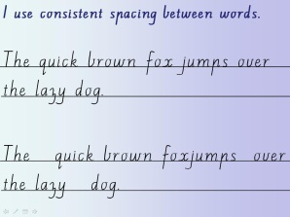
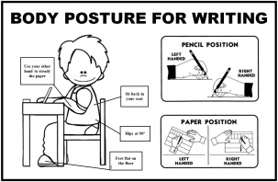
Practise writing these in your book.
Students given worksheet with text to transpose under as practise of today’s skill.

Focus: Starting Points
Sorting letters by their starting points.
‘1 o’clock starts’ ‘High starts’ ’10 o’clock starts’ ‘Rounded starts’ ‘Odd ones’
Students given worksheet with text to transpose under as practise of today’s skill.

Focus: Ending Points
Sorting letters by their ending points.
‘Tick endings’ ‘Under endings’ ‘1 o’clock endings’ ‘Odd endings’
Students given worksheet with text to transpose under as practise of today’s skill.

Focus: Joins
Initial review of joins (more detail in term 2/3)
Students given worksheet with text to transpose under as practise of today’s skill.

