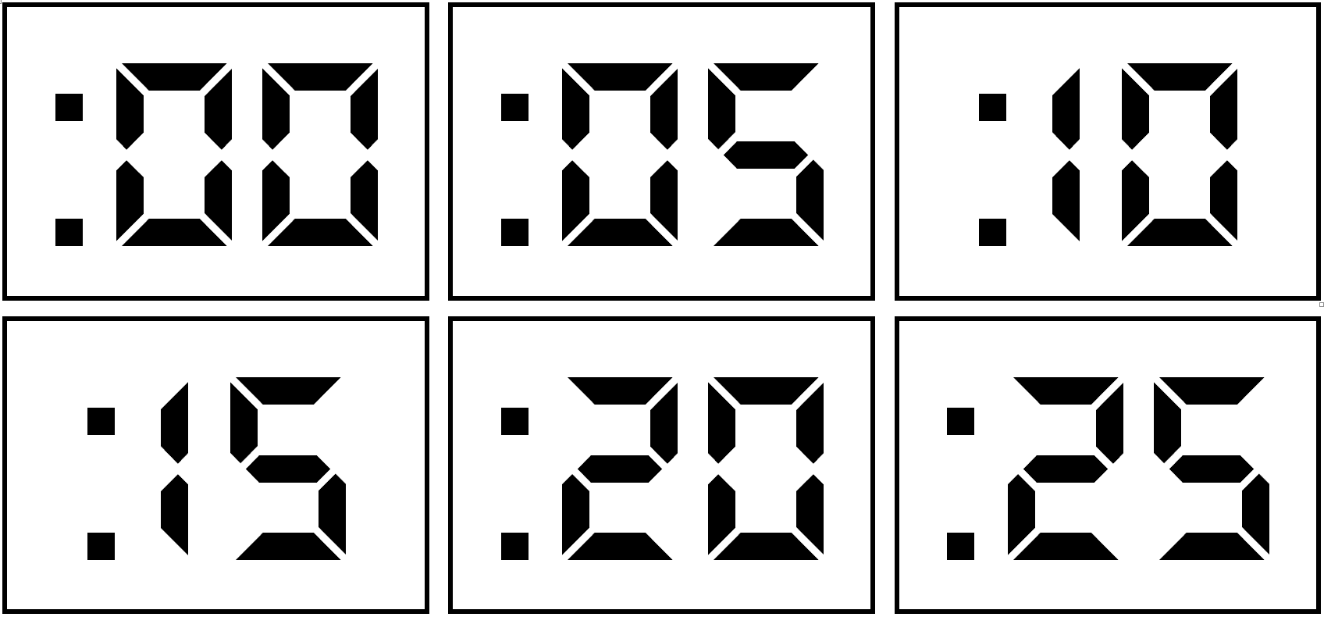

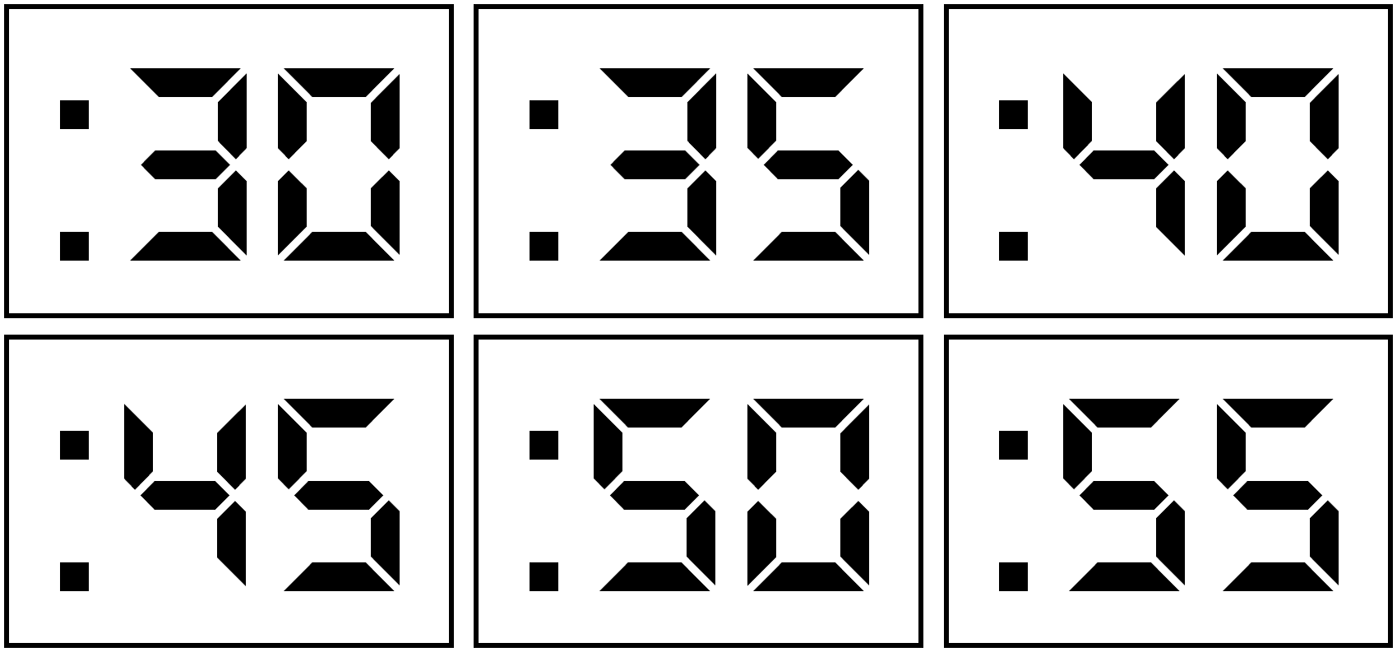

|  |  |  |  |  |
| --- | --- | --- | --- | --- |
| **:00** |  | **:05** |  | **:10** |

|  |  |  |  |  |
| --- | --- | --- | --- | --- |
| **:15** |  | **:20** |  | **:25** |

|  |  |  |  |  |
| --- | --- | --- | --- | --- |
| **:30** |  | **:35** |  | **:40** |

|  |  |  |  |  |
| --- | --- | --- | --- | --- |
| **:45** |  | **:50** |  | **:55** |