

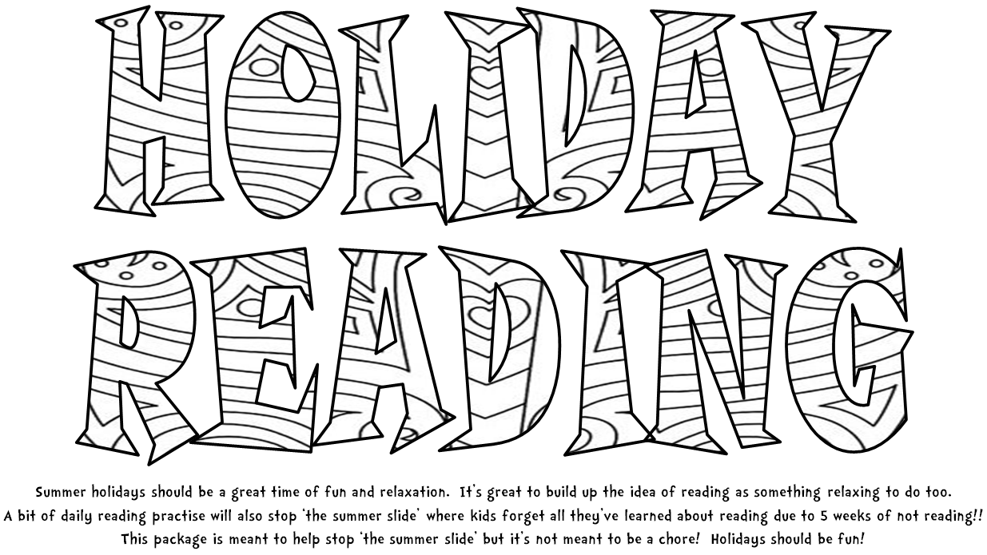



Colour a star for everyday you read and write the titles on the lines

|  |  |  |  |
| --- | --- | --- | --- |
|  |  |  |  |
|  |  |
|  |  |  |  |
|  |  |
|  |  |  |  |
|  |  |
|  |  |  |  |
|  |  |
|  |  |  |  |
|  |  |
|  |  |  |  |
|  |  |