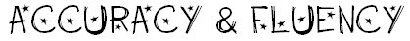

When I record my reading... | 0 | 1 | 2
I’m reading words accurately.
I use punctuation ( ! ? , . “ “ ) to pause and stop at the right places.
I use expression and my voice goes up and down in the right places.
My voice flows so I don’t sound like a robot and words blend into each other smoothly.

When I read to my teacher... | 0 | 1 | 2
I’m reading words accurately.
I use punctuation ( ! ? , . “ “ ) to pause and stop at the right places.
I use expression and my voice goes up and down in the right places.
My voice flows so I don’t sound like a robot and words blend into each other smoothly.

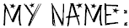

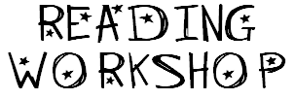
Book Title

Who’s the author?
Draw a picture that sums up the story

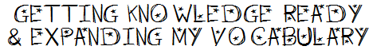
Words I need to understand:
Word | Meaning / Synonyms
Words I need to say:

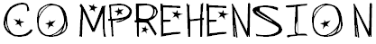
Who are the characters?
Main: | Other:
What’s the setting?
When? | Where?
What happens...
In the beginning?
In the middle?
In the end?
What’s the problem? How is it resolved?

