English Unit Planner
Level: Gr 3/4 Term: 3 2017 Weeks: 1-10
Teachers: Sinead, Kellie and Marg
Language Mode: Reading and Viewing

Specific Resource for Unit: “The Wishing Spell” (Book 1, The Land of Stories) By Chris Colfer
Victorian Curriculum Achievement Standards
They explain how language features, images and vocabulary are used to engage the interest of audiences. They can describe literal and implied meaning connecting ideas in different texts.
Victorian Curriculum Content Descriptions
http://victoriancurriculum.vcaa.vic.edu.au/english/curriculum/f-10
Focus descriptions in blue
Language Strand
Grade 2 Text Structure and Organisation - Understand that different types of texts have identifiable text structures and language features that help the text serve its purpose (VCELA212)
Grade 3 Text Structure and Organisation - Understand how different types of texts vary in use of language choices, depending on their purpose, audience and context, including tense and types of sentences (VCELA246)
Grade 4 Text Structure and Organisation - Identify features used in imaginative, informative and persuasive texts to meet the purpose of the text, and understand how texts vary in complexity and technicality depending on the approach to the topic, the purpose and the intended audience (VCELA277)
Grade 5 Text Structure and Organisation - Investigate how the organisation of texts into chapters, headings, subheadings, home pages and sub pages for online texts and according to chronology or topic can be used to predict content and assist navigation (VCELA310)
Literature Strand
Grade 2 Examining Literature - Discuss the characters and settings of different texts and explore how language is used to present these features in different ways (VCELT219)
Grade 3 Responding to Literature - Draw connections between personal experiences and the worlds of texts, and share responses with others (VCELT251)
Examining Literature - Discuss how language is used to describe the settings in texts, and explore how the settings shape the events and influence the mood of the narrative(VCELT253)
Grade 4 Literature and Context - Make connections between the ways different authors may represent similar storylines, ideas and relationships (VCELT282)
Responding to Literature - Describe the effects of ideas, text structures and language features of literary texts (VCELT283)
Examining Literature - Discuss how authors and illustrators make stories exciting, moving and absorbing and hold readers’ interest by using various techniques (VCELT284)
Grade 5 Literature and Context - Identify aspects of literary texts that convey details or information about particular social, cultural and historical contexts (VCELT313)
Examining Literature - Recognise that ideas in literary texts can be conveyed from different viewpoints, which can lead to different kinds of interpretations and responses (VCELT315)
Literacy Strand
Grade 2 Texts in Context - Discuss different texts on a similar topic, identifying similarities and differences between the texts(VCELY220)
Interpreting, Analysing, Evaluating - Use comprehension strategies to build literal and inferred meaning and begin to analyse texts by drawing on growing knowledge of context, language and visual features and print and multimodal text structures (VCELY222)
Grade 3 Texts in Context - Identify the point of view in a text and suggest alternative points of view (VCELY255)
Interpreting, Analysing, Evaluating - Use comprehension strategies to build literal and inferred meaning and begin to evaluate texts by drawing on a growing knowledge of context, text structures and language features (VCELY257)
Grade 4 Texts in Context - Identify and explain language features of texts from earlier times and compare with the vocabulary, images, layout and content of contemporary texts(VCELY286)
Interpreting, Analysing, Evaluating - Use comprehension strategies to build literal and inferred meaning to expand content knowledge, integrating and linking ideas and analysing and evaluating texts (VCELY288)
Compare and evaluate two texts presenting the same ideas and analyse why one is more comprehensible or engaging than the other (VCELY289)
Grade 5 Texts in Context - Show how ideas and points of view in texts are conveyed through the use of vocabulary, including idiomatic expressions, objective and subjective language, and that these can change according to context (VCELY317)
Interpreting, Analysing, Evaluating - Use comprehension strategies to analyse information, integrating and linking ideas from a variety of print and digital sources (VCELY319)

Pre Assessment Notes  Most students are familiar with most popular fairy tales, especially Disney movie versions. Most students are able to describe the features of a narrative but are not aware of what constitutes a fairy tale. Most students have not heard of The Brothers Grimm and Hans Christian Andersen. None of the students have read ‘The Wishing Spell’. Students showed a variety of levels of knowledge of vocabulary commonly found in fairy tales (eg. ‘enchanted’)  Focus Victorian Curriculum Content Descriptions (from above)  Examining Literature - Discuss how authors and illustrators make stories exciting, moving and absorbing and hold readers’ interest by using various techniques (VCELT284)  Texts in Context - Identify and explain language features of texts from earlier times and compare with the vocabulary, images, layout and content of contemporary texts(VCELY286) | Learning Intentions  - We can explore fairy tales (including nursery rhymes, fables and folk tales) and identify the features of these types of narratives.  - We can familiarise ourselves with the characters, settings and language features of fairy tales.  - We can investigate how authors use techniques to make stories interesting, exciting, moving and absorbing.  - We can use fairy tales to improve our comprehension and engagement in reading.  - We can investigate and discuss how authors and illustrators have used the following to make stories interesting, exciting, moving and absorbing:  - choice of words  - illustrations  - imagery and descriptions  - appealing and non-appealing characters  - plot twists and turns  - satisfying endings  - feelings and emotions  - themes and ideas.

SESSION 1
LEARNING INTENTION
We can explore fairy tales (including nursery rhymes, fables and folk tales) and identify the features of these types of narratives.
WHOLE CLASS FOCUS >> INDIVIDUAL / SMALL GROUP / CLASS SESSION
Tuning In:
Introduction to our topic and a look at the learning intentions of the unit.

Today’s Success Criteria:
I can see what literacy learning we’re going to be doing this term.
I can learn about different types of narratives.
I can identify what a fairy tale is and is not.

Focus: What is a fairy tale?
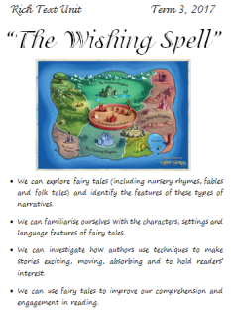
Discuss the narrative genre and how it can be divided further into different categories. Ask for students to write a favourite book title on a sticky note then sort onto a categories poster – adventure, mystery, thriller, horror, historical fiction, science fiction, humorous, realistic, fable, fantasy, folktale, fairy tale, narrative poetry (nursery rhymes). (Make sure a fairy tale is included in the groups).
Focus in on the fairy tale group and ask the students to work in groups to name as many as possible on large sheets. Bring the sheets together at the end to create a masterlist. While the students are working, see if the question of ‘what is a fairy tale?’ comes up.
Checking through the lists discuss some of the questionable ones and work out the need for a ‘definition of a fairy tale’
Powerpoint: Types of Narratives - (Only look at briefly – can be used in more detail later. Focus on the folk tale, fairy tale parts).
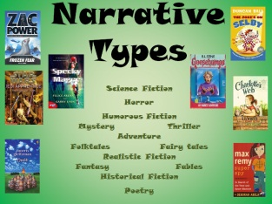
Make adjustments to our master lists for fairy and folk tales based on the features. Eg. Sleeping Beauty = fairy tale. Three Little Pigs = Folktale. Include a nursery rhyme section (narrative poetry) and add titles. (For the purposes of this unit we’ll put all nursery rhyme, folk and fairy tale characters into one category – fairy tales).
REFLECTION | ASSESSMENT
Revisit today’s success criteria.  Child write/talk about one of the following:  My top 5 fairy tales are…  I didn’t know … about fairy tales. | We are looking for...  Students being able to identify the features of fairy tales.

SESSION 2
LEARNING INTENTION
We can familiarise ourselves with the characters, settings and language features of fairy tales.
We can explore fairy tales (including nursery rhymes, fables and folk tales) and identify the features of these types of narratives.
WHOLE CLASS FOCUS >> INDIVIDUAL / SMALL GROUP / CLASS SESSION
Tuning In:
Read fairy tales from collection.

Today’s Success Criteria:
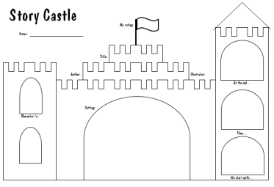
I can identify the characters, settings and events in a fairy tale.
I can explore what an author does to make a fairy tale enjoyable.

Focus: Narrative format
Read big book from collected resources.
Talk about the features of the text – the type of characters, setting, events. Point out some of the language features the author has used.
Model a ‘Story Castle’ response using big book.
Students are then given time to browse the collected resources, choose a fairy tale and complete their own castle response.
Talk to the students about their ratings (on the flag) and asks what the author did or didn’t do with their writing to earn that score.
REFLECTION | ASSESSMENT
Revisit today’s success criteria.  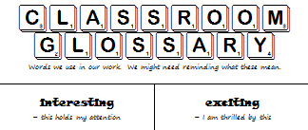  Create a classroom glossary to start adding words used in the unit that may need continual referring to. | We are looking for...  The quality of work provided on the Story Castles.  The way students respond to the question: ‘What did the author do to make this story a good one?’ (or what could they do to make it better).

SESSION 3
LEARNING INTENTION
We can familiarise ourselves with the characters, settings and language features of fairy tales.
We can explore fairy tales (including nursery rhymes, fables and folk tales) and identify the features of these types of narratives.
WHOLE CLASS FOCUS >> INDIVIDUAL / SMALL GROUP / CLASS SESSION
Tuning In:
Read fairy tales from collection.

Today’s Success Criteria:
I can explore fairy tale characters by their appearances and their attributes.
I can investigate and discuss how authors and illustrators have used appealing and non-appealing characters to make stories interesting, exciting, moving and absorbing:

Focus: Characters
Read big book from collected resources.
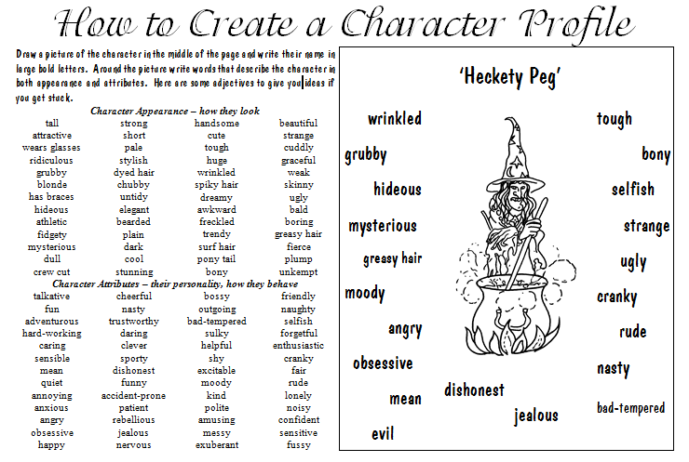
Talk about a main character in the story and discuss how the author communicates what the character is like. Discuss ‘appearance’ and ‘attributes’ (extension – discuss character’s ‘motivations’ as well)
Model a ‘Character Profile’ response using big book.
Students are then given time to browse the collected resources, choose a fairy tale and complete their own character profile response.
Ask students to pair up and ‘interview’ each other – pretending to be their character for a TV interview.
REFLECTION | ASSESSMENT
Revisit today’s success criteria.  Child write/talk about one of the following:  Today I learnt …  I discover the character I chose was… | We are looking for...  The quality of work provided on the Character Profiles.  The ability of students to reflect character attributes when they perform in the interviews.

SESSION 4
LEARNING INTENTION
We can investigate how authors use techniques to make stories interesting, exciting, moving and absorbing.
WHOLE CLASS FOCUS >> INDIVIDUAL / SMALL GROUP / CLASS SESSION
Tuning In:
https://www.youtube.com/playlist?list=PL5hbpwc66yGGyhrMvMWYgBB-3GiVh6YEk
Animated fairy tales.

Today’s Success Criteria:
I can explore what makes a story interesting, exciting, moving and absorbing.
I can investigate and discuss how authors have used plot twists and turns to make stories successful.

Focus: Plots
Read ‘Cinderella’ from collected resources.
Talk about the events in the story and list the points of action
Let’s test this theory by author Kurt Vonnegut: ‘that stories have shapes that can be drawn on graph paper’
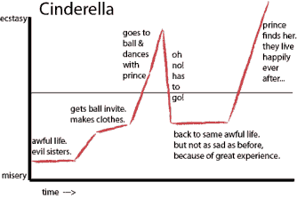
Use graph paper to plot the points of action against the level of emotion eg. misery > ecstasy/happiness (see example). Discuss (extension: what other levels could we plot against? eg. boring > exciting, failure > success, poverty > riches)
Students are then given time to browse the collected resources, choose a fairy tale and complete their own ‘Plot Graph’ response.
Have children hang their graphs on a gallery (same stories could be grouped together). Invite students to look for patterns. Is there a __˄__ commonality?
REFLECTION | ASSESSMENT
Revisit today’s success criteria.  Child write/talk about one of the following:  When I plotted the story I found…  When I looked at others’ work I discovered… | We are looking for...  The quality of work provided on the Plot Graph response.  The ability of students to visualize a story by the points of action.  Students noticing plot patterns in narratives.

Use the responses from sessions 2, 3 and 4 to set up a daily (weekly) classroom routine of reading, responding and sharing. Continue daily ‘read to’.

SESSION 5 (when ready to start the novel)
LEARNING INTENTION
- We can investigate and discuss how authors and illustrators have used the following to make stories interesting, exciting, moving and absorbing:
- choice of words
- illustrations
- imagery and descriptions
- appealing and non-appealing characters
- plot twists and turns
- satisfying endings
- feelings and emotions
- themes and ideas.
WHOLE CLASS FOCUS >> INDIVIDUAL / SMALL GROUP / CLASS SESSION
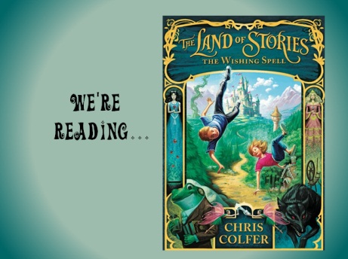
Focus: Serial Reading – ‘The Wishing Spell’
Use the powerpoint ‘The Wishing Spell’ to introduce the novel, including characters, settings and activating prior knowledge by making connections to our work so far on fairy tales.
Use the above list of text features to help ignite discussion about the story
Have post-its nearby when reading for the children to make note of words of interest or words that need defining.
Create a classroom ‘fan art’ gallery of characters and scenes in the story.
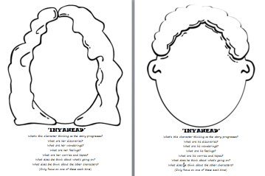
A few chapters into the books, introduce the ‘Inyahead’ project. Each student chooses either Alex or Conner. The head outline is stapled (at the top) to a few sheets of lined paper. After some chapters, have the students record what’s going on in their character’s mind. Use the guide questions on the front cover to help students write reflections on the story from the eyes of Connor or Alex. If time, model this by doing an ‘inyahead’ using the twins’ mother.

REFLECTION | ASSESSMENT
Invite sharing from the Inyahead projects.  Follow up the words written on post its. | We are looking for...  Engagement in and comprehension of the story.  Responses that indicate knowledge of text features.

SESSION 6 (several lessons with the same format but a different focus)
LEARNING INTENTION
- We can use fairy tales to improve our comprehension and engagement in reading.
- We can investigate and discuss how authors and illustrators have used the following to make stories interesting, exciting, moving and absorbing:
- choice of words
- illustrations
- imagery and descriptions
- appealing and non-appealing characters
- plot twists and turns
- satisfying endings
- feelings and emotions
- themes and ideas.
WHOLE CLASS FOCUS >> INDIVIDUAL / SMALL GROUP / CLASS SESSION
Today’s Success Criteria: (Choose one of the following;)
I can investigate and discuss how authors have used choice of words to make stories interesting, exciting, moving and absorbing.
I can investigate and discuss how authors have used illustrations to make stories interesting, exciting, moving and absorbing.
I can investigate and discuss how authors have used imagery and descriptions to make stories interesting, exciting, moving and absorbing.
I can investigate and discuss how authors have used appealing and non-appealing characters to make stories interesting, exciting, moving and absorbing.
I can investigate and discuss how authors have used plot twists and turns to make stories interesting, exciting, moving and absorbing.
I can investigate and discuss how authors have used satisfying endings to make stories interesting, exciting, moving and absorbing.
I can investigate and discuss how authors have used feelings and emotions to make stories interesting, exciting, moving and absorbing.
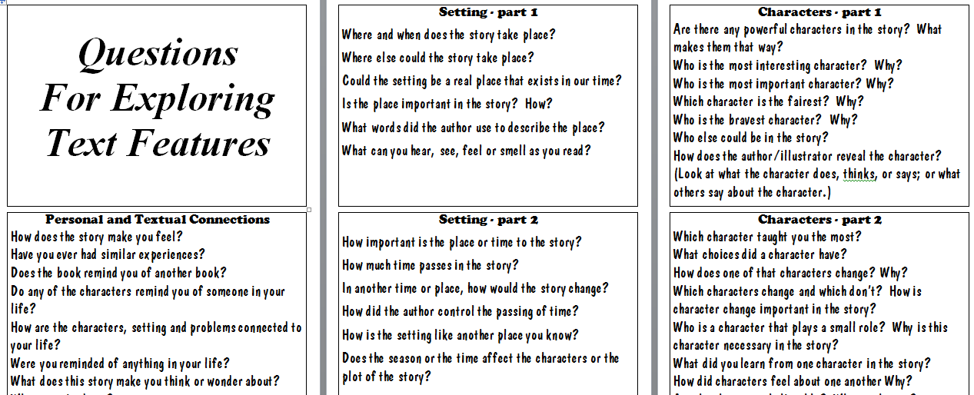
I can investigate and discuss how authors have used to themes and ideas make stories interesting, exciting, moving and absorbing.

Focus: Narrative features
From the above choices, read a story that provides a rich example of this feature and discuss. Use the ‘Questions for Exploring Text Features’ document to support your discussion leading.
Have students form ‘mini book clubs’ to discuss how they have encountered this feature in stories they’ve enjoyed. Use the ‘Questions for Exploring Text Features’ document to scaffold the students’ questions for each other.
Alternately, choose some questions from the same document for students to answer in written form.
REFLECTION | ASSESSMENT
Revisit today’s success criteria. | We are looking for...  The ability of students to articulate and share their understandings of the focus text feature

FURTHER EXPLORATIONS
Look at how fairy tales and nursery rhymes have been changed over the years. Especially look at how modern authors have taken a traditional tale and adjusted, twisted or modernized it.
Story examples: ‘The Paper Bag Princess’, ‘The True Story of the Three Little Pigs’ ‘The Cocky Who Cried Dingo’
Nursery rhyme examples: ‘Far Out Brussel Sprout’ series, Marg’s ‘Rhymes with a Twist’ collection http://margdteachingposters.weebly.com/more-poetry.html

Use the 7 Steps of Writing to explore how analyse a text.

