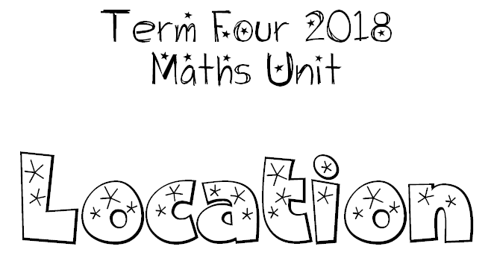
We can use compass points and the language of direction and distance to give locations and describe paths.

We can use a co-ordinate system to give locations and describe paths.

We can draw and interpret simple scale maps and learn what the symbols on maps mean.

