2x Tables | 2x Tables | 2x Tables | 2x Tables
2 x 6 =  2 x 4 =  2 x 1 =  2 x 3 =  2 x 11 =  2 x 12 =  2 x 2 =  2 x 9 =  2 x 0 =  2 x 5 =  2 x 8 =  2 x 7 =  2 x 10 = | 2 x 6 =  2 x 4 =  2 x 1 =  2 x 3 =  2 x 11 =  2 x 12 =  2 x 2 =  2 x 9 =  2 x 0 =  2 x 5 =  2 x 8 =  2 x 7 =  2 x 10 = | 2 x 6 =  2 x 4 =  2 x 1 =  2 x 3 =  2 x 11 =  2 x 12 =  2 x 2 =  2 x 9 =  2 x 0 =  2 x 5 =  2 x 8 =  2 x 7 =  2 x 10 = | 2 x 6 =  2 x 4 =  2 x 1 =  2 x 3 =  2 x 11 =  2 x 12 =  2 x 2 =  2 x 9 =  2 x 0 =  2 x 5 =  2 x 8 =  2 x 7 =  2 x 10 =

5x Tables | 5x Tables | 5x Tables | 5x Tables
5 x 6 =  5 x 4 =  5 x 1 =  5 x 3 =  5 x 11 =  5 x 12 =  5 x 2 =  5 x 9 =  5 x 0 =  5 x 5 =  5 x 8 =  5 x 7 =  5 x 10 = | 5 x 6 =  5 x 4 =  5 x 1 =  5 x 3 =  5 x 11 =  5 x 12 =  5 x 2 =  5 x 9 =  5 x 0 =  5 x 5 =  5 x 8 =  5 x 7 =  5 x 10 = | 5 x 6 =  5 x 4 =  5 x 1 =  5 x 3 =  5 x 11 =  5 x 12 =  5 x 2 =  5 x 9 =  5 x 0 =  5 x 5 =  5 x 8 =  5 x 7 =  5 x 10 = | 5 x 6 =  5 x 4 =  5 x 1 =  5 x 3 =  5 x 11 =  5 x 12 =  5 x 2 =  5 x 9 =  5 x 0 =  5 x 5 =  5 x 8 =  5 x 7 =  5 x 10 =

10x Tables | 10x Tables | 10x Tables | 10x Tables
10 x 6 =  10 x 4 =  10 x 1 =  10 x 3 =  10 x 11 =  10 x 12 =  10 x 2 =  10 x 9 =  10 x 0 =  10 x 5 =  10 x 8 =  10 x 7 =  10 x 10 = | 10 x 6 =  10 x 4 =  10 x 1 =  10 x 3 =  10 x 11 =  10 x 12 =  10 x 2 =  10 x 9 =  10 x 0 =  10 x 5 =  10 x 8 =  10 x 7 =  10 x 10 = | 10 x 6 =  10 x 4 =  10 x 1 =  10 x 3 =  10 x 11 =  10 x 12 =  10 x 2 =  10 x 9 =  10 x 0 =  10 x 5 =  10 x 8 =  10 x 7 =  10 x 10 = | 10 x 6 =  10 x 4 =  10 x 1 =  10 x 3 =  10 x 11 =  10 x 12 =  10 x 2 =  10 x 9 =  10 x 0 =  10 x 5 =  10 x 8 =  10 x 7 =  10 x 10 =

2x Tables | 5x Tables | 10x Tables
2 x 6 =12  2 x 4 =8  2 x 1 =2  2 x 3 =6  2 x 11 =22  2 x 12 =24  2 x 2 =4  2 x 9 =18  2 x 0 = 0  2 x 5 = 10  2 x 8 = 16  2 x 7 =14  2 x 10 =20 | 5 x 6 =30  5 x 4 =20  5 x 1 =5  5 x 3 =15  5 x 11 =55  5 x 12 =60  5 x 2 =10  5 x 9 =45  5 x 0 = 0  5 x 5 = 25  5 x 8 = 40  5 x 7 =35  5 x 10 =50 | 10 x 6 =60  10 x 4 =40  10 x 1 =10  10 x 3 =30  10 x 11 =110  10 x 12 =120  10 x 2 =20  10 x 9 =90  10 x 0 = 0  10 x 5 = 50  10 x 8 = 80  10 x 7 =70  10 x 10 =100

Round to the nearest 10 | Round to the nearest 10 | Round to the nearest 10 | Round to the nearest 10
21 _____  67 _____  188 _____  693 _____  35 _____  1 026 _____ | 21 _____  67 _____  188 _____  693 _____  35 _____  1 026 _____ | 21 _____  67 _____  188 _____  693 _____  35 _____  1 026 _____ | 21 _____  67 _____  188 _____  693 _____  35 _____  1 026 _____
Round to the nearest 100 | Round to the nearest 100 | Round to the nearest 100 | Round to the nearest 100
799 _____  280 _____  2 340 _____  3 528 _____  920 _____  412 _____ | 799 _____  280 _____  2 340 _____  3 528 _____  920 _____  412 _____ | 799 _____  280 _____  2 340 _____  3 528 _____  920 _____  412 _____ | 799 _____  280 _____  2 340 _____  3 528 _____  920 _____  412 _____

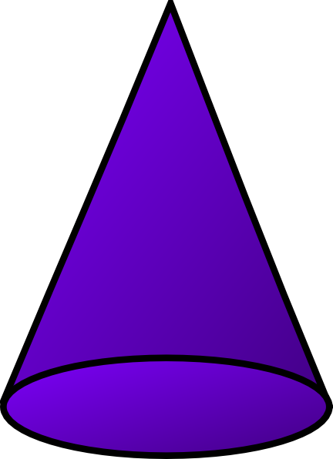 |  | 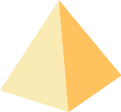

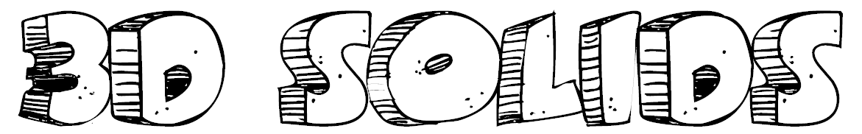
sphere | cube | rectangular prism
cone | pyramid | cylinder

circle | triangle | square | rectangle | rhombus
oval | trapezoid | pentagon | hexagon | octagon

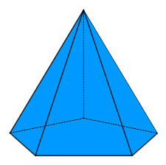 |  | 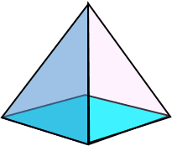 |  | 