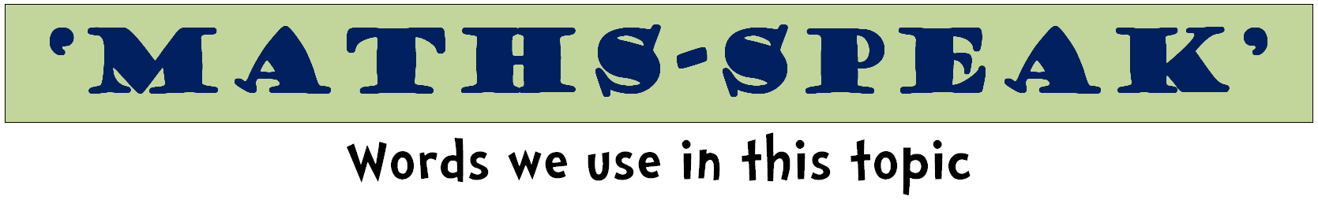
count | collect |  | make
few | many |  | pair
more | less |  | same as
even | odd |  | tally
count on, count back |  | count by ones, twos
order | greater than |  | less than
backwards | forwards |  | up to, back to
total | same |  | different
double | halve |  | pattern
increase | decrease |  | reduce
every | each |  | all
score | most |  | least
compare | continue |  | create
once | twice |  | use

zero | naught | none
one | eleven | ten
two | twelve | twenty
three | thirteen | thirty
four | fourteen | forty
five | fifteen | fifty
six | sixteen | sixty
seven | seventeen | seventy
eight | eighteen | eighty
nine | nineteen | ninety
hundred | thousand | million

unit | ones | tens
hundreds | thousands | millions
digit | place | value
represent | base 10 | exchange

equation | equal to |  | symbol
total | answer |  | equals
compare | plus |  | check
same as | total |  | solve
equals | count |  | operation
unequal | correct |  | incorrect
symbol | sign |  | plus
sum | add |  | difference
subtract | take away |  | product
times | share |  | how many
shared between |  | number sentence
order | right |  | wrong
missing number | less than |  | greater than
halve | double |  | rule

second | minute | hour
o’clock | digital | analogue
half past | quarter past | quarter to
morning | afternoon | evening
night | noon | midnight
am | pm | hands
clock | watch | clock face
stopwatch | timer | timetable
dawn | sunrise | sunset
arrive | depart | duration
early | now | late, later
young | new | old
before | during | after
slow | fast | quick
beginning | interval | end

day | week | Sunday
Monday | Tuesday | Wednesday
Thursday | Friday | Saturday
weekend | month | year
January | February | March
April | May | June
July | August | September
October | November | December
season | Summer | Autumn
Winter | Spring | Fall
holiday | calendar | leap year
yesterday | today | tomorrow
fortnight | decade | century

coin | note | money
cent | dollar | price
cost | buy | pay
value | cheap | expensive
total | amount | worth
spend, spent | sell, sold | buy, bought
borrow | owe | credit
loan | estimate | repay

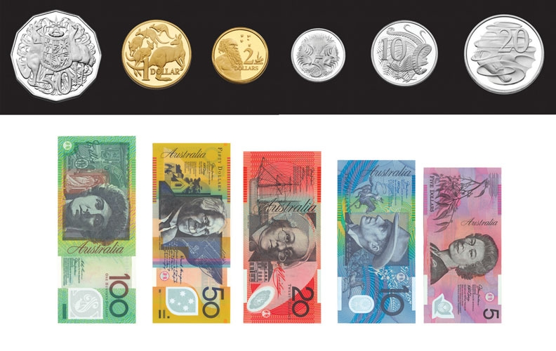

metre | millimetre | centimetre
kilometre | perimeter | boundary
distance | ruler | tape measure
area | cover | surface
square centimetre, square metre
long | length | lengthen
wide | width | widen
high | height | heighten
deep | depth | deepen
short | shorten | tall
 | shallow
gram | kilogram | tonne
milligram | light | heavy
weight | balance | scales
 | load

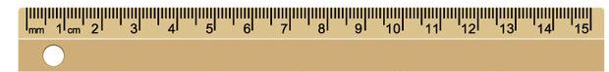

litre | millilitre | container
fill, full | empty | half full
holds | contains | space
volume | jug | tank
degrees | Celsius | thermometer
high | low | cool
hot | cold | warm
weather | boiling | freezing
increase | decrease | forecast

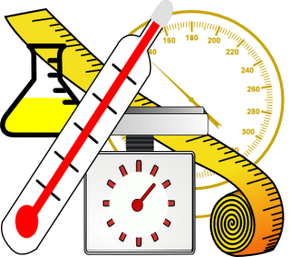

measurement | measure |  | size
metric | unit |  | enough
compare | estimate |  | guess
shape | edge |  | surface
near, nearly | close to |  | about the same
just over | just under |  | exact, exactly
space | approximately
big bigger biggest |  | cold, colder, coldest
cool, cooler, coolest |  | deep, deeper, deepest
empty, emptier, emptiest
full, fuller, fullest |  | hot, hotter, hottest
heavy, heavier, heaviest
light, lighter, lightest |  | little, littler, littlest
long, longer longest |  | wide, wider, widest
warm, warmer, warmest |  | low, lower, lowest
narrow, narrower, narrowest,
shallow, shallower, shallowest
short, shorter, shortest
small smaller smallest |  | tall, taller, tallest
thick, thicker, thickest |  | thin, thinner, thinnest

count | collect | tally
data | sort | group
list | vote | statistics
survey | graph | table
label | questionnaire | pictogram
bar graph | line graph | pie graph
title | axis | chart
most popular | same | most common
least popular | different | least common
analyse | interpret | represent
set | Venn diagram
never | sometimes | always
usually | unlikely | likely
probable, probably, probability
often | opportunity | chance

circle | semi-circle |  | oval
triangle | square |  | rectangle
pentagon | hexagon |  | octagon
rhombus | parallelogram |  | trapezoid
shape | two-dimensional
solid | three-dimensional
prism | sphere |  | cube
cylinder | cone |  | pyramid
triangular prism |  | rectangular prism
flip | slide |  | turn
diagram | net |  | model

base | face | surface
vertices | point | apex
edge | line | side
angle | 2D | 3D
shape | solid | hollow
corner | size | flat
rectangular | circular | triangular
straight | curved | round
line of symmetry, symmetrical

angle | degree | vertex
right angle | point | diagram
acute | obtuse | reflex
shape | base | protractor

whole | part |  | fraction
equal parts | half |  | halves
thirds | quarters |  | fourths
fifths | sixths |  | sevenths
eighths | ninths |  | tenths
numerator |  | denominator

point | zero | naught
tenths | hundredths | thousandths

unit | ones | tens
hundreds | thousands | millions
digit | place | value
represent | base 10 | exchange

add | plus | addition
sum | increase | altogether
more | subtract | subtraction
left | difference between
minus | decrease | take away
equation | operation | symbol
total | score | sign
number facts | leaves | same as
multiply | times | multiplication
array | row | column
repeated addition |  | multiplied by
group | groups of | lots of
equal groups | product | number facts
divide | divided by | division
share equally | how many | split
left over | equation | operation
symbol | sign | same as

make | build | complete
model | record | explain
solve | describe | estimate
add | subtract | multiply
divide | find | use
halve | double | near double
number facts | method | number line
answer | difference | nearly
exact, exactly | join | close to
decrease | increase | about the same
choose | calculate, calculation
display | key | enter
clear | function | shift

left | centre |  | right
direction | compass |  | map
north | south |  | route
east | west |  | journey
co-ordinates | path |  | grid
position | plan |  | rotate
horizontal | vertical |  | diagonal
towards | movement |  | away from
direct | destination |  | arrive
clockwise |  | anti-clockwise
forward | backward |  | sideways
turn, whole turn, half turn, quarter turn
close | closer |  | closest
far | further |  | furthest
near | nearer |  | nearest

above | half way |  | below
front | centre |  | back
before | between |  | after
beside | next to |  | opposite
ahead | in front |  | behind
over | under |  | underneath
up | around |  | down
outside | through |  | inside
bottom | side |  | top
to | across |  | from
on | place |  | off
in | along |  | out
close to | apart |  | far away
ascend, ascending |  | descend, descending
start | middle |  | finish

repeat | continue |  | create
change | fit |  | find
arrange | rearrange |  | swap
separate | place |  | choose
flip | slide |  | turn
count by | skip count |  | symmetry
number pattern |  | tessellate

first | second | third
fourth | fifth | sixth
seventh | eighth | ninth
tenth | eleventh | twelfth
thirteenth | twentieth | hundredth
place | second last | last
order | sequence | position

