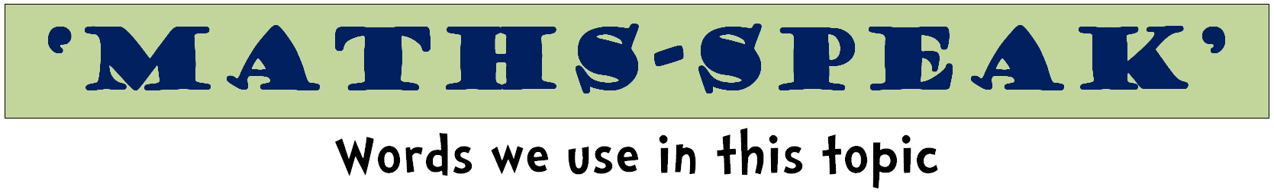
metre | millimetre | centimetre
kilometre | perimeter | boundary
distance | ruler | tape measure
area | cover | surface
square centimetre, square metre
long | length | lengthen
wide | width | widen
high | height | heighten
deep | depth | deepen
short | shorten | tall
 | shallow
gram | kilogram | tonne
milligram | light | heavy
weight | balance | scales
 | load

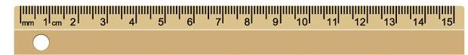

litre | millilitre | container
fill, full | empty | half full
holds | contains | space
volume | jug | tank
degrees | Celsius | thermometer
high | low | cool
hot | cold | warm
weather | boiling | freezing
increase | decrease | forecast

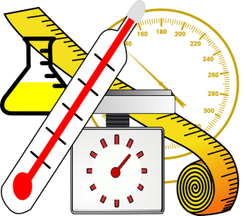

measurement | measure |  | size
metric | unit |  | enough
compare | estimate |  | guess
shape | edge |  | surface
near, nearly | close to |  | about the same
just over | just under |  | exact, exactly
space | approximately
big bigger biggest |  | cold, colder, coldest
cool, cooler, coolest |  | deep, deeper, deepest
empty, emptier, emptiest
full, fuller, fullest |  | hot, hotter, hottest
heavy, heavier, heaviest
light, lighter, lightest |  | little, littler, littlest
long, longer longest |  | wide, wider, widest
warm, warmer, warmest |  | low, lower, lowest
narrow, narrower, narrowest,
shallow, shallower, shallowest
short, shorter, shortest
small smaller smallest |  | tall, taller, tallest
thick, thicker, thickest |  | thin, thinner, thinnest

