Name ________________________________ Measurement Pre Assessment
Here’s a shipping container.
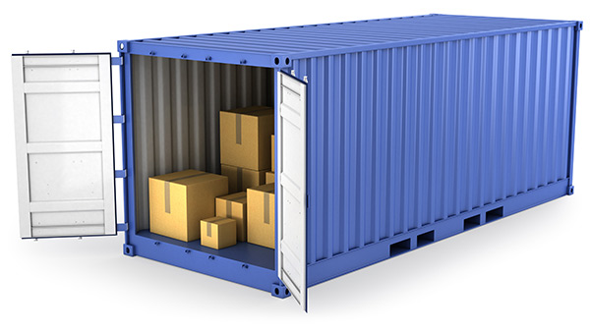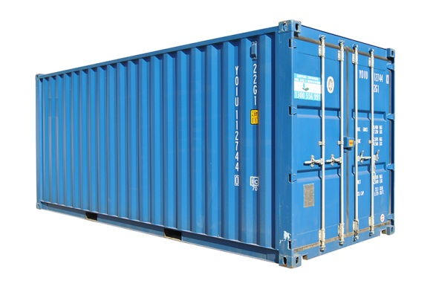
What would you use to measure it if you wanted to find out…
how high it is?
how long it is?
how wide it is?
how far it is all the way around the outside?
the weight of it?
how much it holds?
how hot it is inside?

Now have a guess…
how high is it?
how long is it?
how wide is it?
how far is it all the way around the outside?
how much does it weigh?
how much water could it hold?
how many wheelie bins could fit inside?
how hot it is inside?

Use the rulers on the page to measure these pencils

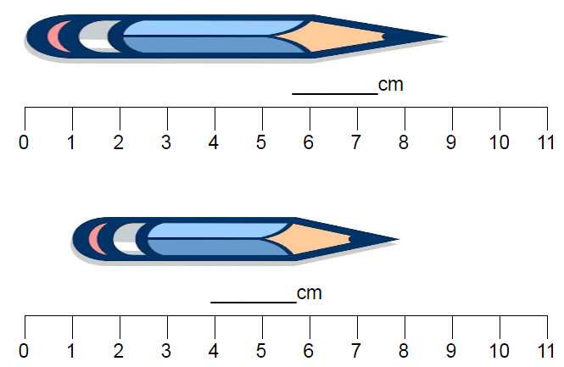

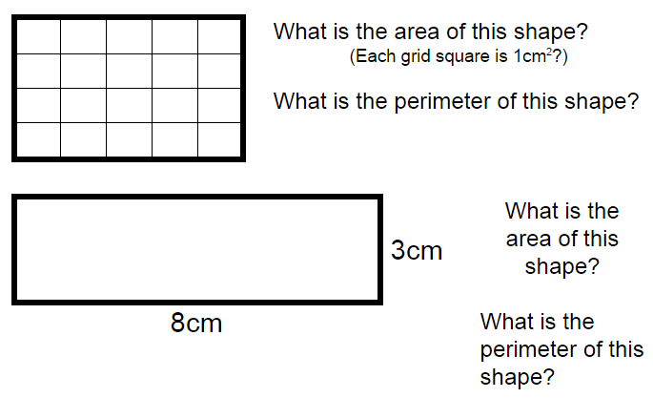

Script for Grade 3/4 pre-assessment Measurement
March 2017

Key Ideas:
Recognising the unit used to measure

The task:
“Here’s a shipping container.” – Students suggest different ways of measuring the shipping container

The Script:
Here’s a picture of a shipping container.
What’s a shipping container? What’s it used for?
You are being asked to show what tools of measurement you would use to find out about the container.
Then you are being asked to estimate what sort of measurements the shipping container might have
On the reverse you are being asked to show what you know about measuring a pencil and a rectangle

Enabling Prompts:
What do you think we could use to measure the height (weight, temperature, volume)
What’s your best guess?

Extending Prompts:
Can you give us more information in your answers?

