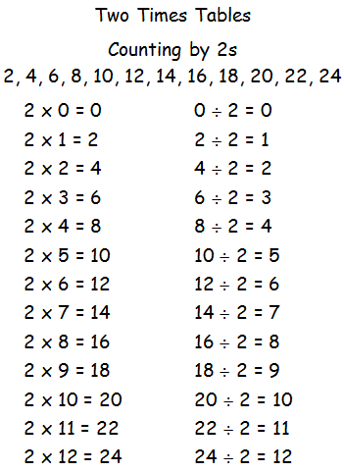

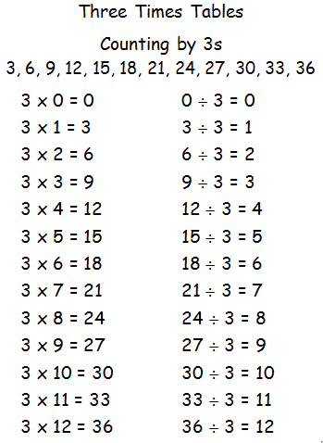

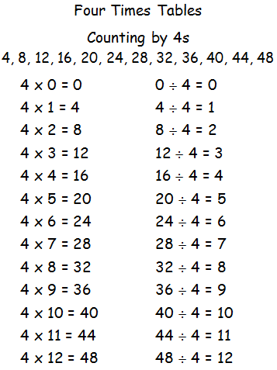

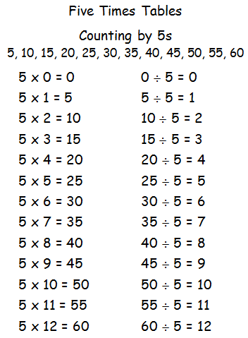

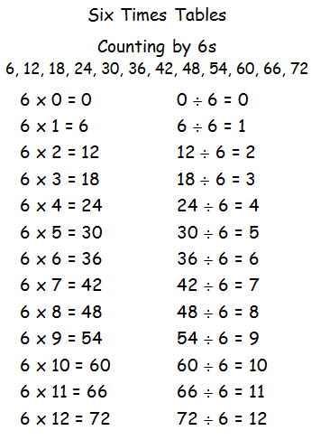

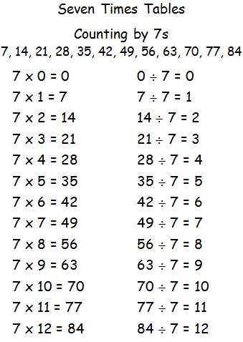

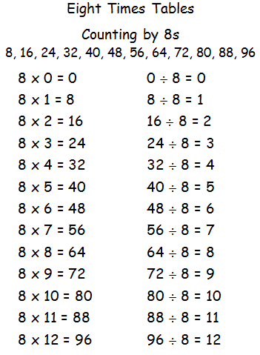

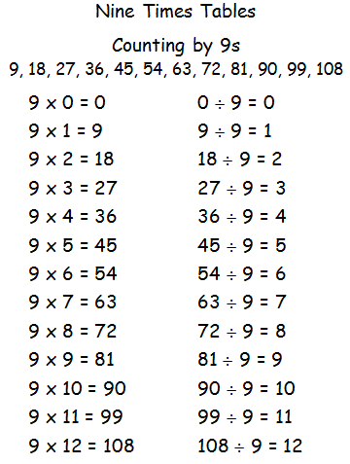

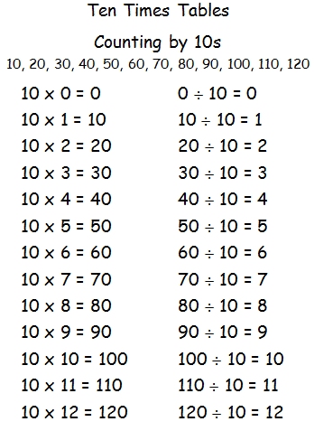

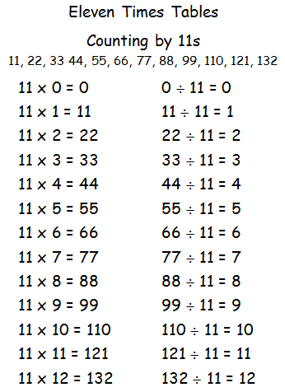

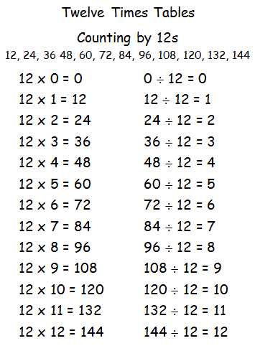

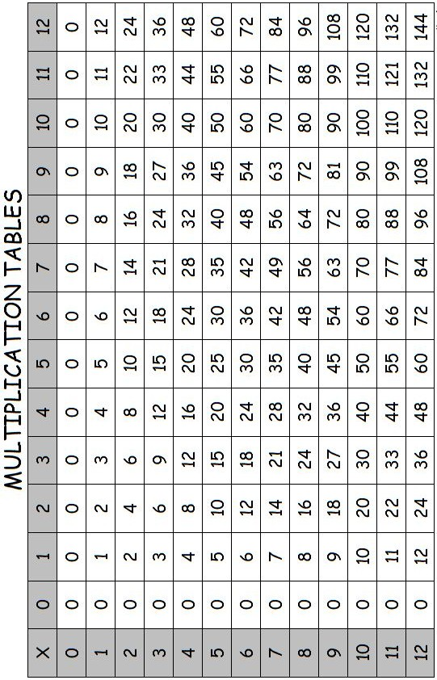

Choose a table set to learn - you will need to become really quick with these so you can earn a brag tag. Get a concentration cubicle so you can really focus on your set.

Recommended Order:
2x
10x
5x
11x
9x
3x
4x
6x
8x
12x
7x

First…  Copy your table set neatly onto grid paper.  - Just the answers across  - Forwards down  - Randomly down | Whisperphones  Recite your tables in a whisper voice. Go forward, backwards and randomly.
Flashies  Lay out about 20. Answer and turn over to check. Put them in piles and . Repeat with the pile until they’re all in the pile. | Coloured Pens  Rainbow write your tables using coloured pens.  Go forwards, backwards, sideways, up and down, randomly.
LSNCWC  Use our LSNCWC process on the 8 hardest tables in your set. | Dice  Use the 12 sided dice. Roll and multiply by the table set you’re learning. Write them as you solve them.

