MATHEMATICS WEEKLY/UNIT PLANNER
Level: Gr 3/4 Term: 3 2018 Weeks: 1-5
Teachers: Sinead, Fran and Marg
Dimension: Number
Specific Focus for Unit: Multiplication and Division

Victorian Curriculum Content Descriptions  http://victoriancurriculum.vcaa.vic.edu.au/mathematics/introduction/rationale-and-aims | Key Concepts  https://drive.google.com/file/d/0B3ydL4IWBSAbbk5laWtLOEprYXc/edit
Yr 2: -Recognise and represent multiplication as repeated addition, groups and arrays  -Recognise and represent division as grouping into equal sets and solve simple problems using these representations  -Apply repetition in arithmetic operations, including multiplication as repeated addition and division as repeated subtraction  Yr 3: -Recall multiplication facts of two, three, five and ten and related division facts  -Represent and solve problems involving multiplication using efficient mental and written strategies and appropriate digital technologies  Yr 4:- Investigate number sequences involving multiples of 3, 4, 6, 7, 8, and 9  -Recall multiplication facts up to 10 × 10 and related division facts  -Develop efficient mental and written strategies and use appropriate digital technologies for multiplication and for division where there is no remainder  -Explore and describe number patterns resulting from performing multiplication  -Solve word problems by using number sentences involving multiplication or division where there is no remainder  -Define a simple class of problems and use an effective algorithm that involves a short sequence of steps and decisions to solve them  Yr 5: -Solve problems involving multiplication of large numbers by one- or two-digit numbers using efficient mental, written strategies and appropriate digital technologies  -Solve problems involving division by a one digit number, including those that result in a remainder  -Use efficient mental and written strategies and apply appropriate digital technologies to solve problems  -Use equivalent number sentences involving multiplication and division to find unknown quantities | Commutative Property (for revision)  The order in which two numbers are multiplied does not affect the product- eg. 3 x 6 gives the same product as 6 x 3  Role of Zero – Null Factor Property (for revision)  Recognising that the product will always be zero when a number is multiplied by zero – eg. 5 x 0 = 0  Identity Property (for revision)  Recognising that when a number is multiplied by one, the quantity does not change – eg. 5 x 1 = 5  Concept of Equal Groups  Recognising that the number in each group is the same  Distributive Property  Factors can be split into parts, multiplied separately and then added to each other  – eg. 14 x 7 = (10 + 4) x 7  = (10 x 7) + (4 x 7)  Relationship to Division  Recognising the inverse relationship between multiplication and division – eg. 3 x 4 = 12 and 12 ÷ 4 = 3

Reporting statements:
Year 3: Recall multiplication facts of two, three, five and ten and related division facts
Year 4: Solve multiplication and division problems using strategies including times table facts up to 10x10

Pre-Assessment | Insights | Learning Intentions
Task:  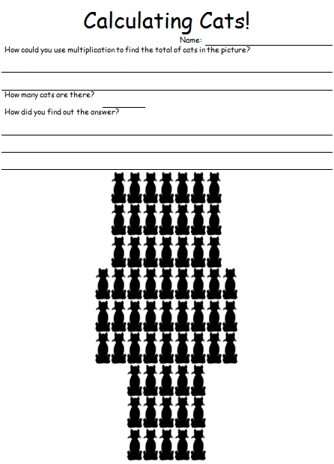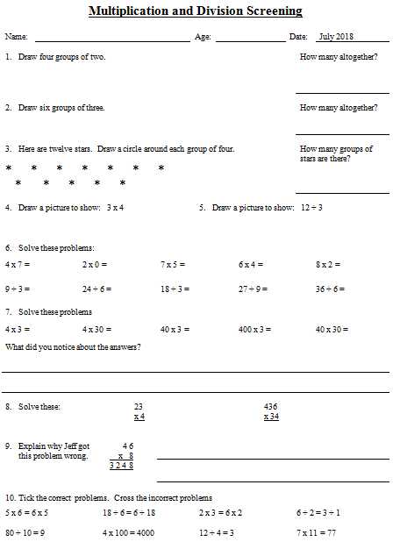 | Brag tags were a successful strategy for many students in grade 3 last year (current grade 4s)  NO idea about division for most students.  Division symbol unknown.  Going to need lots of worded problems for both multiplication and division. | We can learn our times tables and investigate number sequences.  I will be successful if:  I can identify the repeating sequence of numbers when counting by 3s, 4s. 5s, 6s, 7s, 8s, 9s, 10s. (Extension 11s, 12s).  I can earn my times table ‘brag tags’.  We are learning various methods of multiplying and dividing numbers.  I will be successful if:  I can use arrays to make discoveries about numbers.  I can use horizontal and vertical methods of solving problems.  I can use the ‘distributive’ property to solve a problem.  We are learning how multiplication and division are related.  I will be successful if:  I can show how division is the ‘inverse’ of multiplication.  I can solve division problems.  I can use an array to show 2 multiplication and 2 division problems.  We are learning the commutative, null factor and identity properties of multiplications.  I will be successful if:  I can prove that swapping the numbers around does not change the product (the answer). eg. 3 x 6 gives the same product as 6 x 3 (Commutative property)  I can identify rules that work when multiplying by 0 and 1.

SESSION NUMBER  KEY IDEA  LEARNING INTENTION  & SUCCESS CRITERIA | TOOL SESSION  A short, sharp task relating to fluency in mental computation or the focus of the lesson.  WHOLE CLASS FOCUS  Sets the scene/context for what students do in the independent session. | INVESTIGATION SESSION  Extended opportunity for students to work in pairs, small groups or individually. A time for teacher to probe children’s thinking or work with a small group for part of the time. | REFLECTION  Focused teacher questions and summary to draw out the mathematics and assist chn to make link/s. | TEACHER ASSESSMENT  We are looking for...
Session 1  LEARNING INTENTION  We are revising what we know about multiplication  I will be successful if…  I can produce a video lesson on Multiplication or Division.  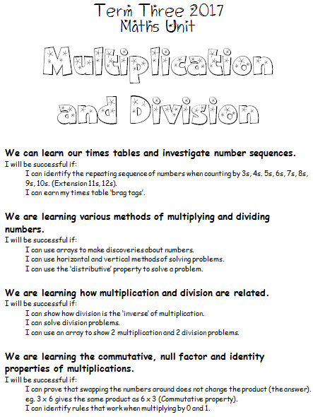 | TOOL SESSION  None yet ‘til ‘Tables at Tables’ is set up  WHOLE CLASS FOCUS  Introduction to learning intentions of unit.  Tuning into Mulitplication  What’s happening when we multiply?  Use ‘Cats on Mats’ powerpoint to model using student insights  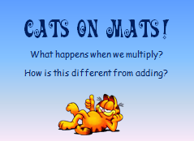 | INVESTIGATION  Task: See Saw Lesson  Working individually or in pairs, students make and post a See Saw video ‘lesson’ on Multiplication.  - Spark ideas – what needs to go into the video?  - Prepare a script  - Rehearse  - Do you need maths equipment to demonstrate?  - Record  Extending Prompts:  Make lesson on Division  Enabling Prompts:  Watch others before making your own. | REFLECTION  Give students time to watch others’ videos and critique with warm and cool feedback through See Saw comments  ‘I liked…’  ‘Even better if…’  ‘Your video showed me…’  ‘Did you think of…’ | ASSESSMENT  Videos should provide good information about students’ understanding
Administer Pre Assessments

Session 2  LEARNING INTENTION  We can learn our times tables and investigate number sequences.  I will be successful if:  I can identify the repeating sequence of numbers when counting by 3s, 4s. 5s, 6s, 7s, 8s, 9s, 10s. (Extension 11s, 12s)  I can earn my times table ‘brag tags’ | TOOL SESSION  None yet ‘til ‘Tables at Tables’ is set up  WHOLE CLASS FOCUS  Why do we need to learn our times tables?  How many facts do we have to learn? (144 – 156 if you count the 0s) How can we cut this number down –  You Tube:  https://www.youtube.com/watch?v=pSb40J9pcck  “How Many Times Tables do you Really Have to Learn?”  Do this exercise with class on chart.  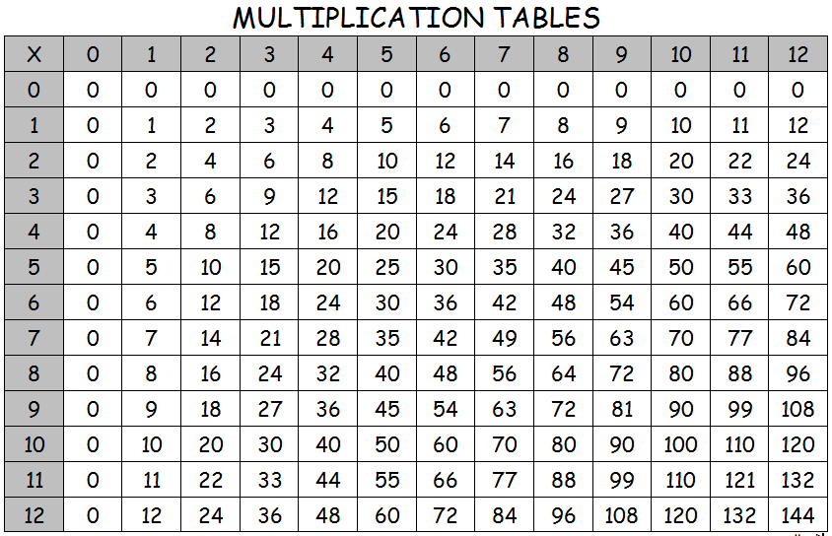 | INVESTIGATION  Setting up ‘Tables at Tables” procedures using Brag Tags  ‘Tables at Tables’ mini books  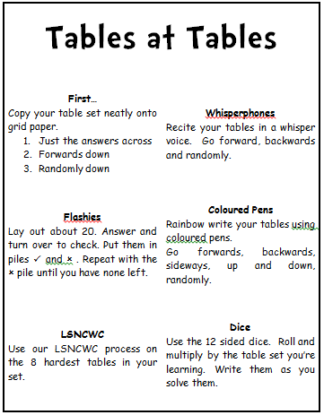  Matific assigned activities – multiplication and division | REFLECTION  Keep a class chart of who is learning which tables.  Use reflection starters: | ASSESSMENT  Encourage students to create videos for See Saw explaining the short cuts and tips for learning different tables.

Session 3  LEARNING INTENTION  We are learning various methods of multiplying and dividing numbers.  I will be successful if:  I can use arrays to make discoveries about numbers.  I can use horizontal and vertical methods of solving problems. | TOOL SESSION  ‘Tables at Tables’  WHOLE CLASS FOCUS  Exploring Arrays  What are arrays and why do we use them for multiplication and division?  Powerpoint – ‘Real Life Arrays’  Model the horizontal and vertical methods of recording multiplication. | INVESTIGATION  Task: Investigating Arrays, Numbers and Multiplication  Students are given a number to investigate using a variety of arrays. Students make as many type of arrays as possible and record the x algorithm using horizontal and vertical methods.  Numbers: 12 16 18 36 100 24 20 48 60  Task: Multiplication Arrays  In pairs, students roll 2 dice and colour the area on the grid indicated by the dice. Eg: if a player rolls a 4 & 6 they colour in any (4x6 ) rectangle. Students write down their multiplication fact inside the squares they have blocked. Keep playing until one player cannot fit an array. The last student to make a full array wins. | REFLECTION  (20 mins before lesson end)  How have you been successful?  (Revisit success criteria)  What might someone find difficult?  Who’d like a study buddy to help them finish?  Keep working for 10 more minutes then we’ll correct together | ASSESSMENT  Collect student samples to check.  Are algorithms correct?

Session 4  LEARNING INTENTION  We are learning various methods of multiplying and dividing numbers.  I will be successful if:  I can use arrays to make discoveries about numbers.  I can use horizontal and vertical methods of solving problems. | TOOL SESSION  ‘Tables at Tables’  WHOLE CLASS FOCUS  What is Division?  You Tube clips: - choose from:  https://www.youtube.com/watch?v=gT0HFbA1Mow  Basic Division for Kids | It's AumSum Time  https://www.youtube.com/watch?v=rGMecZ_aERo  Division for Kids | Basic Math Learning Video  https://www.youtube.com/watch?v=gjqxhtjyfC4  Learn Division for Kids - 2nd and 3rd Grade Math Video  https://www.youtube.com/watch?v=ndfeFjoperg  Introduction to Division | Basic Math Learning Video for Kids  https://www.youtube.com/watch?v=p3EgNTr4i1M  Basic Division  https://www.youtube.com/watch?v=BFhUXNoRpQE  Math Basics: Division  www.youtube.com/watch?v=J0lsX2d7y08  Division Song- My Dog Division | INVESTIGATION  Worksheet: Division Problems  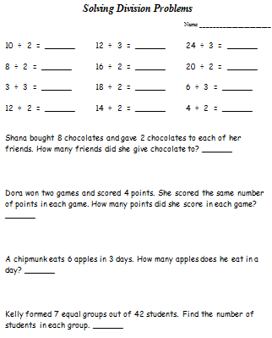 | REFLECTION  Correcting worksheet together | ASSESSMENT  Collect student samples to check.  Are algorithms correct?

Session 5  LEARNING INTENTION  We are learning various methods of multiplying and dividing numbers.  I will be successful if:  I can use arrays to make discoveries about numbers.  I can use horizontal and vertical methods of solving problems. | TOOL SESSION  ‘Tables at Tables’  WHOLE CLASS FOCUS  Exploring Arrays -Division  Powerpoint – ‘Real Life Arrays’  Use the arrays as a way of explaining division. | INVESTIGATION  Task: Investigating Arrays and Division  Students make an array and record the division algorithms.  Eg. Cut out an array of 6 squares  I can make 6 ÷ 2 = 3  and 6 ÷3 = 2  Sample numbers: 8 10 15 16, 18, 21 64 24 30 48 60  Extending Prompts:  Can you make different looking arrays for these numbers? 64 24 48  . | REFLECTION  Return to success criteria and make a self assessment. Is there more to do next time? | ASSESSMENT  Check

Session 6  LEARNING INTENTION  We are learning the commutative, null factor and identity properties of multiplications.  I will be successful if:  I can prove that swapping the numbers around does not change the product (the answer). eg. 3 x 6 gives the same product as 6 x 3 (Commutative property)  I can identify rules that work when multiplying by 0 and 1. | TOOL SESSION  ‘Tables at Tables’  WHOLE CLASS FOCUS  Product  Looking at ‘Mathspeak’ chart. Ensure student understand ‘product’  You Tube clip  https://www.youtube.com/watch?v=3SrN2RdWv1Y  ‘Multiplication Vocabulary’ | INVESTIGATION  Investigating the Commutative Property.  Can you prove that this is true or false?  ‘Swapping the numbers in a multiplication does not change the product.’  Investigating the Null Factor and Identity Properties  What rules can you construct that will always work when multiplying by 0 and by 1. Prove it. | REFLECTION  (20 mins before lesson end)  How have you been successful?  (Revisit success criteria)  What might someone find difficult?  Who’d like a study buddy to help them finish?  Keep working for 10 more minutes then we’ll correct together | ASSESSMENT  Check the conclusions students have come to and use ‘Thinking About our Maths’ questions to prompt answers  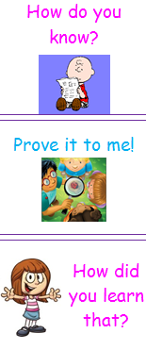

Session 7  LEARNING INTENTION  We are learning various methods of multiplying and dividing numbers.  I will be successful if:  I can use horizontal and vertical methods of solving problems. | TOOL SESSION  ‘Tables at Tables’  WHOLE CLASS FOCUS  Introduction:  Working through problems on whiteboard. | INVESTIGATION  Task: Drill sheets  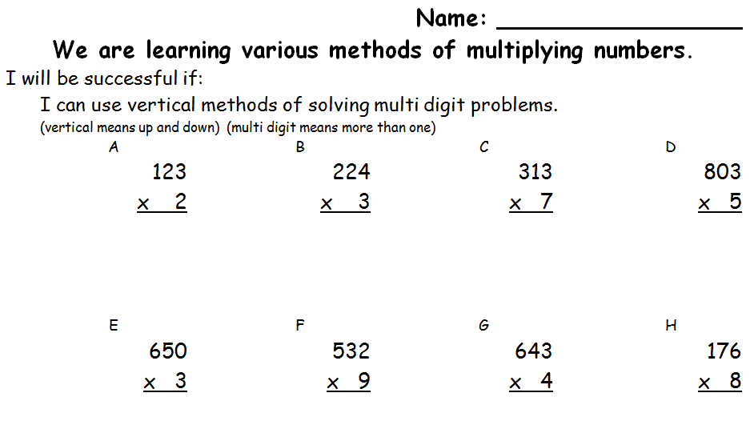  Extending Prompts:  Use Mathantics videos to take them to the next step  Enabling Prompts:  Working through with teacher | REFLECTION | ASSESSMENT  Check
A, B, M, Ja, C, S, K

- Watch the video: http://www.mathantics.com/section/lesson-video/multi-digit-multiplication-pt1

- Open the worksheet: http://www.mathantics.com/section/exercises/multi-digit-multiplication-pt1

- Copy the problems onto a piece of grid paper and answer. If you have any difficulty – watch the explanation video: http://www.mathantics.com/section/examples-video/multi-digit-multiplication-pt1 This will also be a good way to correct your work

We are learning various methods of multiplying and dividing numbers.  I will be successful if:  I can use horizontal and vertical methods of solving problems. | TOOL SESSION  ‘Tables at Tables’  WHOLE CLASS FOCUS  Introduction:  Working through problems on whiteboard. | INVESTIGATION  Task: Drill sheets  Extending Prompts:  Use Mathantics videos to take them to the next step  Enabling Prompts:  Working through with teacher | REFLECTION | ASSESSMENT  Check

Session 8  LEARNING INTENTION  We can learn our times tables and investigate number sequences.  I will be successful if:  I can identify the repeating sequence of numbers when counting by 3s, 4s. 5s, 6s, 7s, 8s, 9s, 10s. (Extension 11s, 12s).  I can earn my times table ‘brag tags’.  We are learning various methods of multiplying and dividing numbers.  I will be successful if:  I can use arrays to make discoveries about numbers.  I can use horizontal and vertical methods of solving problems.  I can use the ‘distributive’ property to solve a problem.  We are learning how multiplication and division are related.  I will be successful if:  I can show how division is the ‘inverse’ of multiplication.  I can solve division problems.  I can use an array to show 2 multiplication and 2 division problems.  We are learning the commutative, null factor and identity properties of multiplications.  I will be successful if:  I can prove that swapping the numbers around does not change the product (the answer). eg. 3 x 6 gives the same product as 6 x 3 (Commutative property)  I can identify rules that work when multiplying by 0 and 1. | TOOL SESSION  ‘Tables at Tables’  WHOLE CLASS FOCUS  Review:  Looking at the learning intentions and revisiting what we did to achieve these learning intentions.  Review:  Working through the initial assessment tasks again to see what we’ve learned and what we still need to work on.  Celebration of brag tags.  Stand up all those who have their 2x tag (take a photo)  Repeat with all others.

