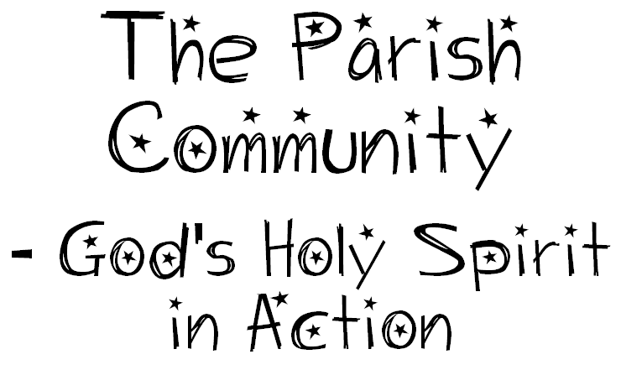

Seeking Discoveries
Where do we see the Holy Spirit in action in our families, in the parish and in the wider community?
As people of the Holy Spirit how can we serve the community?

Understandings:
Jesus Christ is the model of Christian love and service.
The Holy Spirit inspires Christians to love and serve others.
The Holy Spirit is active in each person in different ways and through different gifts.
The Holy Spirit is active in the people of the local parish.
The parish is part of the worldwide Church and the wider community.

Scripture Text
1 Cor 12: 4–6, 11 The Variety and Unity of Gifts

