Child’s photo  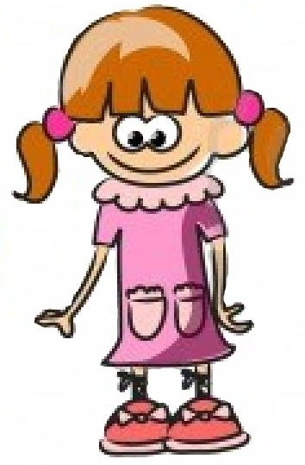 |  |  |  |  |  | School logo

after | bed | day | had | is | next | played | the | very
all | big | did | have | it | night | said | them | was
am | birthday | do | he | like | not | Saturday | then | watched
an | bought | dog | her | little | of | saw | there | we
and | brother | for | him | lived | on | school | they | weekend
are | but | friends | his | lots | once | she | time | went
at | called | fun | home | made | one | sister | to | were
ate | came | get | house | me | our | so | too | when
back | can | go | I | mum | out | some | two | will
be | car | going | in | my | park | Sunday | up | with
because | dad | got | into | name | play | that | upon | you

Numbers 1 - 100 |  |  |  |  |  |  |  |  |  |  |  |  |  |  |  |  |  |  |  | Colours |  |  | Days of the Week | Months of the Year
1 | 2 |  | 3 |  | 4 |  | 5 |  | 6 |  | 7 |  | 8 |  | 9 | 10 |  |  |  | red |  |  | Sunday | January
11 | 12 |  | 13 |  | 14 |  | 15 |  | 16 |  | 17 |  | 18 |  | 19 | 20 |  |  |  | blue |  |  | Monday | February
21 | 22 |  | 23 |  | 24 |  | 25 |  | 26 |  | 27 |  | 28 |  | 29 | 30 |  |  |  | yellow |  |  | Tuesday | March
31 | 32 |  | 33 |  | 34 |  | 35 |  | 36 |  | 37 |  | 38 |  | 39 | 40 |  |  |  | green |  |  | Wednesday | April
41 | 42 |  | 43 |  | 44 |  | 45 |  | 46 |  | 47 |  | 48 |  | 49 | 50 |  |  |  | orange |  |  | Thursday | May
51 | 52 |  | 53 |  | 54 |  | 55 |  | 56 |  | 57 |  | 58 |  | 59 | 60 |  |  |  | purple |  |  | Friday | June
61 | 62 |  | 63 |  | 64 |  | 65 |  | 66 |  | 67 |  | 68 |  | 69 | 70 |  |  |  | brown |  |  | Saturday | July
71 | 72 |  | 73 |  | 74 |  | 75 |  | 76 |  | 77 |  | 78 |  | 79 | 80 |  |  |  | black |  |  |  | August
81 | 82 |  | 83 |  | 84 |  | 85 |  | 86 |  | 87 |  | 88 |  | 89 | 90 |  |  |  | white |  |  | Summer | September
91 | 92 |  | 93 |  | 94 |  | 95 |  | 96 |  | 97 |  | 98 |  | 99 | 100 |  |  |  | pink |  |  | Autumn | October
 |  |  |  |  |  |  |  |  |  |  |  |  |  |  |  |  |  |  |  |  |  |  | Winter | November
1st |  | 2nd |  | 3rd |  | 4th |  | 5th |  | 6th |  | 7th |  | 8th |  |  | 9th |  | 10th |  | ( last ) |  | Spring | December
