Still and quiet  Eyes tracking the writing  Choosing a spot by myself  Getting comfy  sitting/laying down  Quietly laughing at the  funny bits in the story  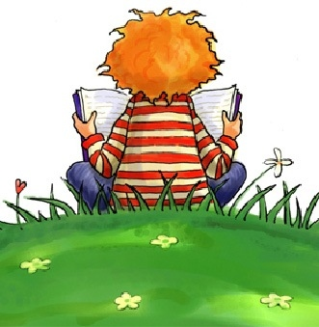  Slow page turns  Settling quickly  Finger tracking | Flicking through pages  Looking over someone  else’s shoulder  Looking around the room  Checking teacher to  see if she’s looking  Sitting next to a friend  Taking a long time to  choose a book

