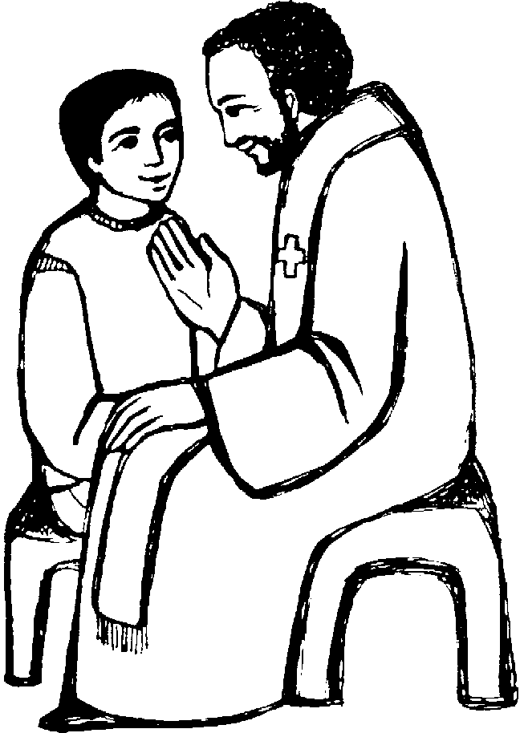 | 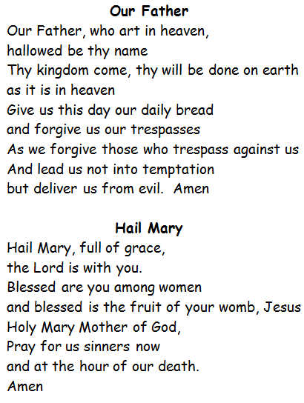
I ask forgiveness for  all my sins, especially for  because | Act of Contrition  O my God, I am very sorry that I have sinned against you.  Because you are so good  and with your help,  I will try not to sin again.  Thank you Father

