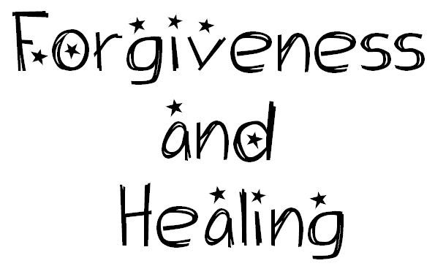
Seeking Discoveries
What does it mean to forgive and be forgiven?
How do people heal relationships?
Why and how do people celebrate the sacrament of Reconciliation?
Understandings:
Forgiving and being forgiven bring peace to self and others.
Healing involves reflecting on what has happened, saying sorry, and giving someone a second chance.
Scripture stories about forgiveness help Christians think and pray about forgiveness in their own lives.
Forgiveness and healing are celebrated in the sacraments of Penance and Anointing.
Through the sacrament of Penance Christians rebuild their relationship with God and others.
Scripture Text
Lk 19: 1–10 Story of Zacchaeus; Lk 15: 11–32 The Prodigal Son and His Brother.

