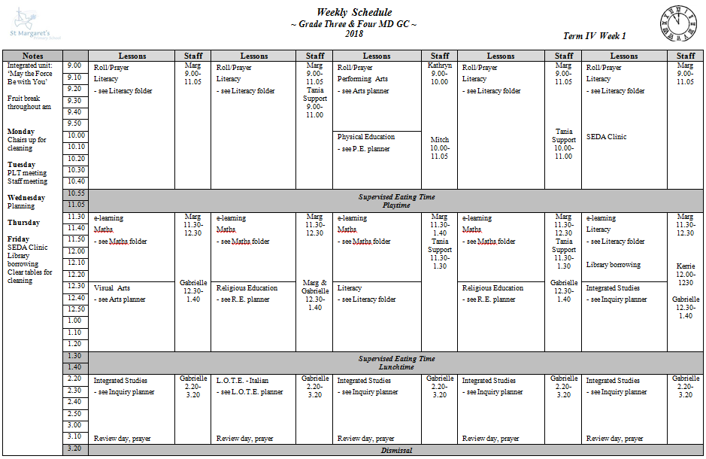 | Adjustments for Sample Child (ASD)  Seating  Sample Child needs to be placed carefully each week so that he has space and is not anxious about who he’s sharing with. Do not sit with name or name.  Time  Sample Child needs to be given extra time to finish a task he is engaged in. He finds it very difficult to put incomplete work away – even with the promise of continuing the next day.  Social Exchanges  Sample Child needs reminding (and sometimes explanation why) to use positive comments to others. He also so needs to be told when he is making inappropriate comments and why.  His Tone of Voice  Can be very negative. Insist that you will not listen to negative (rambling) statements but only to questions/statements expressed respectfully.  Teacher Tone of Voice  Unfortunately, sometimes Sample Child will only respond when a loud authoritative tone is used with him after he has ignored directions several times.  Alternatives  Alternative work and extension is needed to have on hand for Sample Child for when he refused to join class or displays work refusal. May need to complete in a different room.

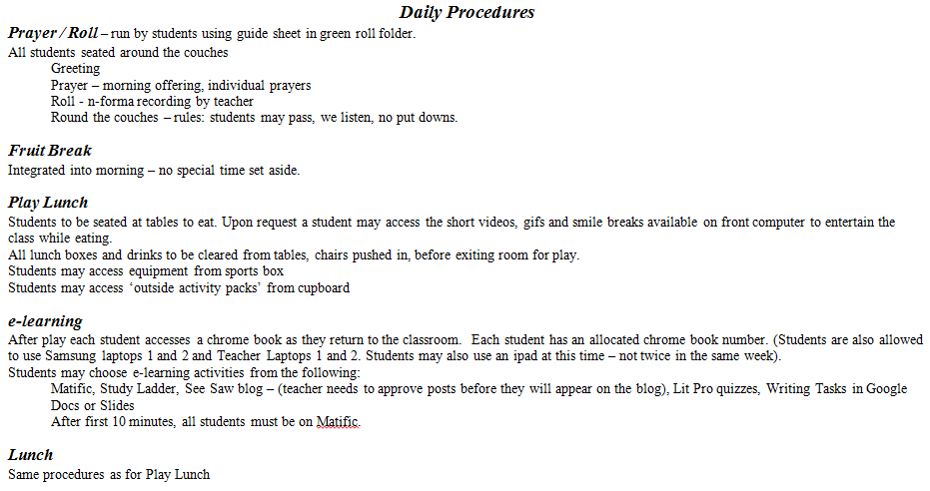 | Upon first arrival, ascertain mood and give a positive greeting to start.  Sample Child will often sit away from the group as he likes a bit of distance. He may need reminding not to continue commenting throughout the prayer/roll time.  Sample Child is heavily reliant on the visual timetable. When routines are put out Sample Child will exhibit high anxiety and misbehaviour. Forewarn as much as possible.  Often has his fruit break and reads at table rather than with class  Sample Child does not like to play on senior playground and sometimes will sneak inside to read/browse books. C/r teacher has a pass to allow him to sit inside sometimes and all teachers know if he doesn’t have the pass, he should be outside.  Sample Child is often first in after play  Sample Child loves e-learning!  He does need to be checked that he is not on ‘other’ pages – you tube, games. Sanctions may be necessary. Frequent supervision necessary

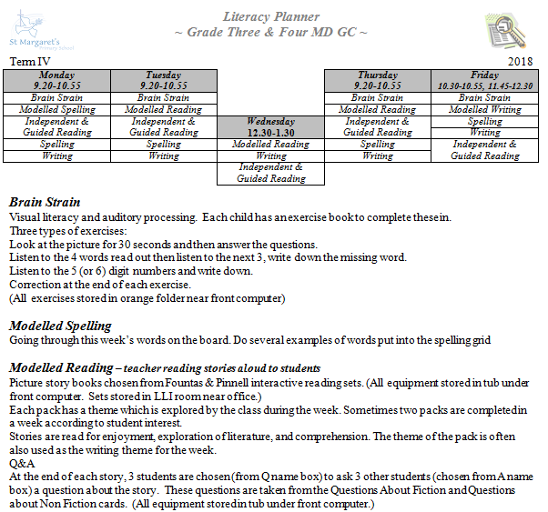 | Has refused to participate in Brain Strain so is given alternative work from purple folders. Best to set this up before school as sheets will need explaining.  Can have LSO work on Brain Strain with Sample Child separately at another time.  Depending upon his interest, Sample Child will join the class round the couches, or watch from his table or read at his table.  Has a tendency to call out answers and needs explaining why it’s important to take turns and be tolerant of others who may not know what he knows.
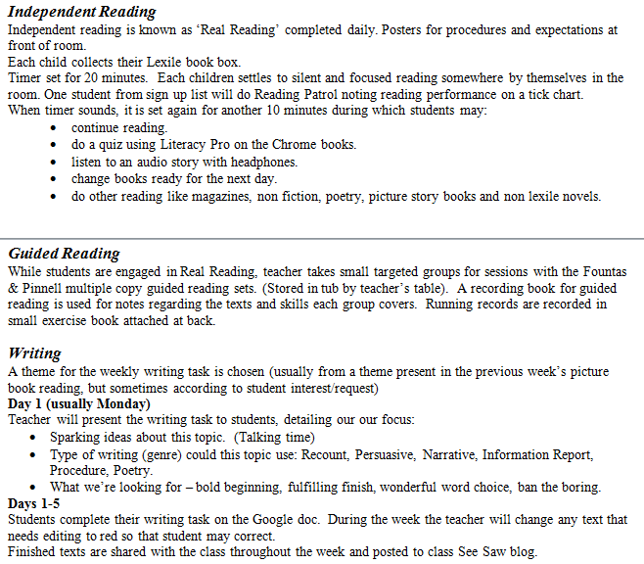 | Sample Child likes to read shorter books and has a voracious appetite for doing quizzes. Keep box well stocked.  Continue to provide longer books that he may enjoy.  Sample Child loves being top of the quiz ladder – allow him to share this and acknowledge his achievements  Sample Child likes to make full use of Lit Pro program and likes to share statistics with teacher. Encourage.  Becomes impatient during these sessions and will avoid reading text if left to finish independently. Redirect and insist.  Make sure he is focussed during modelling session. Does not enjoy writing. Will use avoidance tactics.  Likes to finish writing quickly. He will avoid it as long as possible then does the bare minimum. Redirect and insist. Often needs extra support to keep him on track, talk his writing through and keep him from copying and pasting screeds from web.  Use e-learning time as bargaining chip/sanction if necessary.
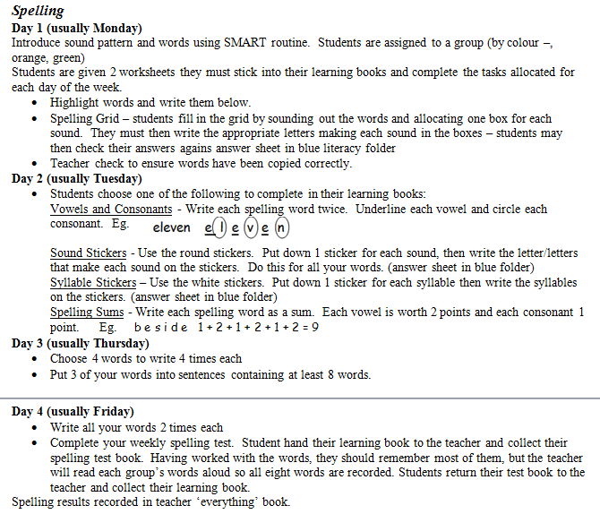 | Sample Child is a fluent speller and will want to complete work as quickly (but also as thoroughly) as possible. Often requests to keep going and uses spelling tasks to keep himself from doing writing.  Puts a tremendous amount of effort and detail into spelling – encourage.  Needs access to blue literacy folder to make sure he is correct.  Sample Child likes to do things in order – eg spelling tests must be done in the order of words on the list and to have work checked immediately. It’s usually helpful to do Sample Child’s spelling test separate from others

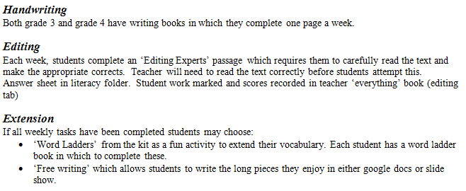 | Has pen licence but prefers to use pencil as he compulsively MUST erase errors.  Will try to avoid completing weekly handwriting sheet.  Needs access to blue literacy folder to make sure he is correct.  Enjoys new activities and will ask to do more and more. Does tire of activity eventually then becomes reluctant.
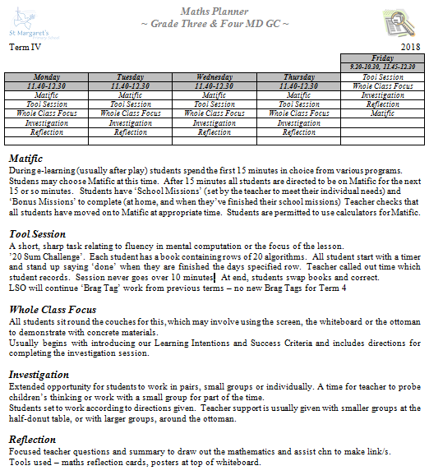 | Highly capable in Maths.  Has an extension Maths book which he likes to do with an adult’s support.  Enjoys Mathantics videos.  Loves Matific / Studyladder  Does not like to be disturbed by others.  Does not like others to correct his work – but will change any answers he has wrong. Best to negotiate a child he trusts to correct his work.  Has all brag tags  Best for Sample Child to know what’s happening in Maths each day before lesson begins. Make sure he is paying attention when giving directions  Finds it difficult to work with others.  Will need extension activities (preferably self-correcting as he will insist on knowing)  May need reminding that not everyone finds maths as easy as he does so he needs to be patient with those who need more explaining.

