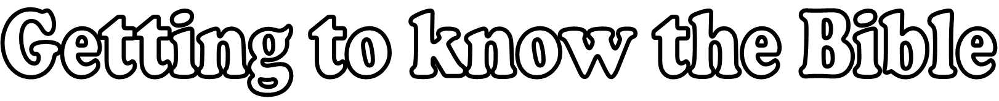

Today we’re reading ___________________________

3, 2, 1
Write 3 facts about the passage:
Fact 1
Fact 2
Fact 3
Write 2 questions that will help you understand the passage better:
Question 1
Question 2
Write 1 connection from the passage to your own life:
Connection 1
Draw an image or symbol about the passage:

