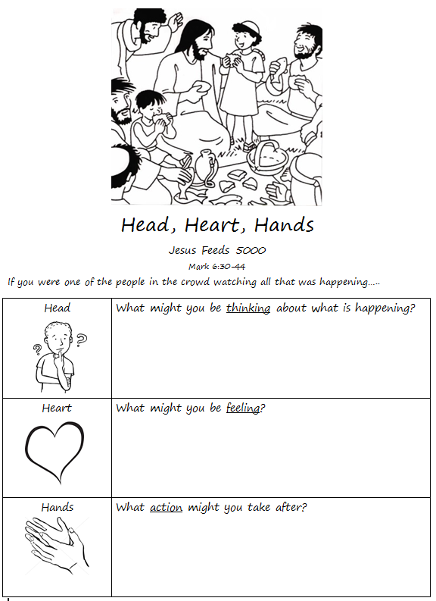

John 6

Feeding the Five Thousand
6 After this Jesus went to the other side of the Sea of Galilee, also called the Sea of Tiberias.^{[a]} ² A large crowd kept following him, because they saw the signs that he was doing for the sick. ³ Jesus went up the mountain and sat down there with his disciples. ⁴ Now the Passover, the festival of the Jews, was near. ⁵ When he looked up and saw a large crowd coming toward him, Jesus said to Philip, “Where are we to buy bread for these people to eat?” ⁶ He said this to test him, for he himself knew what he was going to do. ⁷ Philip answered him, “Six months’ wages^{[b]} would not buy enough bread for each of them to get a little.”⁸ One of his disciples, Andrew, Simon Peter’s brother, said to him,⁹ “There is a boy here who has five barley loaves and two fish. But what are they among so many people?” ¹⁰ Jesus said, “Make the people sit down.” Now there was a great deal of grass in the place; so they^{[c]} sat down, about five thousand in all. ¹¹ Then Jesus took the loaves, and when he had given thanks, he distributed them to those who were seated; so also the fish, as much as they wanted. ¹² When they were satisfied, he told his disciples, “Gather up the fragments left over, so that nothing may be lost.” ¹³ So they gathered them up, and from the fragments of the five barley loaves, left by those who had eaten, they filled twelve baskets. ¹⁴ When the people saw the sign that he had done, they began to say, “This is indeed the prophet who is to come into the world.”
¹⁵ When Jesus realized that they were about to come and take him by force to make him king, he withdrew again to the mountain by himself.

