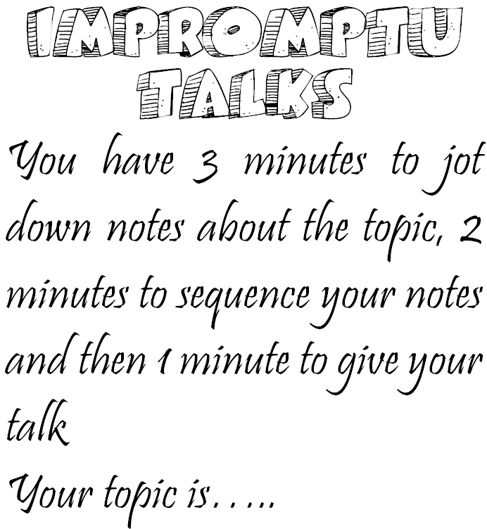  My First Day  at School |  | The Environment

Cartoons |  | Tsunamis

The Moon |  | Mice

Computer  Games |  | i-Pods

Advertising |  | Bushfires

Whales |  | Snakes

A Famous Person |  | Exercise

My Family |  | Peace

Soccer |  | Saving Water

Kindness |  | The Olympics

Pizza |  | Netball

My Favourite  Movie |  | Holidays

My Favourite  Music |  | Recycling

Sharks |  | Cricket

Weekends |  | Dreams

Dolphins |  | The Internet

Sports Day |  | Pets

Bushfires |  | Tropical  Cyclones

Homework |  | Baking a Cake

Eating Out |  | The Outback

War |  | Global Warming

Manners |  | Fears

