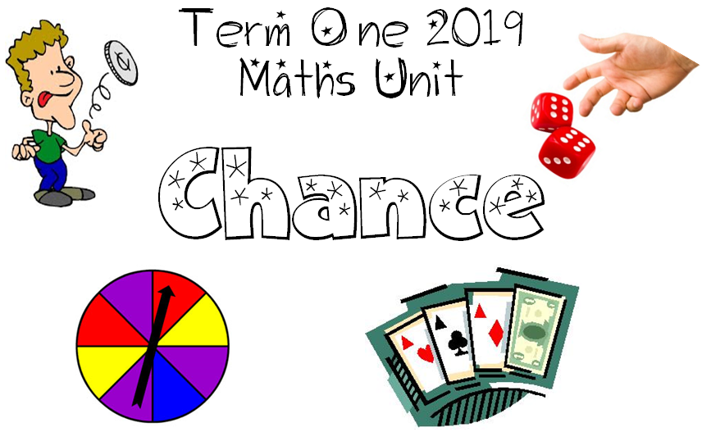
We are learning to describe everyday happenings that involve chance.
I will be successful if:
I can identify daily events that involve chance.

We are learning to use the language of chance to make predictions about the likelihood of everyday events.
I will be successful if:
I can talk and write about chance events using the language of ‘likely’, ‘unlikely,’ impossible’, ‘probable’, ‘possible’, ‘certain’.

We are learning to explain why some actions are more possible than others.
I will be successful if:
I can talk about some of the reasons that make things more possible than other things.
I can put events in order of their chance of happening or not happening.

We are learning to recognize the ways that ‘fairness’ can be affected.
I will be successful if:
I can discover ways to change games to make them fairer or less fair.
I can identify how making chances more equal connects with fairness.

