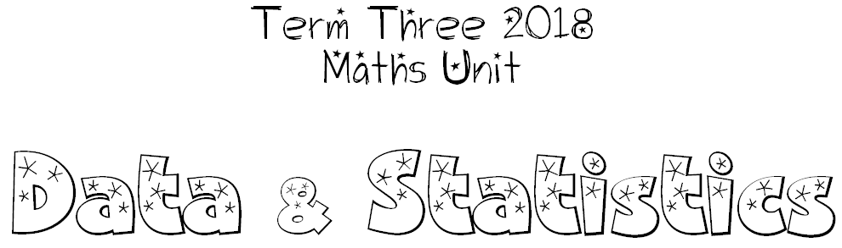
Classification
We can make decisions about the categorisation of objects.

The Data Process
We can use a four-step process in our data investigations and interpretations. These steps include:

- Question Posing
What questions do we have that we need to collect data for?
- Data Collection
How are we going to collect our data?
(We could use one of these: surveys, questionnaires, interviews, experiments, tables, tallies).
- Data Representation
How are we going to show our information?
(We need to choose something that shows our data clearly. We can choose from: tables, pictographs, bar/column graphs, line graphs, pie graphs, Venn diagrams.)
Data Interpretation / Analysis
What can we say about the data? What is it telling us?

