Step Up 2018 for 2019 Ideas

Welcome and Introductions
Circle time sentence finishers
My name is … and I eat …
My name is … and I don’t eat ...
I am … years old and my birthday month is …
Circle time silent statements
Change places if you’re in Grade 3
Change places if you’re in Grade 4
Change places if you’re in Red sports team
Change places if you’re in Green sports team
Change places if you’re in Blue sports team
Change places if you’re in Gold sports team
Cat person or dog person.
Change places if you’re a cat person.
Change places if you’re a dog person
Change places if you like to draw
Change places if you like sport
Change places if you like reading
Change places if you like computers
Change places if you like maths
Change places if you like music

Talking about our classroom for next year
Where it will be

Powerpoint: Classroom Rights and Responsibilities
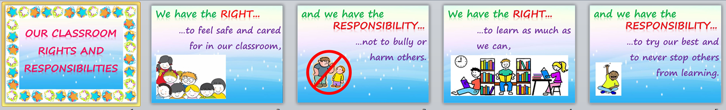

Activity: What makes a great classroom?
Show teacher samples and explain task.
Show how ideas sheet can be used to get started

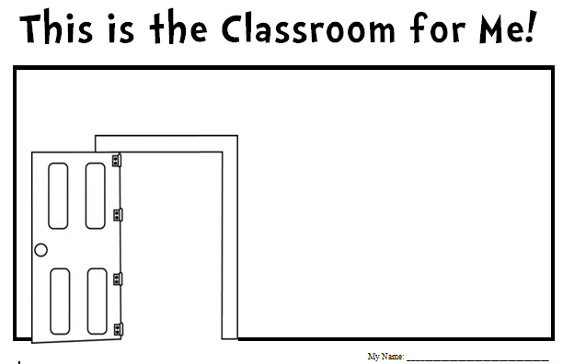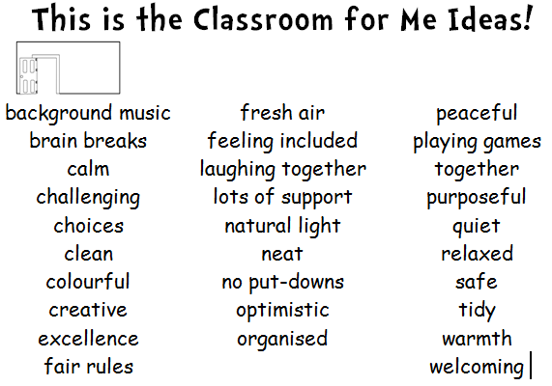

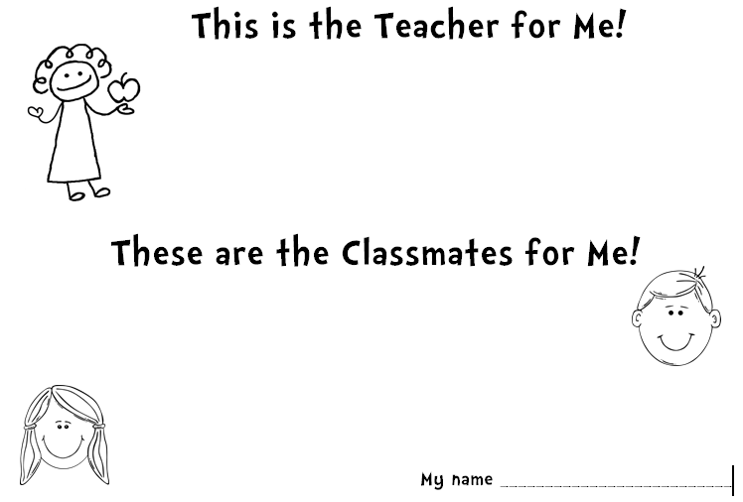 | 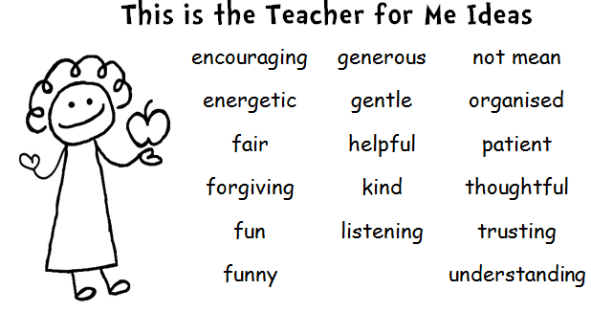
 | 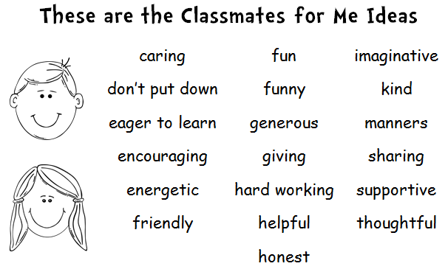

Name label colouring
