We measure time in
Seconds Minutes Hours
60 seconds = 1 minute | 60 minutes = 1 hour
Days Weeks Months Years
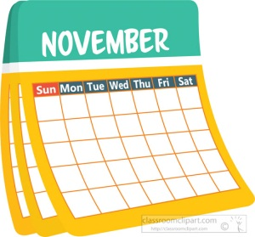  24 hours in a day  7 days in a week | 52 weeks in a year  12 months in a year
We also use
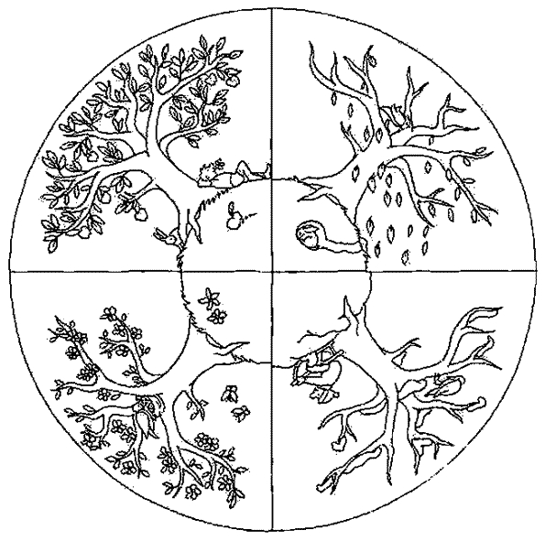
Seasons Fortnights
4 seasons in a year  Summer, Autumn, Winter, Spring | 14 days = a fortnight  2 weeks = a fortnight
MargD

