MATHEMATICS WEEKLY/UNIT PLANNER
Level: Gr 3/4 Term: 2019 Weeks:
Teachers: Leonie, Fran and Marg
Dimension: Measurement and Geometry
Specific Focus for Unit: Measurement – Calendar Time
Victorian Curriculum Content Descriptions  http://victoriancurriculum.vcaa.vic.edu.au/mathematics/introduction/rationale-and-aims | Key Concepts  https://drive.google.com/file/d/0B3ydL4IWBSAbbk5laWtLOEprYXc/edit
Name and order months and seasons (VCMMG118)  Use a calendar to identify the date and determine the number of days in each month (VCMMG119)  Yr 3:  Tell time to the minute and investigate the relationship between units of time (VCMMG141)  Yr 4:  Convert between units of time (VCMMG167)  Use am and pm notation and solve simple time problems (VCMMG168)  Yr 5:  Compare 12- and 24-hour time systems and convert between them (VCMMG197) | Time Span  • daily events – morning/afternoon/evening  • tools – calendar, timetable  • social/cultural phenomena, e.g. Easter, Christmas  • time cycles – millennia, centuries, decades, years, seasons, months, weeks, days  • AD & BC / CE & BCE.
Reporting Statements:
Grade 3 - Tell the time to the nearest minute.
Grade 4 - Solve simple time problems.

Learning Intentions & Success Criteria
We are learning how to use a calendar.
Success Criteria: I will be successful if…
I can name and order months (and seasons).
I can work out the number of days in any month.
We are learning to solve problems involving time (calendar and clocks).
Success Criteria: I will be successful if…
I am able to calculate the time between dates using a calendar.

SESSION NUMBER  LEARNING INTENTION  & SUCCESS CRITERIA | TOOL SESSION  A short, sharp task relating to fluency in mental computation or the focus of the lesson.  WHOLE CLASS FOCUS  Sets the scene/context for what students do in the investigation session. | INVESTIGATION SESSION  Extended opportunity for students to work in pairs, small groups or individually. A time for the teacher to probe children’s thinking or work with a small group for part of the time. | REFLECTION  Focused questions and summary to draw out the mathematics and assist children to make links. | TEACHER ASSESSMENT  We are looking for...
Session 1  LEARNING INTENTION  We are learning how to use a calendar.  SUCCESS CRITERIA  I will be successful if…  I can name and order months (and seasons).  I can work out the number of days in any month. | TOOL SESSION  20 Sum Challenge  WHOLE CLASS FOCUS  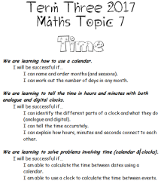  Introduction of topic and guidance through the learning intentions on the cover sheet.  Video – You Tube  https://www.youtube.com/watch?v=HtQcnZ2JWsY  Days of the week to the tune of the Addams Family.  https://www.youtube.com/watch?v=CiYIya36vLM Instrumental version  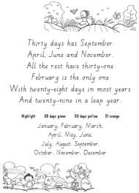  Poem – Thirty Days Has September  Read through the poem several times to learn together. Have students colour code the months by their number of days. | INVESTIGATION  Task: Months and Seasons Wheel  Students create a seasons wheel labelling the pictures, using appropriate colours for the trees and writing in the months (in order) in the surrounding ring.  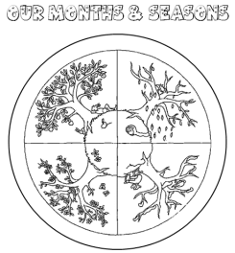  Task: Flash Card Sequencing  Students create a personal batch of month and season flash cards. Students work in pairs to time each other sequencing cards:  sequence the months / seasons  match the seasons to months  sort by number of days  Write down your times to see if you can improve.  Extending Prompts:  Can you do it starting in the middle of the year? Can you do it backwards? How fast can you get?  Enabling Prompts:  Have the months worksheet and seasons wheel nearby so you can use it for help. | REFLECTION  What are some of the tricks and tips to learning these?  How have you been successful?  What might someone else find hard? How would you help them?  Are your times getting faster?  Revisit success criteria  Study Ladder: ‘Calendar Time’ pod  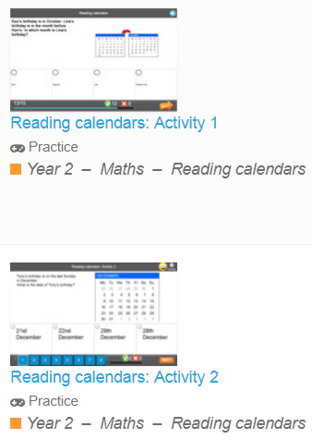 | ASSESSMENT  Check the months and seasons wheels are correct  Set up two extra ‘Brag Tags’ kids can earn:  reciting months in sequence.  reciting ‘30 days’ poem.

Session 2  LEARNING INTENTION  We are learning to solve problems involving time (calendar).  SUCCESS CRITERIA  I will be successful if…  I am able to calculate the time between dates using a calendar. | TOOL SESSION  Tables at Tables (number fact practise) Extra brag tags for months  WHOLE CLASS FOCUS  Game: ‘What Date Am I?”  Put a large copy of any month on the screen. Teacher has a secret date in their head. Students must work out the date by asking ‘yes’ or ‘no’ questions. As questions are asked dates can be eliminated from the large calendar. First time, model this by a student having secret date and teacher asking questions  Sample questions:  Does your date have a 1 in the tens column? Does your date fall on a Monday? Is your date even? Is your date odd? Is your date a single digit? Does your date have a 0 in the ones column? Does your day fall on the weekend? Is your date in the 2nd week of the month? Is your date after the 15th? Is your date before the 16th?  Variations  - Use a calendar for several months.  - Give each child a copy of a month and everyone marks a different date. Teacher asks the questions and the last person to have their date identified is the winner. | INVESTIGATION  Task: Investigating the Year with a Calendar  Using A3 calendar of the year (maybe 1 for each table) students answer questions on worksheet  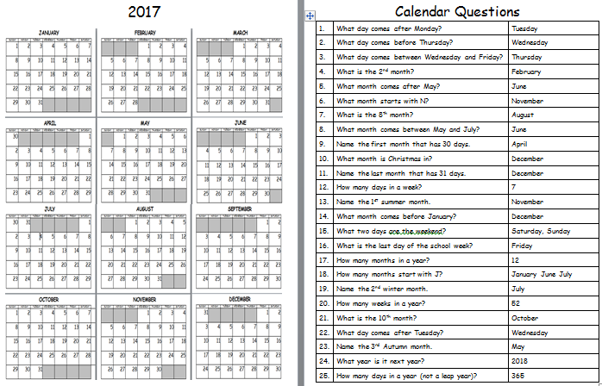  Task: Investigating September  Students answer questions about the specifics of the month of September  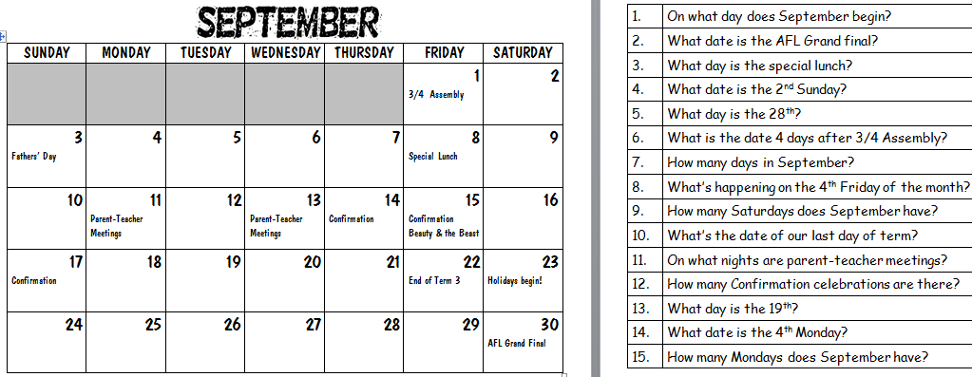  Extending Prompts:  Use the classroom calendar to make up questions for October  Enabling Prompts:  Make sure you read the questions carefully and you’re using the calendar to find the answers. Check with others. | REFLECTION  (20 mins before lesson end)  How have you been successful?  What might someone find difficult?  How does this help us in our everyday lives?  How do our Mums and Dads use calendar time?  Who’d like a study buddy to help them finish?  Revisit success criteria and use the ‘Where Am I At with My Learning?’ poster:  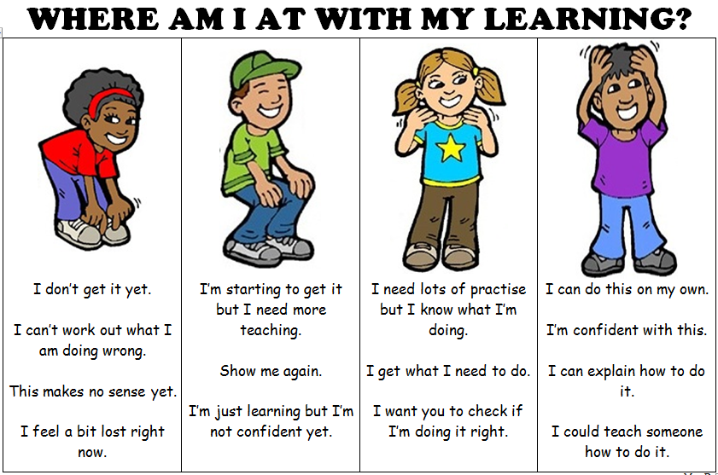  Keep working for 10 more minutes then we’ll correct together  Study Ladder: ‘Calendar Time’ pod | ASSESSMENT  Correct as a class and collect sheets for assessment

