USING THE SNIPPING TOOL TO CUT AND PASTE PICTURES
(PC Users)

If you don’t have the Snipping Tool down on the bottom task bar already – get me to put it there!!

Find the picture you want to copy
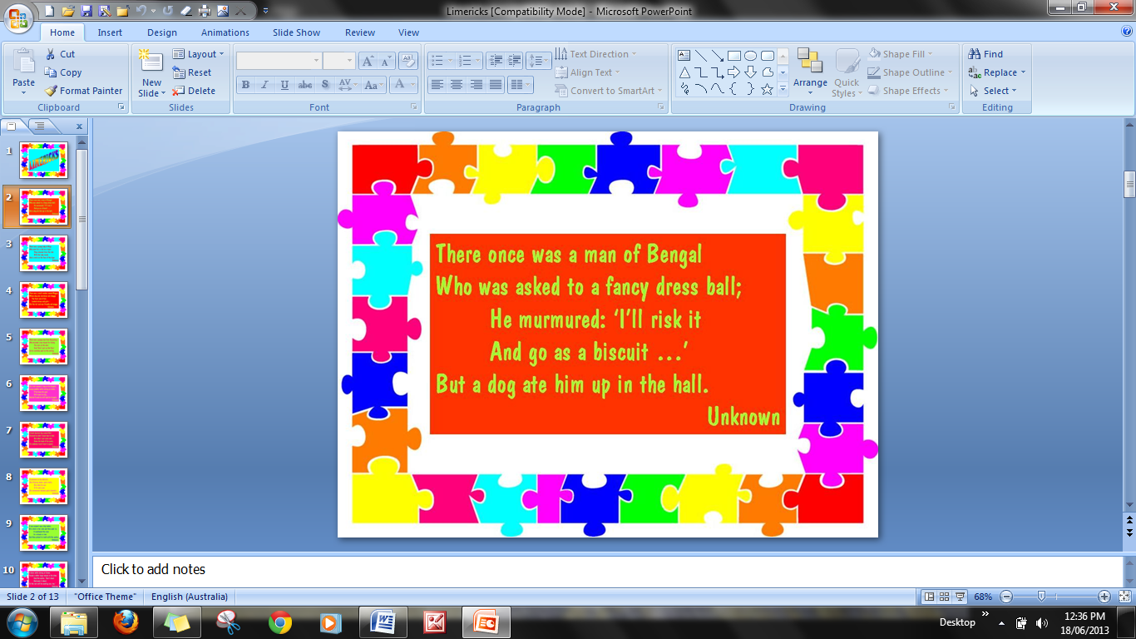
I only want this bit

So use the snipping tool to grab it like this:

Click on the scissors, trace around the bit that you want with the mouse pressed down, lift the mouse button and the bit that you want will come up inside the snipping tool screen.
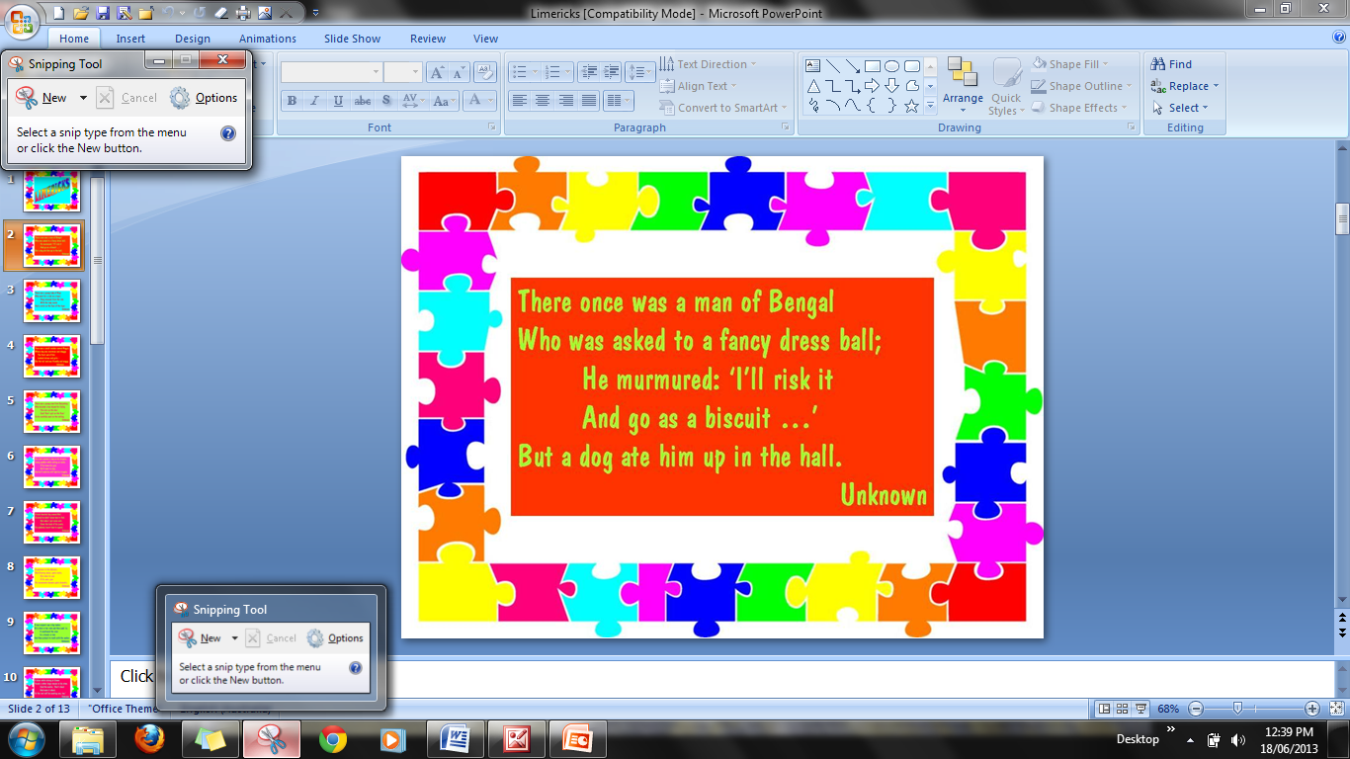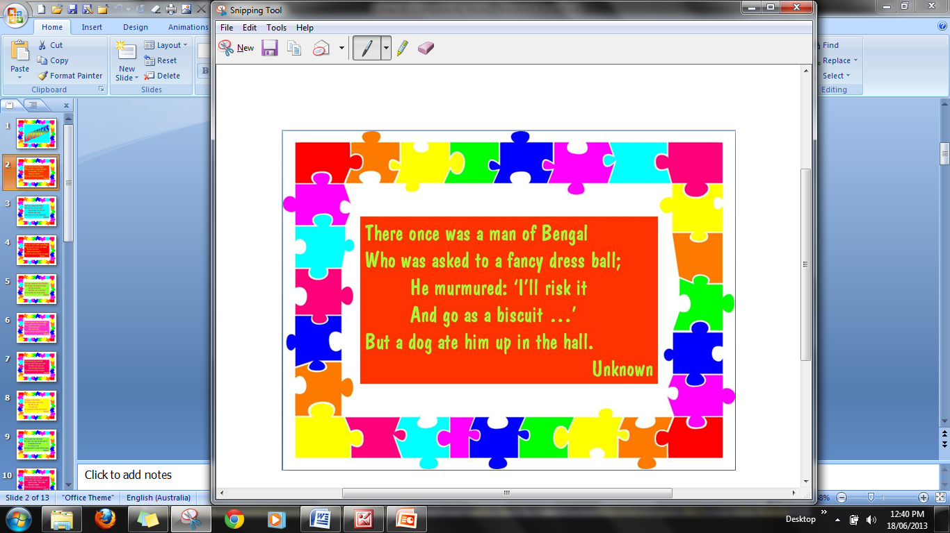

Now you can save it onto your computer. I keep mine in the ‘Pictures’ Folder.
Or
You can just copy and paste it directly into wherever you want it.

Very Handy Tool!

