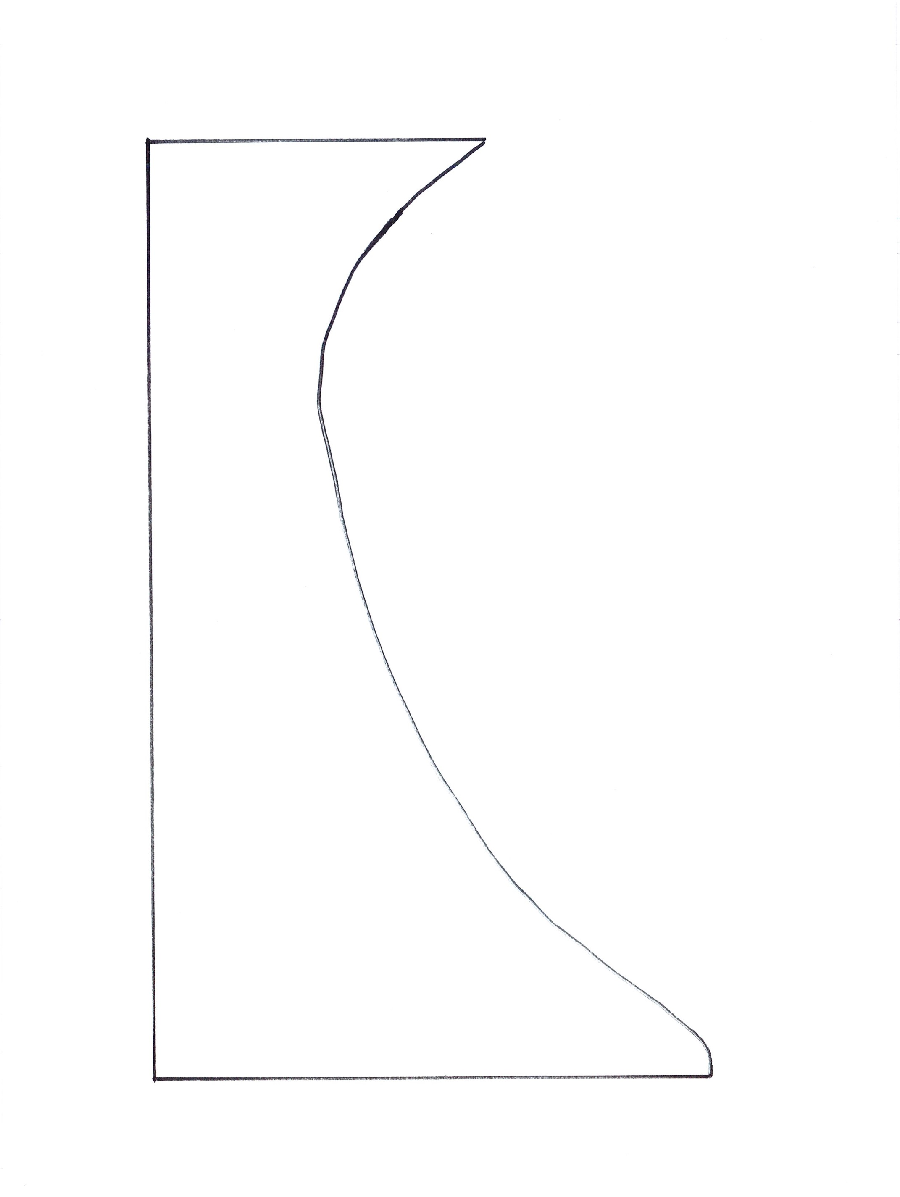Planning Title: ________________ By: _________

Graph

