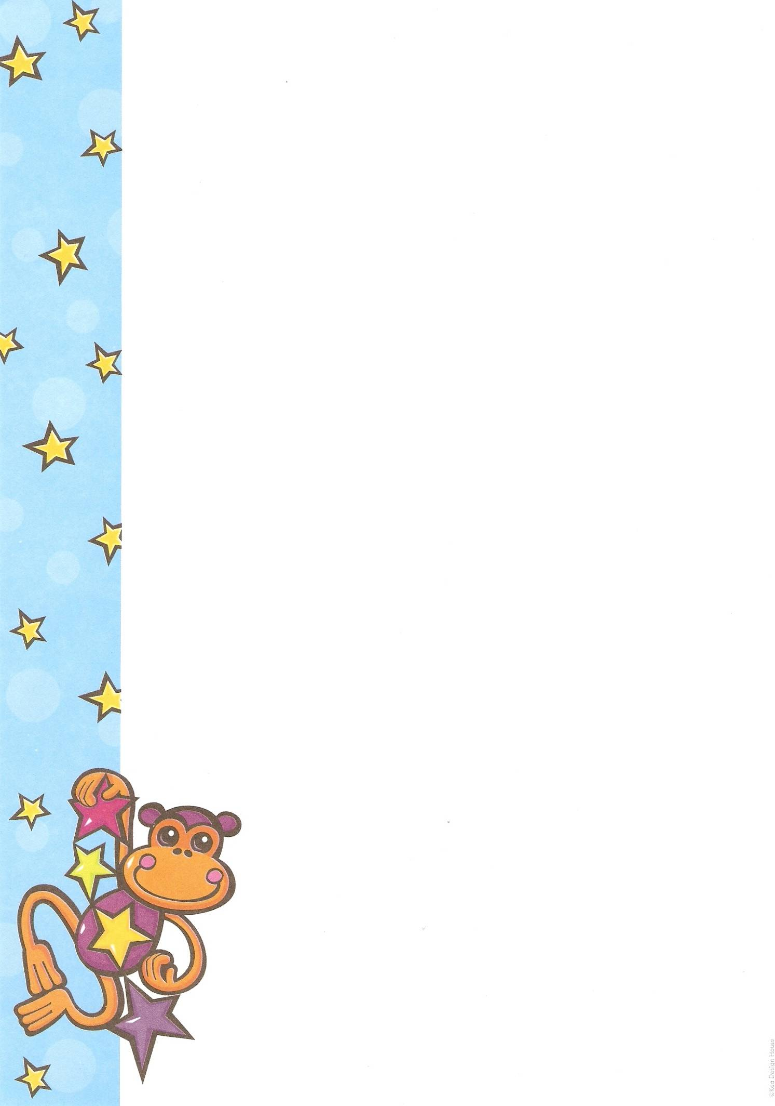


Story Starters to get you going
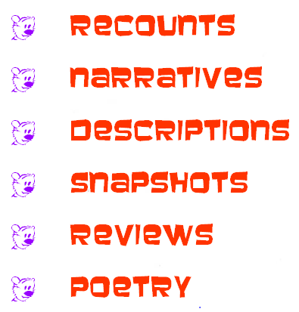

You will run through a patch of wild flowers screaming…

When I lived in a tree house…

When I was six I made friends with a pixie…

Bare feet are good.

My grandfather did not believe in flowers…

Fred enjoyed potatoes but…

Ophelia and Bedelia are making daisy chains…

Why I am scared of fairies

There will be a circus in the garden shed at 3pm…

Being four

King Turnip and Madame Pumpkin

It was a weird time

She sat under the striped sun umbrella drinking…
A box of secrets lies buried…

When robots go bad.

The world’s most boring job

Evil flowers

Strange habits

It started with bananas on toast for breakfast…

Being fabulous

Purple pens

I told her my name was Daisy

Slime balls

Glossy bossy people

Travels with my aunt

The day things started disappearing

If I had magical powers…
Beautiful people, ugly noses

At night the wind sounded like a mad dog barking…

Save it for someone who believes you

Fairy dust and elf powder

Fear of water

Handbags I have known

Winter

Edible flowers

In soft rain…

My island

The land of blue socks

Mr Harris wept

The best motel

Soup, toast and loneliness

Daytime television

The day after I died

Being weird

I smell like peanut butter and old roses

It takes a long time to cut a lawn with nail scissors.

I sound like crazy wind through rusty wire

Toes

The green sofa

Blossoms

A bad habit

Being young

Porridge

Being wonderful
Moonblossoms

Being sorry

Once I loved…

Dressing in an old satin kimono…

Scary sunsets

My relationship with sticky cakes

Being old

I hear elves chanting and windows creaking

A new religion

Being mad

My skin feels like old velvet

I taste like mud / melon/ ocean

