English Unit Planner
Level: Gr 3/4 Term: 1 2 2019 Weeks: 1-4
Teachers: Leonie, Fran and Marg
Language Mode: Writing

Victorian Curriculum Content Descriptions
http://victoriancurriculum.vcaa.vic.edu.au/english/curriculum/f-10

Grade 2
Create short imaginative, informative and persuasive texts using growing knowledge of text structures and language features for familiar and some less familiar audiences, selecting print and multimodal elements appropriate to the audience and purpose (VCELY230)
Grade 3
Plan, draft and publish imaginative, informative and persuasive texts demonstrating increasing control over text structures and language features and selecting print and multimodal elements appropriate to the audience and purpose (VCELY266)
Grade 4
Plan, draft and publish imaginative, informative and persuasive texts containing key information and supporting details for a widening range of audiences, demonstrating increasing control over text structures and language features (VCELY299)
Grade 5
Plan, draft and publish imaginative, informative and persuasive print and multimodal texts, choosing text structures, language features, images and sound appropriate to purpose and audience (VCELY329)

Reporting Statements
Grade 3
Create clearly structured sentences using correct grammar and punctuation.
Develop clearly structured text and use detailed paragraphs.
Grade 4
Select vocabulary from a range of resources and use accurate spelling.
Accurately select words and punctuation to add detail and interest to writing.
Develop writing pieces that are creative, informative and detailed for different audiences.

Learning Intentions and Success Criteria
We are learning to plan our writing.
I will be successful if…
I can use the story graph to help me plan.
I can plan out a topic for a persuasive text.
I can plan out a story.
I can use what I know about bold beginnings and fulfilling finishes.
I can let my personality shine through my writing to persuade and entertain.

SESSION 1
WHOLE CLASS FOCUS >> INDIVIDUAL / SMALL GROUP / CLASS SESSION
Tuning In:
Example of narrative text: ‘Princess and the Pea’.

Focus: Structure of a narrative text
Revisit ‘Story Graph’
Introduce ‘Planning Graph’. Discuss and identify the components:
Bold Beginning
Paint the Picture - details
Paragraphs 1, 2, 3 with Increasing Interest
Fulfilling Finish

Students practise drawing their own, identifying the components
Use blank planner to deconstruct the example text: ‘Princess and the Pea’.
Do another with ‘The Elves and the Shoemaker’

REFLECTION | ASSESSMENT
Revisit success criteria and use the ‘Where Am I At with My Learning?’ poster:  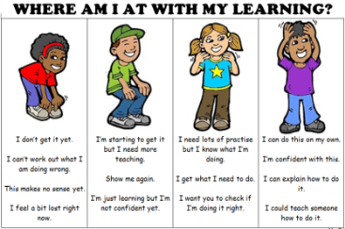 | We are looking for...  - Students to be able to draw their own planning graph.  - Students to identify each part of the planning graph.  - Students ‘having a go’ at using planning graph.

SESSION 2
WHOLE CLASS FOCUS >> INDIVIDUAL / SMALL GROUP / CLASS SESSION
Tuning In:
Example of narrative text: ‘Goldilocks and the Three Bears’.

Focus: Planning
Deconstruct the example text into characters, problem and solution.
Create our own characters, problem and solution.
Plan out the story using the planning graph.
Students work individually or pairs to write parts of the story. (*No dialogue)
Regroup to share our work

REFLECTION | ASSESSMENT
Revisit success criteria and use the ‘Where Am I At with My Learning?’ poster: | We are looking for...  - Students to be able to draw their own planning graph.  - Students to identify each part of the planning graph.  - Students ‘having a go’ at using planning graph.

SESSION 3
WHOLE CLASS FOCUS >> INDIVIDUAL / SMALL GROUP / CLASS SESSION
Tuning In:
Example of persuasive text: ‘Cats Versus Dogs’.

Focus: Structure of a persuasive text
Revisit ‘Story Graph’
Revisit ‘Planning Graph’. Discuss and identify the components:
Bold Beginning
Paint the Picture details
Paragraphs 1, 2, 3 with increasing interest
Fulfilling finish

Students practise drawing their own, identifying the components
Use blank planner to deconstruct the example text: ‘Cats Versus Dogs’.

REFLECTION | ASSESSMENT
Revisit success criteria and use the ‘Where Am I At with My Learning?’ poster: | We are looking for...  - Students to be able to draw their own planning graph.  - Students to identify each part of the planning graph.  - Students ‘having a go’ at using planning graph.

SESSION 4
WHOLE CLASS FOCUS >> INDIVIDUAL / SMALL GROUP / CLASS SESSION
Tuning In:
Example of persuasive text: ‘Visit to the Beach’.

Focus: Planning
Deconstruct the example text into characters, problem and solution.
Create our own characters, problem and solution.
Plan out the story using the planning graph.
Students work individually or pairs to write parts of the story. (*No dialogue)
Regroup to share our work

REFLECTION | ASSESSMENT
Revisit success criteria and use the ‘Where Am I At with My Learning?’ poster: | We are looking for...  - Students to be able to draw their own planning graph.  - Students to identify each part of the planning graph.  - Students ‘having a go’ at using planning graph.

Further session to practise the planning and writing skill
Possible topics
- NAPLAN sample 2015
- NAPLAN sample 2016
- School uniforms
- Spelling
- Bedtime
- Free time Friday
- Which is better
- Best game

Resources
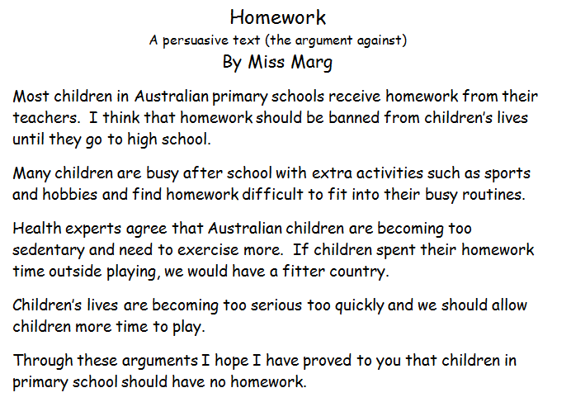
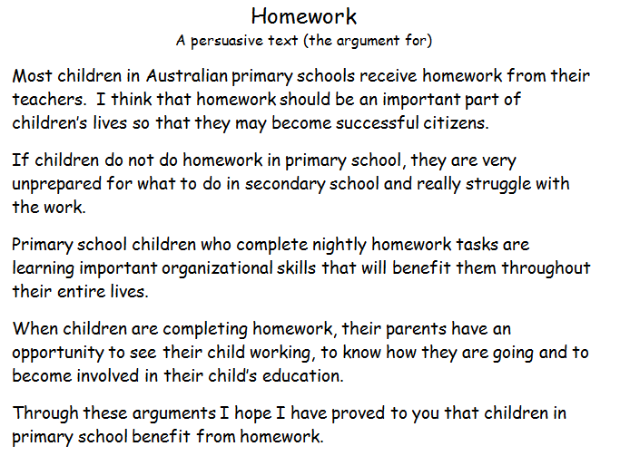
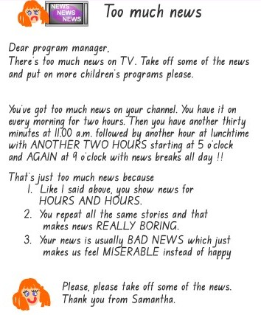
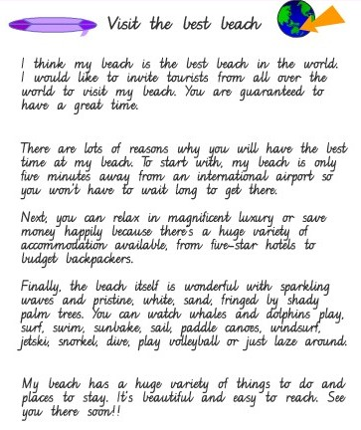

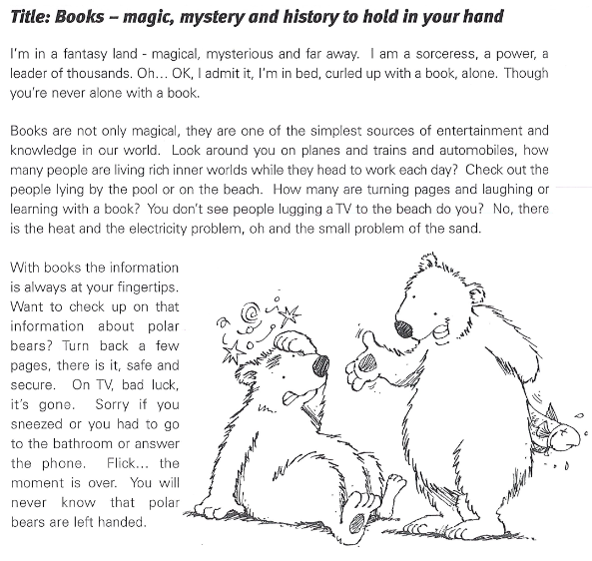
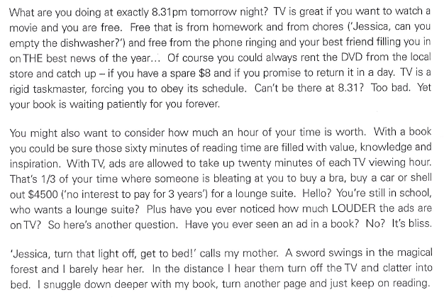

Bold Beginning
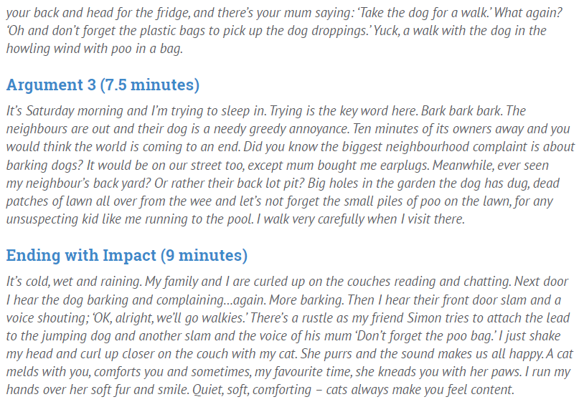

Fulfilling Finish

