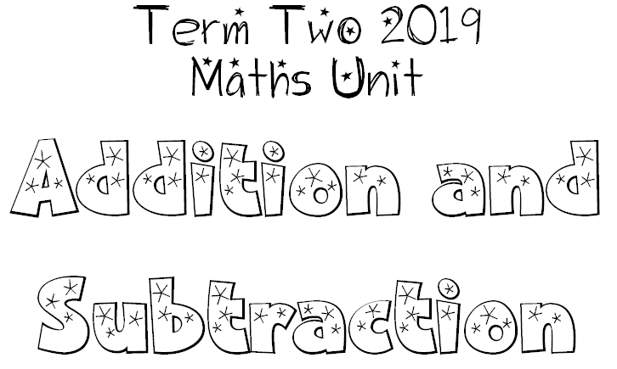
We are learning that there is a clear relationship between addition and subtraction.
I will be successful if:
- I can find connections between 3 numbers (three for free strategy).
- I can use my understanding of addition to assist in subtraction problems.
- I can use my understanding of subtraction to assist in addition problem.

We are learning to use many different strategies to work out addition and subtraction problems.
I will be successful if:
- I can describe how to use lots of strategies to work out addition and
subtraction problems.

