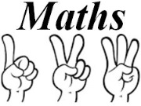
Pre Assessment for Addition and Subtraction

Name: ____________________________

5 + 18 = | 34 – 7 =
16 + 13 = | 57 - 23 =
47 + 24 = | 62 – 35 =
7 + ___ = 13 | ___ - 5 = 26
___ + ___ = 81 | ___ - ___ = 7
341 + 250 = | 358 - 40 = ___
26  + 350 | 56  - 21
2148  + 3014 | 742  - 19

