Ants

Ants on my driveway
Ants in my pants
Ants in the kitchen
Ants! Ants! Ants!

Ants on my ankle,
Ants on my toe.
Ants on my apple,
Go, ants, go!

Brian Bertie Baker

Brian Bertie Baker
Blew up a blue balloon
Brian Bertie Baker
At biscuits on the moon

Blowing Bubbles

I blew a little bubble
On my bubble pipe one day.
I tried to blow it bigger
But a breeze blew it away

I blew a bigger bubble.
I blew and could not stop!
My bubble with a rainbow
Burst with a great big ‘POP’!

Caterpillar

Caterpillar, caterpillar,
Crunch, crunch, crunch.
Eating every leaf in sight
For your lunch.

Caterpillar, caterpillar,
In a cocoon.
Can I see a butterfly
Coming out soon?

Carlo the Crocodile

Carlo the crocodile
Crushes and crunches
Cornflakes and carrots
For his lunches

Denny Dragon

Denny Dragon got a fright,
When he opened his bathroom door last night.
In his bath were some dancing mice,
Playing with a spotted dice.

Drip! Drop!

Drip, drop, drip, drop,
Drip from way up high.
Down fell the raindrops,
Dropping from the sky.
Dripping on my lawn,
Dripping on my tree,
Dripping on my garden,
But not on me!

An Elephant

An elephant goes
Like this and that,
He’s terribly big,
And he’s terribly fat.
He has no fingers,
And he has no toes,
But goodness gracious,
What a nose!

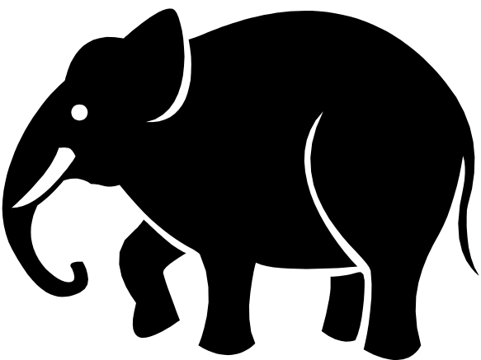

Fiddle Fiddle

Foodle Fie

Fiddle fiddle foodle fie
Finches flying in the sky
Fiddle fiddle foodle fee
Fishes flying in the sea

Five Frogs

Five fat, freckled frogs
Looking for some food,
Jumped up on a lily pad
In a hungry mood.

Five fat flies flew by
Flying to their home –
Five frogs’ tongues went FLICK!
And five flies were gone.

Gertrude Goat

Gertrude is a greedy goat,
A greedy goat of mine.
She chewed up Grandpa’s gumboots
And clothes pegged on the line.

Gertrude is so greedy,
Going munch, munch, munch.
She chewed up all my homework,
My school bag and my lunch!

Hurry Up, Harry!

Hurry, hurry, Harry!
I need your help today,
My horse is very hungry,
He needs a heap of hay.

Harry, you must hurry,
Hurry with your feet.
My hungry horse is happy,
When he has hay to eat.

Igloo

We made our home an igloo,
A place where we could hide.
It was so very cold in there,
We lit a fire inside.

It soon began to melt away.
I stood and scratched my head.
We set to work until we had,
A snowman there instead.

Jess and Jo

Jess jumps up,
And Jo jumps down.
Jess is the pup,
And Jo is the clown.

Jumping

Jump! jump! jump!

Jump up high.

Jump in the air

Touch the sky.

Jack can jump,

So can John,

Jill and Jessica,

Jim and Ron.

Kicks

Kick with your left foot,

Kick with your right,

Kick each one in turn

With all your might.

Lollipops

I licked eleven lollipops,

I went lick lick lick!

I licked and licked them all until...

I felt very, very sick!

I like to lick a lollipop,

But only one, I fear.

Licking lots of lollipops


Is not a good idea!

Muffins

Mummy munches muffins
Muffins, muffins
Mummy munches muffins
Munch, munch, munch!

Marmaduke Mouse

Has anyone seen Marmaduke?

Marmaduke, my mouse.

He’s hiding from my mother cat

In his mouse house.

When the cat is sleeping

Marmaduke peeps out.

He creeps out of his mouse hole

And scampers all about.

Nancy

Nancy never goes to bed

Until the sun goes down.

Nancy loves the night sky

Above her home town.

Nancy puts her toys to bed

At the end of the day.

When the night is over

They’ll all wake up and play.

Oh, Oh, Oh!

Oh, oh, oh!

What do you know?

An owl and an octopus

Went for a row!

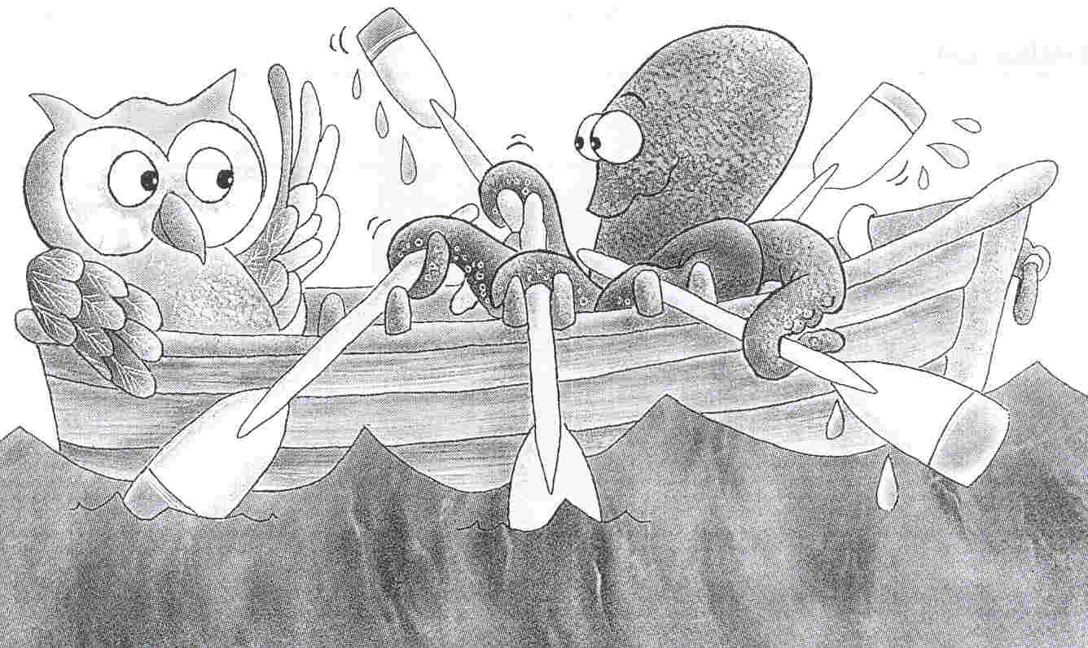

Octopus

If I were an octopus,
I’d live down in the sea,
Where my octopussy friends
Would come and visit me.

We’d play octopussy games,
And often have some tea
At the Octopussy Restaurant
At the bottom of the sea.

Percy Pig

Percy is a perfect pig,
His manners are the best.
He never grunts or spills his food,
He never is a pest.

Percy is a perfect pig,
A present from my mummy.
When I have some coins to spare,
I put them in his tummy.

Quackers

Listen to the quiet ducks
Quack, quack, quack.
Now here come the noisy ones
QUACK! QUACK! QUACK!

Running

Run, run, run,
Run to the tree.
Run to the fence,
Run back to me.

Ring, ring, ring,
Ring the little bell.
Ring it for the children,
Ring it very well.

Simon’s Socks

Simon had some stripy socks
Of yellow, blue and white.
Simon wore his stripy socks
Morning, noon and night.

Squeezes

We love to squeeze bananas,
We love to squeeze ripe plums.
And when we are feeling sad,
We love to squeeze our mums.
Brian Patten

Toy Train

Tickety tack,
Tickety tack,
A train is coming
Down the track.

Tickety tack,
Tickety tack
The train driver stops
To pick up Jack.

Tippy Tippy Tiptoe

Tippy tippy tiptoe
Tigers go,
Tippy tippy tiptoe
Fast and slow.

Tippy tippy tiptoe
Tigers run
Tippy tippy tiptoe
‘round the sun.

My Umbrella

Under my umbrella
Is a good place to be.
When the rain from the clouds
Is falling down on me.

Up went my umbrella
One rainy, rainy day.
I held it very tightly
But the wind blew it away!

Vegetables Vegetables

Vegetables, vegetables in the pot.
What a lot of soup you’ve got.
Drink and eat down to your tummy.
Drinking vegie soup is very yummy!

Violets

Victor picked some violets
When the day was fine.
Victor put them in a vase
For his Valentine.

His Valentine was Valerie
She waited for a week
Before she said, “Thank you”
And kissed him on the cheek.

Watermelon

I wanted some cold watermelon
All juicy, ripe and sweet.
I let it drip all down my chin
As I walked along the street.

“Wait for me,” my friend called out
“Is that watermelon cool?”
So we shared that watermelon
On our way down to the pool.

About X

X is the sound that always can be found
At the end of words such as these:

Mix and fix,
Ox and box.

It’s even at the end of chicken pox!

Yellow Day

Yesterday was Yellow Day
It was a lot of fun.
We all dressed up in yellow clothes
And made a yellow sun.

We drew Safety House posters
In yellow yesterday.
Yes, we listened to the safety rules
For home and school and play.

ZZZZzzzz

Do buzzing bees in their hives
Go ZZZZzzzz?
Do sleepy zebras at the zoo
Go ZZZZzzzz?

Does the last letter in the alphabet
Put you all to sleep?
Or wake you up like buzzing bees
Going zzzzzzzzZZZZZZZZ?

