We’re Learning About Blends

Learning about blends helps us to spell words correctly and increases our vocabulary.

Words that begin with
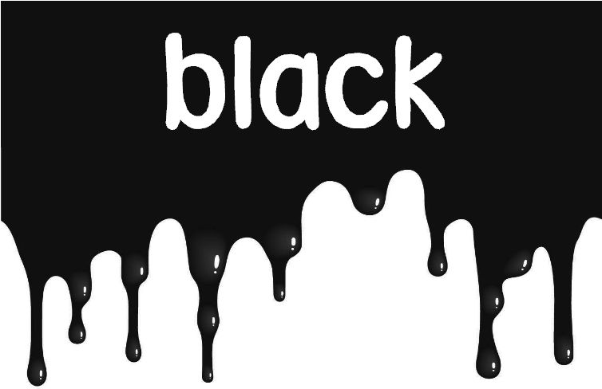
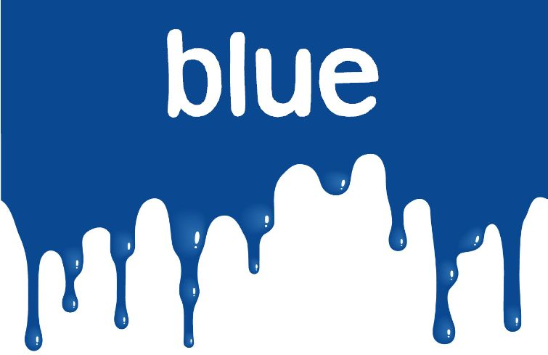
bl

What words have a ‘bl’ blend?

black | blue | blame
blow | blood | blanket
blew | block | blind
blaze | blend

Word Search for ‘bl’ Blend Words
B F O X B L A N K E T F W W A  J L P W Y B C O P K Q U E O P  B O A J C B A M L R Y L V G D  I T O C L B D N I L B D T H Y  U J E A K L Y B B B D W L I D  A Y Z H F S B L I L E V G X S  Q E U W L V G Q X A K K X N A  B E E N E E P K K M D C C B P  L J M D V O A G G E O Z O Y D  B Y E Q K M B L O W O Y X L J  N L G R D I X S E Y L A S E B  A Z U T W T L Q N B B Y Z G C  K A X E X B G A I N T E J I B  J K J K Y E B W L L E Y Z K M  P U D F A W C B G A K H O F Q | BLACK  BLAME  BLANKET  BLAZE  BLEW  BLIND  BLOCK  BLOOD  BLOW  BLUE

Make a Flip Book

bl

Words you can do  (Verbs) | Words that are something  (Nouns)
Words that describe something  (Adjectives) | Not sure

I’ve built a big blue rocketship
with silver stars and stripes.
It flies me to the yellow moon
and through the dark black night
10, 9, 8, 7, 6, 5, 4, 3, 2, 1, 0
Blast off!
What words have a ‘bl’ blend?
Would a dictionary help?

