We’re Learning About Blends

Learning about blends helps us to spell words correctly and increases our vocabulary.

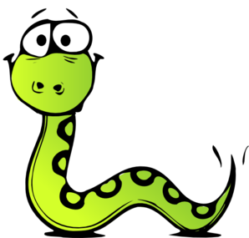
Words that begin with
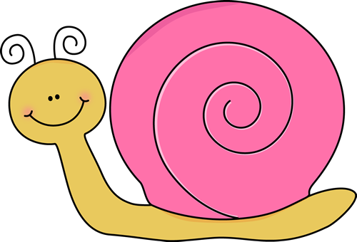
sn

What words have a ‘sn’ blend?

snail | snake | snap
snow | snug | sneeze

Word Search for ‘sn’ Blend Words
F V C E T I S H W C G K O T F  Z Q P Y E G M I H G O B M E T  W H Y W K C N Q Y C X M O C O  S O H T C B I J S N A I L S J  Y G U N S P A L A W D K G N C  S A Q O W M X A X I T N Q A R  E A X Q F Q I Z R V F G L P B  Z T U Q O E A S I F I S V O S  A U I A W U E D R F R S E N H  Q W W R S F E E I N N Z O G W  T K H B U N T B T C E W E E K  G P N S G X A Z O E R B F X M  H D O M Q F M K N V R B V Z R  S D P R N O C S E D S R W P E  G R U F N Z V A I D W W C B R | SNAIL  SNAKE  SNAP  SNOW  SNUG  SNEEZE

Make a Flip Book

sn

Words you can do  (Verbs) | Words that are something  (Nouns)
Words that describe something  (Adjectives) | Not sure

We sneak and we snoop
through the tall grass and trees.
We’re hiding from you
but the grass makes us sneeze...
I found you!

What words have a ‘sn’ blend?
Would a dictionary help?

