We’re Learning About Blends

Learning about blends helps us to spell words correctly and increases our vocabulary.

Words that begin with
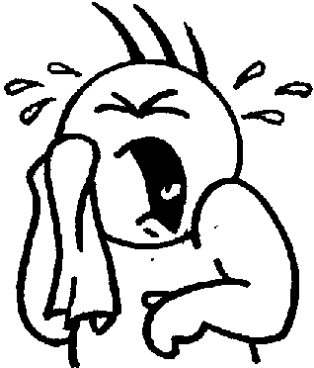
cr

What words have a ‘cr’ blend?
Would a dictionary help?

What words have a ‘cr’ blend?

crib | crawl | cream
cried | crack | creek
crowd | cry | crow
crop | cross | crook

Word Search for ‘cr’ Blend Words
D J K S S S E N R B B M Y S S  W Y U E S Y X S P J O J V G F  O R E O E O Q R R U V Q N J F  R P R S Z R C X F O K C D H D  C C K C A R C O I B D R T E I  A J X R U S X T J X D O X L C  J A I B S L Q R V O C W Y R C  Z U E E M O K C F K Q T O O A  L G F E B N R H O G E X G W L  C Y U I Y I D K D Y F C G S Y  G R G O E I Q T L N R R Y D D  C D A D C R O O K C Y E C N M  S R Q W O Q U F R Q X A L B A  H C I Y L D V O Y G Q M H Y J  E F U B G U P C J D J T M W L | CRIB  CRAWL  CREAM  CRIED  CRACK  CREEK  CROWD  CRY  CROW  CROP  CROSS  CROOK

Make a Flip Book

cr

Words you can do  (Verbs) | Words that are something  (Nouns)
Words that describe something  (Adjectives) | Not sure

Crabs and crayfish,
Creep and crawl.
Crowds of crabs,
Now none at all.

