We’re Learning About Blends

Learning about blends helps us to spell words correctly and increases our vocabulary.

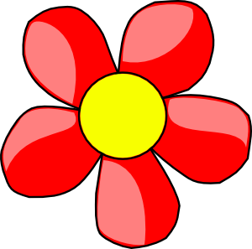
Words that begin with
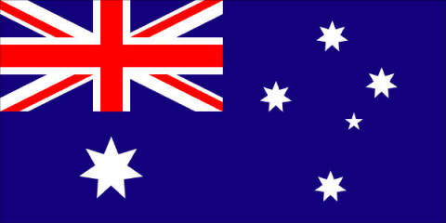
fl

What words have an ‘fl’ blend?
Would a dictionary help?

What words have an ‘fl’ blend?

flag | flower | floss
fly | flick | flood
flat | flip | flew

Word Search for ‘fl’ Blend Words
I S A F V K B K S V L C G I R  K R S I G G S C S L P Y J Y H  N Z K O E L V I H P C C Y J W  Y L F Z L D Z L M C R T Q J X  H Q V L O F H F E Z B M U R Q  G H D O P J C Q O F C B C D R  P A L F Q U Q C L U Y O N I K  H F E A O H B E Y F B B W F L  U N B S V D W F M V L D L J W  R K C V F S U H M F P A H P R  B R K N S L H Y U L S F T F F  N U J W L J V G O U P Y J T L  S F L A G Y Q M O T I A X Y I  L B X W J R J S Y M N X U B P  Q I Q P E I R E W O L F Y V E | FLAG  FLOWER  FLOSS  FLY  FLICK  FLOOD  FLAT  FLIP  FLEW

Make a Flip Book

fl

Words you can do  (Verbs) | Words that are something  (Nouns)
Words that describe something  (Adjectives) | Not sure

Butterflies flutter
and some flowers float.
Flutes sparkle and shine
as they play out a note.
Flamingos can fly
but some of them don’t!

